A Mixed Method Project to Investigate Users’ Self-Assessment of News Literacy on Social Media

Task 1: Research Proposal

Introduction
My research proposal examines how students view their ability to critically assess news and information within the realm of content driven by social media algorithms. As these algorithms curate material based on user data, it’s essential to explore if students can differentiate between credible sources and information. This study will delve into students self-reported critical thinking abilities, the influence of algorithmic content distribution on their evaluation of information and the effectiveness of educational initiatives designed to boost digital literacy. Ultimately, the goal of this research is to improve students’ awareness and resilience to online misinformation.

Literature Review
In recent years, social media has become a ubiquitous tool among university students, with 73% using it in education to collaborate with classmates on electronic devices (Khaled, 2023). However, the rise of algorithm-driven content has transformed how information is consumed, often prioritizing engagement over accuracy. These algorithms, designed to maximize user interaction, amplify sensational and emotionally charged content, which not only risks spreading misinformation but also affects students' academic capabilities. Students, as a result, may struggle with evidence evaluation and become more susceptible to unreliable news sources (Ku et al., 2019).
This vulnerability is further compounded by the speed at which false information spreads on social media. Unlike legacy media, where dissemination of content is often constrained by editorial checks, social media algorithms cater to users' existing beliefs, reinforcing subscribed dogmas rather than exposing them to diverse perspectives (Vosoughi et al., 2018). The accessibility of this information—available anytime and anywhere without financial constraints—has made social media the dominant source of news, surpassing traditional platforms like TV (Tobitt, 2024). This transition to online platforms fosters echo chambers, where curated content reinforces users' existing views, creating filter bubbles that guide exposure toward familiar ideas (Kahne & Bowyer, 2016).
Adding to this dynamic is the format of social media itself, which often prioritizes snackable content. Cultural and informational materials are condensed into short, shareable formats designed to provoke emotional reactions rather than critical engagement (Moura, 2011 as cited in Nam & Jung, 2021). Over time, this format trains users to avoid lengthy or detailed information, making it harder for them to engage with or trust nuanced, well-researched sources.
This pattern of behaviour ties closely to Goffman’s dramaturgical theory, which explains how individuals adopt and integrate beliefs, true or false into the roles they perform in social interactions. When misinformation aligns with an individual’s sense of self, they may publicly endorse these ideas within their social groups, creating a psychological barrier to admitting they were wrong (Goffman, 1990). Doing so could threaten their "front," the aspect of their performance that defines the situation for an audience. Consequently, students may resist engaging with nuanced or opposing views, as doing so risks destabilizing the identity they have constructed.
For university students, among the most active social media users, this exposure to misinformation/disinformation has significant consequences. Given its accessibility and real-time nature, young adults frequently rely on social media as their primary source of news and information. However, sensational and misleading content is more likely to go viral than genuine news, affecting students' understanding of critical issues such as politics, health, and social affairs (Saquete et al., 2022). Moreover, the influence of disinformation on academic research jeopardizes the integrity of their work, as reliance on unreliable sources can skew findings and hinder credible scholarship.
This interplay between social media algorithms and misinformation underscores the ethical responsibilities of social media corporations in content moderation. While some platforms have introduced fact-checking systems and warning labels for misleading information, their effectiveness remains under scrutiny. Ultimately, the high usage of social media among students and the prevalence of algorithm-driven misinformation highlights the urgent need for enhanced digital literacy and critical thinking skills to navigate the complexities of online information ecosystems.

Research Questions:

Quantitative Research Question
What is the relationship between SOC2702 students’ social media usage and the ability to accurately identify misinformation on social media platforms?

Qualitative Research Question
In what ways do SOC2702 students perceive their ability to critically evaluate news and information to relation to algorithm-driven content on social media platform?

Methodology:
To find the answer, the 2-research question, we would need to use a mixed method explanatory approach where I collect and analyse quantitative data (data sheets) followed by qualitative data which would be done in a form of a semi-structured interview

Quantitative Approach/ Survey
Quantitative research hones into a collection of numerical data to explore phenomena. Key methods in quantitative research includes surveys and questionnaires, which widely recognised for their ridged and structured approach (Bryman, 2016, pp. 149). For this study, a questionnaire comprising 10 closed ended questions was developed (questionnaire guide attached in Task 3). For some of the questions, the survey utilized a Likert scale, which provides participants with multiple choice options to indicate their opinions. For example, one of my questions asked participants about how much value they place on friends/family in terms of sending people information, offering options such as “Extremely valuable”, “Very Valuable”, “somewhat valuable”, “Not so valuable”, “Not at all valuable” (Bryman, 2016, pp. 246-249).
To administer the questionnaire, the survey link was shared via email to three to five participants. Data collection process aimed to obtain responses between 3-5 second-year students enrolled in the SOC2702 module at Middlesex University, as part of a pilot study to ensure the questionnaires effectives and to prevent such errors to protest the questionnaire in full or in part (Bryman, 2016, pp. 260-261) Three participants completed the pilot survey about social media and critical evaluation of misinformation
Ethics were considered throughout the research process. The survey participation. Participants were provided with information to make an informed consent before completing the questionnaire, ensuring adherence to ethical research guidelines and inform them that they have a right to not partake in the survey, since students would fear that non-participation will somehow affect their grade (Babbie, 2015), ensuring that anonymity by emailing the link of the Momentive questionnaire to students via email.
After data collection was completed, statistical analysis was carried out, including univariate analysis, which involves describing a case in terms of a single variable, for example, the participant’s gender. Bivariate analysis, which examines the relationship between two variables (Babbie, 2015) to investigate connections between gender/ beliefs about romance scam and being a victim of an online romance scam.

Qualitative Research/ Semi structured Interview:
To answer the qualitative study topic, data was gathered through one to two semi-structured interviews with SOC2702 students at Middlesex University. Semi-structured interviews, as opposed to surveys, are interactions between an interviewer and a respondent in which the interviewer has a general plan of inquiry that includes the topics to be covered but not a set of questions that must be answered in order, but rather to cover the general aspect of the topic (Bryman, 2016, pp. 471). This flexible approach allows interviewees to discuss topics freely, even if their responses deviate from the order of questions.
To guide the interview, a protocol with six main questions and three probing questions was developed. A pilot interview was conducted to gather feedback on the guide’s clarity and effectiveness. Constructive criticism from this pilot informed minor adjustments to improve the interview process before full implementation. I utilised purposive sampling to identify interview participants. Purposive sampling (a type of non-probability sampling) occurs when the researcher selects persons who are relevant to the research, (students who take SOC2702) (Bryman, 2016, p. 422). In addition, I would use convenience sampling (Bryman, 2016) to locate participants depending on their availability; owing to my short deadline of having this interview done, I used these approaches to discover individuals from the SOC2702 module if they are willing to participate in this study.
Ethical considerations were integral to the process. An ethics review was conducted to ensure that the interview questions were not intrusive or harmful. A consent form and an information sheet explaining the purpose of the study were sent to participants, emphasizing their right to withdraw at any stage without impacting their academic standing.
Permission to audio-record the interviews was requested, and recordings were saved on a password-protected device accessible only to me. These recordings will be transcribed and analysed, with all data destroyed within three weeks of completion to ensure confidentiality and mentioned that request of deletion after the three-week period would be impossible since the researcher would have gone further within their research.
Following transcription, I plan to conduct a thematic analysis using Bryman’s (2016) framework. This process involves open coding, which is the process of breaking down segments of the data, axial coding, which are similar codes together to uncover relationships and theoretical coding to link the highlighted themes to existing literature (Bryman. 2016, pp. 567-570) . This approach will help identify trends, categorize the data, and contextualise the findings within theoretical framework, contributing to the study’s overall objectives.

Time Frame:
 | Oct 14-20 | Oct 21-27 | Oct 28-Nov 3 | Nov 4-10 | Nov 11-17 | Nov 18-24 | Nov 25-Dec 1 | Dec 2-8 | Dec 10 - 15
Obtain ethical approval
Recruit participants for survey
Recruit participants for interviews
Conduct interviews
Transcribe interviews
Analyse data using 6 SPSS and thematic analysis

Task 2: Ethical Forms
Qualitative Ethics Approval Pack

Please complete and gain approval for the table below (in Weeks 3 & 4 seminars), the Consent Form on page 2 and Participant Information Sheet on pages 3-5 (both in Weeks 3 and 4 seminars).

PLEASE NOTE: YOU MUST RECEIVE ETHICS APPROVAL FROM THE SEMINAR TUTOR FOR ALL PARTS OF THIS ETHICS PACK (i.e. the table below, the consent form and the participant information sheet).

My research topic is: | Social Media
My qualitative research question is: | In what ways do SOC2702 students perceive their ability to critically evaluate news and information in relation to algorithm-driven content on social media platforms?
Please state whether you are conducting 4 separate interviews online or on campus and why | I will be conducting only two interviews that will take place on campus due to the ease of the participants opening up on their answers and prevent them from getting distracted online compared to a controlled environment (e.g classroom)
Please state who your research sample will be and why: | My research sample will be SOC2702 students because of the restrictions placed with the student module handbook  I will approach the participants with a request to participant in the research
Please state how you will implement the following to make your study ethical: | Confidentiality:  I will avoid reporting individual level data. I will assign pseudonyms to protect identities of the participants. The recording of the interview will be stored on a password protected laptop that only I will have access to.
Anonymity:
Give them a different name that would prevent revealing information that can be traced back to the real person.
Removing all personal information and deleting the recording.

Reduce harm to participants:
I will not ask participants question that directly harm or discomfort.
I will also make sure to inform the participant they have the right to not answer any question and even withdraw from the interview any anytime without a reason with no repercussions

Ethically approach participants:
I will only approach students taking the module SOC2702 to ask them if they would be interested in my research and accept the offer

Data protection & storage of data:
The recoding of the interview would be saved on a password protected device that I only have access to, in which would be transcribed, and the data would be analysed by the researcher. Once the data has been used and processed, the data would be destroyed within 3 weeks of the research, after that the request would be impossible.


PARTICIPANT CONSENT FORM
Title of Project: Social Media and Critically Evaluating Misinformation
Name of Researcher: Ugonna Ezenekwe
Please initial box
- I confirm that I have read/discussed and understand the information sheet dated ...................…………for the above study and have had the
1
opportunity to ask questions.
2
- I understand my involvement will entail taking part in an interview on campus
- I understand my involvement will entail being audio recorded for
a semi-structured interview at a time and place to suit my needs.
3

- I understand my participation is voluntary and I am free to
4
withdraw my participation a week after being interviewed, without giving any reason and without penalty. I understand I can do this by emailing the researcher using my MDX email account
5
- I agree for that this form that bears my name and signature may be seen my
module leader and seminar tutor for SOC2702

- I am assured that the confidentiality of my data will be upheld
through the removal of any personal identifiers and any audio recordings
bearing my voice will be deleted and destroyed after data transcription.
6
7
8
- I agree to take part in the above study.

Name of participant: Name of researcher:
Date: Date:
Signature: Signature:
1 copy for participant; 1 copy for researcher: The researcher will take a electronic signature and will store it on their encrypted University OneDrive. The participant will be sent a signed copy by the researcher. The form will be destroyed after publication of results. All zoom interview recordings will be stored on a licenced encrypted cloud and deleted after transcription.

MIDDLESEX UNIVERSITY

PARTICIPANT SHEET (PIS)

Participant ID Code:……………………………………………

1. Study title
Social Media and Misinformation

2. Invitation paragraph
You are being invited to take part in a research study. Before you decide whether to take part, it is important for you to understand why the research is being done and what it will involve. Please take time to read the following information carefully and discuss it with others if you wish. Ask us if there is anything that is not clear or if you would like more information. Take time to decide whether or not you wish to take part. Thank you for reading this.

3. What is the purpose of the study?
The purpose of the study is to raise awareness about misinformation with algorithm-driven content and how it effects people to critically evaluate information with student in Middlesex University.
Knowing this information will help to identify and bring awareness with social media and how social media algorithms spread information.
4. Why have I been chosen?

Since you meet the criteria (You attend Middlesex University and take the module SOC2702) and have indicated that you have an interest into taking part in this study

I am also interested in learning about your views and experiences on a sense of belonging on campus at Middlesex University.

5. Do I have to take part?
It is up to you to decide whether or not to take part. If you do decide to take part, you will be given this information sheet to keep and be asked to sign a consent form. If you decide to take part, you are still free to withdraw at any time and without giving a reason. If you do decide to withdraw from the study then please inform the researcher as soon as possible, and they will facilitate your withdrawal. If, for any reason, you wish to withdraw your data please contact the researcher within three weeks of your participation. After this date it may not be possible to withdraw your individual data as the results may have already written up. However, as all data are anonymised, your individual data will not be identifiable in any way.

A decision to withdraw or a decision not to take part, will not affect your status as a student in any way.

6. What will I have to do?
You will be asked to take part I one individual semi- structured interview that would last around for up to 20 minutes on campus in person at a convenient time and date for you
You will be asked a series of questions about how you perceive your ability to critically evaluate news and the information in relation to the algorithm-driven content on social media platform
7. What are the possible disadvantages and risks of taking part?

It is not expected that you will experience any psychological discomfort in taking part in this research. However, please be assured that you don’t have to answer all the questions and you can withdraw from the interview at any time without giving any reason or suffer any repercussions if you wish withdraw also.

Appropriate risk assessment for all procedures have been conducted and will be followed throughout the duration of the study

8. What are the possible benefits of taking part?
“We hope that participating in the study will help you. However, this cannot be guaranteed. The information we get from this study may help us to understand how SOC2702 students can critically perceive information with algorithm=-driven content on social media platforms.

9. Will my taking part in this study be kept confidential?

The research team has put a number of procedures in place to protect the confidentiality of participants. You will be allocated a participant code that will always be used to identify any data you provide. Your name or other personal details will not be associated with your data you provide. For example, the consent form that you sign will be kept separate from your data. All paper records will be stored in a locked filling cabinet accessible only for the research team and all digital data will be stored in a password protected computer. All information you provide will be treated in the accordance with the UK Data Protection Act

10. What will happen to the results of the research study?

The results of the research study will be written up and used for the researcher’s undergraduate’s mixed research report. The result may also be presented to the module leader. Furthermore, the researcher would also use this information as a template for future research.

However, the data will only be used by a member of the research team and at no point will your personal information or data will be revealed. The data will be destroyed as soon as the final grade of the SOC2702 assignment is received and confirmed you require further information, have any questions or would like to withdraw your data then please contact:

Task 3: Research Tools

Structured Questionnaire
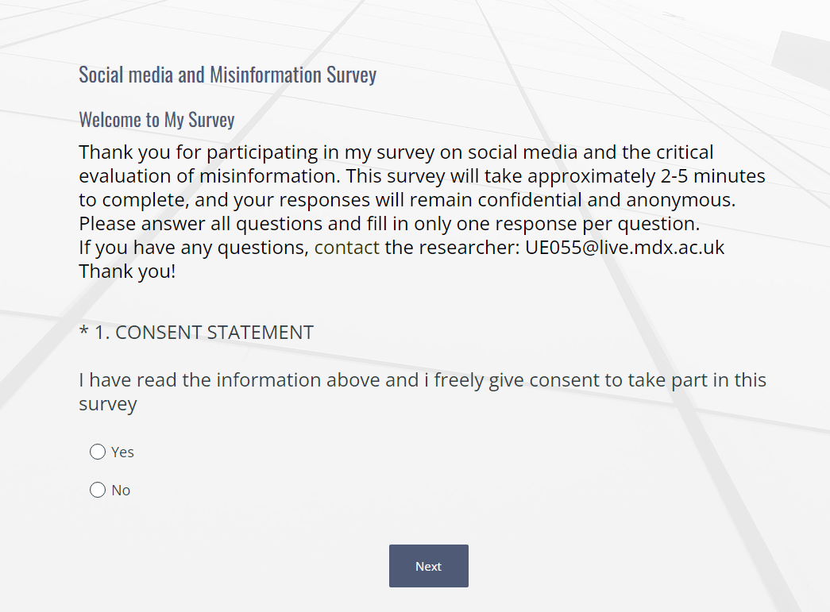
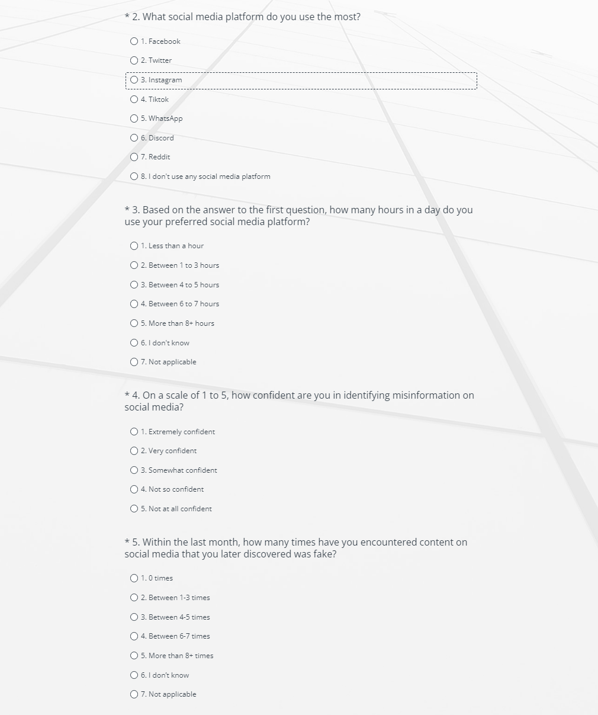
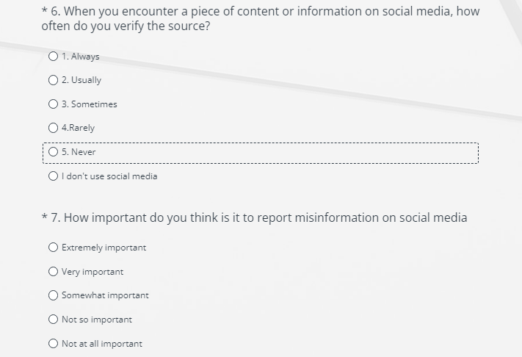
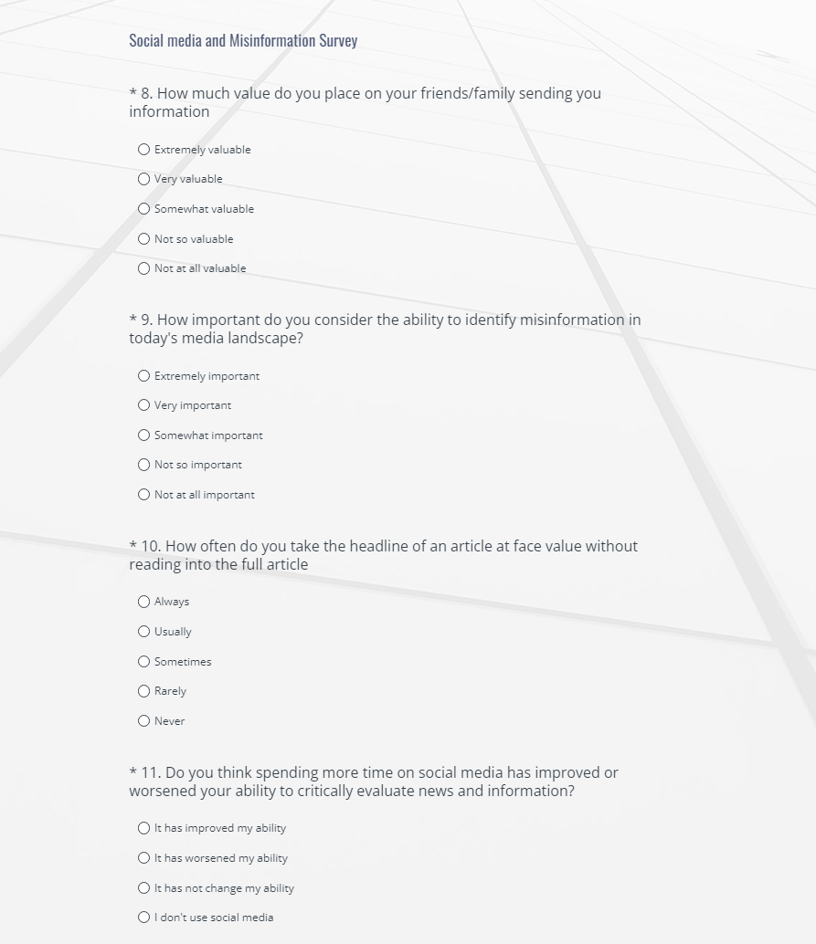

Interview Guide
My name is Ugonna Ezenekwe, a second-year Sociology with Criminology student at Middlesex University. I am conducting a study on social media and critical thinking in relation to algorithm-driven content.
Thank you for participating in this interview, which consists of six questions and is voluntary. You may withdraw at any time, including during the interview. The interview will last up to 20 minutes and take place in person on campus at a time convenient for you. You’ll be asked about your ability to critically evaluate news and algorithm-driven content on social media. With your consent, the interview will be audio-recorded to assist in transcription. I assure you this study is ethical, anonymous, and confidential; no personal information, including your name, will be included. Do I have your consent to proceed?

Do you have any questions?
Shall we proceed with the interview?
Introductory questions
- How is your day?
- Tell me about yourself?

Main interview questions
- How do you usually access news and information?
- What social media do you rely on the most and why?
- How do you know that [*Input used social media from participant*] is creditable about the information?
- What do you do to verify the information presented?

- In your opinion, how does the content recommended to you by social media platforms influence your views or opinions on current events?
- Do you believe the algorithm affect your exposure to diverse viewpoints?
- Have you ever gone out of your way to sought other viewpoints to get a good understanding of the content being presented?

- Have you ever encountered misinformation or fake news on social media? If so, how did you handle it?
- How did that experience your influence your trust in news shared on social media?
- Do you think there should be regulation in terms of how information is being easily ascertained on social media? If so what should it look like?

- Have you ever changed your perception of a piece of news or information after learning more about the algorithm that promoted it? Can you share an example?
- What factors influenced your change in perception and how did this experience affect your trust in similar content in the future?
- In what ways do you feel that social media algorithms influence your exposure to diverse talking points?
- What factors helped decide which version of information to trust the most?

- Do you think people are more likely to believe information shared by friends and family over other sources on social media? Why? Why not?
- What factors do you think influence whether someone trust information from friends and family more than from other sources on social media?
- Can you think back to a time when you doubted information shared by a friends and family on social media, and what was their reaction?

- In your experience, does the source of information (friends/family vs unknown source) affect how credible it feels?

- Should misinformation be removed from the internet? Why or why not?
- How can we distinguish misinformation from opinions or controversial viewpoints?
- Who should be responsible for deciding what qualifies as misinformation?
- What are the potential risks of removing misinformation, such as censorship or bias?
- Could public education or fact-checking initiatives be a better alternative to outright removal?

References:
Babbie, E. (2015) The Practice of Social Research. 14th edn. Boston: Cengage Learning.
Bryman, A. (2016). Social Research Methods. Oxford: Oxford University Press.
Goffman, E. (1990) The presentation of self in everyday life. London: Penguin.
Khaled, M. (2023). Social Media and Education: Exploring the Pros and Cons with Surprising Statistics in 2023 | ProfileTree. [online] Profile Tree. Available at: https://profiletree.com/social-media-and-education-exploring-statistics/. [Accessed: 1 November 2024].
Ku, K.Y.L. et al. (2019). What predicts adolescents’ critical thinking about real-life news? The roles of social media news consumption and news media literacy. Thinking Skills and Creativity, 33, pp. 100570-. Available at: https://doi.org/10.1016/j.tsc.2019.05.004. [Accessed: 13 October 2024].
Nam, J. and Jung, Y. (2021). Digital natives’ snack content consumption and their goals: A means-end chain approach. Telematics and Informatics, 63, p.101664. doi: https://doi.org/10.1016/j.tele.2021.101664. [Accessed: 27 October 2024].
Saquete, E., Zubcoff, J., Gutiérrez, Y., Martínez-Barco, P. and Fernández, J. (2022). Why are some social-media contents more popular than others? Opinion and association rules mining applied to virality patterns discovery. Expert Systems with Applications, 197, p.116676. doi: https://doi.org/10.1016/j.eswa.2022.116676. [Accessed: 22 October 2024].
Tobitt, C. (2024). Online overtakes TV as biggest source of news in UK for first time. [online] Press Gazette. Available at: https://pressgazette.co.uk/media-audience-and-business-data/media_metrics/online-overtakes-tv-as-biggest-source-of-news-in-uk-for-first-time/. [Accessed: 28 October 2024].

Task 4: Reflective and Reflexive Account
The growing influence of social media in spreading and reporting news and information, particularly among students, drove my decision to focus on critically evaluating misinformation. At Middlesex University, I noticed students' engagement in conversations and their perceptions of various topics, sparking my curiosity about how they critically assess news and algorithm-driven content on social media. Immersed in this environment, I realized my own reliance on social media, often using it to check updates or as a means of procrastination. Conducting both a pilot survey and interviews was successful, with participants reporting a positive experience. The structured process allowed participants to reflect on their use of social media platforms and how these platforms influence their understanding of news and information. This process pushed me out of my comfort zone, as I approached participants I rarely interacted with, which helped prepare me for my dissertation and future research.
Reflecting on qualitative research is essential, as it addresses the researcher’s biases, assumptions, and preconceptions (Finlay, 2002, as cited in Ide and Beddoe, 2023). My research highlighted the platforms students commonly use and their vulnerabilities to misinformation. Research shows that Gen Z is particularly prone to misinformation (Murray, 2023), so I investigated how their activities on social media curate content based on past behavior and how third-party influences, like friends and family, shape their perspectives. Given their limited worldview, they are likely to align with the opinions of close social circles, which impacts how they interpret information. For the pilot survey, many participants identified TikTok as their most-used platform (see Appendix 4). In contrast, I use Twitter/X, where information is often lengthy and supplemented with measures like community notes to counter misinformation. I selected participants who frequently used platforms known for short-form content delivered in a “snack format” short, engaging, and easily digestible material designed for quick consumption (Nam & Jung, 2021). These platforms often lack safeguards to educate users on misinformation.
This experience greatly informed my interview questions, focusing on how participants gather and interpret information, especially if they fall for misinformation. The pilot study provided insights into the participants' perspectives and strengthened my understanding of the challenges posed by social media. It also emphasized the importance of reflexivity in research, enhancing my ability to critically evaluate my role in shaping the research process and my interactions with participants. These findings will guide my dissertation and future academic endeavors.

Task 5: Data Analysis

Quantitative data analysis
To answer the research question, is there a relationship between gender and being a victim of an online dating romance scam? and is there a relationship between beliefs about romantic love and whether a victim of an online dating romance scam? we will being univariate and bivariate analysis.

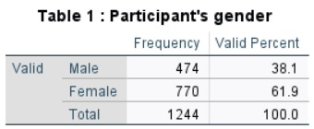
Table 1 shows us in the sample of the online data survey, most respondents (61.9%) were female as opposed to 38.1% which sated to be males.

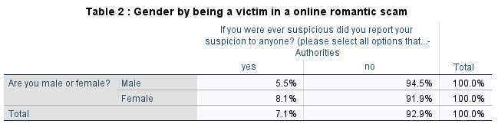
Table 2 highlights a gender difference in reporting suspicions to authorities: 8.1% of women reported suspicions compared to 5.5% of men. Conversely, 91.9% of women and 94.5% of men did not report suspicions. While women are slightly more likely to report, the majority of both genders refrain from reaching out to authorities, indicating widespread hesitation or uncertainty.
This aligns with Rogers' (1975) Protection Motivation Theory, suggesting fear appraisal and recognition barriers influence reporting behaviours. Additionally, societal norms may play a role: women, often viewed as more emotionally sensitive, may be more inclined to report, whereas norms emphasizing male self-reliance and resilience may discourage men from doing so.

Table 3 : Participants' beliefs about romantic love

Please describe your own beliefs about romantic love by indicating the extent to which you agree or...-When I find my 'true love' I will probably know it soon after we meet
 |  | Frequency | Valid Percent
Valid | Strongly Disagree | 56 | 4.5
Valid | Moderately Disagree | 95 | 7.7
Valid | Disagree | 210 | 17.0
Valid | Neutral | 307 | 24.8
Valid | Agree | 303 | 24.5
Valid | Moderately Agree | 158 | 12.8
Valid | Strongly Agree | 107 | 8.7
Valid | Total | 1236 | 100.0

In Table 3, 27.6% of participants agree that “if I find my true love, I will probably know it soon after we meet,” followed by 18% who are neutral, and 14.4% who strongly agree. Meanwhile, 13.8% disagree, 13.5% moderately agree, 7.9% moderately disagree, and 4.7% strongly disagree with this belief.

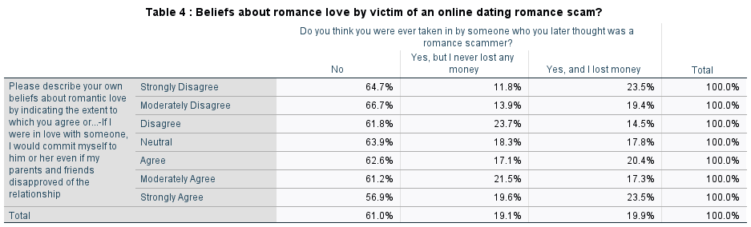
Table 4 shows that 62.5% of respondents answered "No" to being victims of online dating romance scams, while 37.5% answered "Yes" (including those who lost money and those who didn’t). Among respondents who strongly disagree with romantic beliefs, 23.5% reported losing money, compared to 11.9% who were victims but didn’t lose money. Similarly, 23.5% of those who strongly agree with romantic beliefs reported financial loss, compared to 19.6% who didn’t lose money.
These findings suggest a link between strong romantic beliefs and vulnerability to scams. Festinger’s cognitive dissonance theory (1957) explains how victims rationalize their actions, prioritizing romantic ideals over rational judgment, even against external disapproval or warning signs.

Qualitative data analysis
When analysing the qualitative data (provided to me by the module tutor) using thematic analysis, I identified two common themes:
- Relapse as a tool for self-reflection
- Trauma triggers relapse

Theme one – Relapse as a tool for self-reflection

When asked about their experiences with relapse, all participants viewed it as a learning opportunity that forced them to confront emotional struggles and behavioural patterns.

For Trish, relapse exposed emotional immaturity and overconfidence in managing triggers. She used journaling and gratitude practices to reflect on her thoughts, leading to personal growth and improved relationships. Her approach aligns with Cognitive Behavioural Therapy strategies, which promote replacing negative behaviours with constructive ones (National Institute on Drug Abuse, 2011).

Rick identified isolation and complacency as key factors in his relapses. He used these moments to reassess his environment, recognizing the value of external support systems and structured routines in addressing vulnerabilities.

Toby viewed relapse with fear and newfound awareness, realizing his substance use was a way to avoid problems. He turned to singing lessons, reflecting Skinner’s (1953) operant conditioning framework, which emphasizes replacing harmful behaviours with positive activities like arts or social engagement.

Tristan rejected the notion that relapse is an inherent part of recovery, arguing it undermines autonomy and provides an excuse for failure. While acknowledging his own journey, he emphasized that relapse is not universal and should not be seen as inevitable.

References:
Cross, C., Dragiewicz, M. and Richards, K. (2018). Understanding Romance Fraud: Insights From Domestic Violence Research. The British Journal of Criminology, 58(6), pp.1303–1322. doi:https://doi.org/10.1093/bjc/azy005. [Accessed 11 Dec 2024]
Festinger, L. (1962) A theory of cognitive dissonance. London: Tavistock Publications.
Ide, Y. and Beddoe, L. (2023). Challenging perspectives: Reflexivity as a critical approach to qualitative social work research. Qualitative Social Work, 23(4), p.147332502311735. doi:https://doi.org/10.1177/14733250231173522. [Accessed: 23 December 2024]
Murray, C. (2023). Gen Z And Millennials More Likely To Fall For Fake News Than Older People, Test Finds. [online] Forbes. Available at: https://www.forbes.com/sites/conormurray/2023/06/28/gen-z-and-millennials-more-likely-to-fall-for-fake-news-than-older-people-test-finds/. [Accessed 12 Nov 2023]
National Institute on Drug Abuse (2011). Treatment and Recovery. [online] National Institute on Drug Abuse. Available at: https://nida.nih.gov/publications/drugs-brains-behavior-science-addiction/treatment-recovery. [Accessed: 10 December 2024]
Rogers, R.W. (1975). A protection motivation theory of fear appeals and attitude change. The Journal of Psychology, [online] 91(1), pp.93–114. doi:https://doi.org/10.1080/00223980.1975.9915803.
Skinner, B.F. (1953). Science and human behaviour. [online] Bfskinner.org. Available at: https://www.bfskinner.org/newtestsite/wp-content/uploads/2014/02/ScienceHumanBehavior.pdf. [Accessed: 23 December 2024]

Appendix

Appendix 1: Interview Transcript
U: All right, thank you for coming to this interview.

U: Before, we get started, I just want to get to know yourself, so tell me about yourself?

J: My name is Joanna. I’m a student studying Sociology with Criminology. My favourite colour is pink, and my favourite character is My Melody
U: How was your day today?

J: Um, it’s been good. How about you?
U: How do you usually access news and information?

J: I use social media like BBC News and Instagram

U: You kind of went into my second question.

U: But anyway, why?

J: It’s because it’s more accessible for me to get faster news

U: Is it accessible… is it accessible in a way that you can just it out of your pocket and just read through it or accessible in the way of its writing, like understandable for someone else to read?

J: I think both because I can literally just go on the BBC News app and it tells me the latest news of the week and Instagram because it comes on your page so I can just pull it out and because its easier to read so BBC News finds ways to make it simpler for all readers and Instagram kind of uses languages that is more typically for teenagers

U: Okay, how do you know that BBC News and Instagram is credible about its information?

J: They normally give references of where they got the information from and they normally give live feeds so you can kind of see what they are talking about. For example, if there was a fire at a hospital, they’ll normally be live at the scene seeing how they’re dealing with the situation.

U: What do you do to verify the information presented?

J: I go look for a secondary source of that information and try to see if the primary information that BBC News or Instagram has given me matches my secondary data.

U: Do you like type up the events name on google and click on the first link or do you scroll down and click on other places as well.

J: I tend to scroll down like other news (uhhh) channels or pages to kind of see (uhhh) the differences of what they are writing. Sometimes they can change what the witness is saying, so I kind of see from there and see if it’s credible or not.

U: Okay, Second question. In your opinion, how does the content recommended to you by social media platform influence your views or opinion on current events?

J: Um, I think in a natural way because I tend to take news with a pinch of salt in a way because I know there’s exaggeration in the media so I kind of just see the information given to me and kind of just (pause) not go too dramatic over it because I know a lot of people’s job in the media is to exaggerate a situation to create moral panic.

U: (mmm) because they do it in a way to create like a emotion where people emotionally are essentially charged and I always find it weird as you know it’s very noticeable but based on their language used and that obviously with me it helped me you know (pause) look into it (pause) with like a different with a different eye, I guess because the second they use like a different term of language, my guard is immediately up so then as I’m reading, I’m literally guarding myself from ever deep diving what they actually have to say, so why I get that under the premise of the information, I’m not fully giving like a total opinion on that but yeah.

U: Do you believe the algorithm affected your exposure to diverse viewpoints?

J: I don’t think so, (uhhh)… in a sense of Instagram is more of an urban app, I would say that you have people from different ethnic backgrounds giving their opinion and Instagram is less shielded so anyone can basically say their opinion and when... whereas if you kind of compare it to BBC News, I can say that in that effect, yes because BBC News have control of what is published and not on who can speak whereas Instagram they don’t really have a say//anyone can speak and say their mind so I think it’s not an issue but for BBC News I think It is.

U: That’s a very interesting take I’ve never heard anyone say exactly.

U: Um, have you ever gone out of your way to sought out any other viewpoints to get a good understanding of content being presented?

J: umm (long pause) I think so, in the sense of what’s been going on with nurses and their pay

So, because I have studied health and social care and have a lot of family who are in the health care sector, that I think is more of a focus of how nurses are getting paid and the pay they are getting is more going straight to taxes and how the government is dealing with that. Umm and so I think, yeh, in that aspect. Other than that, I don’t really think so.

U: Have you ever encountered misinformation or false news on social media? if so, how did you handle it?

J: um I think when we look at the covid times and how things were delt with so a lot of the time with social media, people were going and spreading information about how shops are going to stop selling certain things, so we had a lot of people rioting to go to shops and stocked up on toilet paper, people buying like 10 packs 20 packs and funny enough social media was crying about people not buying seasoning so I think in that aspect, I think I kind of take it with a pinch of salt and I kind of just look at it and just be like okay because then again we have a moral panic and the job of the internet is to create moral panic to create more people giving views and likes

U: Do you think there should be regulation in terms of how information is being easily ascertained [essentially transmitted] on social media? If so, what should it look like?

J: I think no, in a sense because we already have the and the government already do that and you can see the negative effect it has on because we have news of where, for example we can talk about the war that’s happening in Palestine and Israel, we have the government which shielded certain things, certain people searching up certain things and saying certain things which create more tension between the two states, whereas if you just let people have free control, I think it’s more easier to defuse the situation because they know that nothing is being hindered.

U: In terms of like, let’s say Instagram do you think there should be regulation?

J: I think it depends on the situation because somethings can cause external harm whereas there’s somethings that will just die down on its own, So I think if it’s political, no because it’s apolitical opinion and it’s one of our British rights to have an opinion, so I think that’s fine.
Whereas if it’s something that is to do with their personal life, then yes because that could hinder somebody’s life and no matter what they would still see that on social media.

U: Okay. Have you ever changed your perception of a piece of news or information after learning about the algorithm that promoted it? And if you can, can you share an example?

J: I think with the government or the political parties that's been going on, I think I was more full labour in a sense of thinking that labour is for the people at a more friendlier towards people who come from a less privileged background, whereas now that I see it, they are just the same as conservative. I kind of prefer conservative a bit more because they're more open and honest about what they're going to do. And even though it might not be to our like, and at least we know that the government's not hiding certain information towards us as if we look at it now, labour has got criticisms of all the things they said it was going to do, it hasn't happened. Whereas with the conservative party for 14 years, they have kept what they were saying, even though it hasn't been the best, their word hasn't changed.

U: What factors help decide which version of information to trust the most?

J: I think seeing people come up with their own stories and how they've been impacted because that's a primary source that's not hindered with them being maybe paid off or anything. That's just them talking about their life and how it's been affected.

U: it's actually interesting because when certain events happen, you always get out of the woodworks. Many, I guess people who shared experiences with a particular person, and they always thought, okay, this person came out because this person was already getting dragged down, so they want to come in and get a popular just for this. I always thought I wanted to ask you; do you think people do behave like that in terms of people just come out for the sake of just dragging another person down because they're already down?

J: I think yes, but at the same time they wouldn't be able to drag you down if they didn't have certain information. If the information wasn't as big as people say it was, they wouldn't be able to drag you down. For example, if somebody committed a crime and someone said, oh, well he stole my pencil in year three, that's not credible because it's a pencil, whereas it's something bigger that can hold onto their case. I think then it's not really dragging the person down just giving extra information.

U: Do you think people are more likely to believe information shared by their friends and family over other sources on social media?

J: I don't think so anymore because I think with the generation as Gen Z because of more of social media awakening and seeing other people having an opinion of what's going on, I think there's kind of been in a sense of a war between children and parents because parents were more hindered to social media because they didn't have the technology that we have now, whereas children are more awakening to what's going on. For example, you could talk about the US thing that was going on about how there was Joe Biden and Kamala happening. You could see there was more children going towards Kamala because they could see that that was their future, whereas the older generation still had the (significant long pause)…

J: I think you're just being, once you have a view, they normally stay in it because they're more comfortable in that view, for example, they don't really know anything more. So, the Donald Trump view is more easier to accept because that's what's always been around. Even though quote of Make America Great again, there's nothing new that they worries is about. It's kind of comforting. Whereas trust Sam, someone new that Kamala Harris kind taken a gamble since it's easy as to stay in a post comfort comfortable with and taking a gamble and not knowing what's going on. And I think Donald Trump also, for example, he kind of did put a divide as well because he spoke about housing and more parents care about that, whereas children more care about their freedom and having time to express themselves. So, I think that can kind of cause an issue.

U: So with your saying about how more people are leaning towards Kamala, well the statistics that I was looking is that more women, more Gen Z women are now falling towards Trump than they did in 2020 with Biden. So the Gen Zs was one part that made an impact to why he won. So it's interesting that they don't influence their parent. They don't, I guess, share their parents' point of view because it makes it seem that the Gen Z or just the Gen Zs are, I guess typical idea is that we follow essentially, no, we follow the tradition. No, not tradition. We follow a more progressive viewpoint because of social media, but because they didn't make an impact in terms of Trump winning is actually a very interesting idea that whether they follow the family, so for example, ethnic minorities, they have this, they will have perceived value, a perceived idea that the system, that their race will be systematically against them and whatever they do, there's nothing that they can do about it. But people vote when those black voters, particularly like the 26% of them vote for Trump. They weren't thinking about the race. They were thinking about how they could afford something, who's talking to them the most. And yeah, it's really eye opening to see that.

J: I think it's more of a sense of identity because if you look at the stats, you can see there was more people of colour that voted for Trump and a sense of a lot of the people who were voted for him were people who immigrated to America or had parents that did immigrate. So I think them doing that is more of a sense of they believed that they feel like them being given the opportunity to get better housing and stuff like that is more of them having a sense of identity of being able to sustainably live in America. Whereas people who are more, I would say white don't really have that sense of thinking because they never really gone through looking for pressure or sense identity unless we're looking religious wise. You can have white Jewish people. However, I think more white people kind of look for a sense of, I think expressing themselves in different ways because systematically they already have that self of they already have that protection, whereas people who are colour, they don't really have that protection. So, it's better to vote for someone who you already know how they're thinking than to vote for someone, which you don't.

U: What factors do you think influence wherever someone trusts information from their friends and family more than other sources? But sorry, since because you said they don't believe it. Well, yeah, the opposite. Why do they trust social media more than their family and friends?

J: I think because in a way social media is less biassed because for example, if you use TikTok and you search up something easily, you'll see two points of views. Whereas where you come from a household, you strictly on a democratic type of mindset is more harder to actually get another opinion or is hindered at home because you know that if it's voice that causes a lot of tension at home, while social music, nobody cares, everyone says how they're feeling. If you don't like it, you can put not interested. Whereas at home you don't really have that type of time to do so in a sense of social media gives people a sense to understand and get involved or basically just debate with each other until you reach a conclusion.

U: Okay. Can you think back to a time where you doubted information shared by your friends and family on social media and what was their reaction?

J: I think to do with what's happening with Belgium and Congo, I think something around that because my family, we still watch conation. You said what's going on and we standing that Belgium still has certain control and my father has a mindset of Congo will never be free and we just have to accept it. Whereas I think my mother has a view of anything as possible. So I think in that sense where he will find information that basically proves that how Congo will ever be free because of how many countries depend on Congo, whereas he's not actually looking at the fastest happening, the tradings happening. So we have that Congo has now kind of become an East African country of trading to get more money. They're trying to get independence from people stealing their resources. For example, we have country like the US and the UK funding Rwanda to visit there to be able to give them money and to Congo and get all the oil minerals. So by them joining East African S, giving them more perception to get the independence that they want. But I think more of my father, he has more of a, you can't really wish for luck or anything. You just have to do it and do it. And because Congress has been fight for independence since the early nineteens, it's kind of gotten to a point where he kind of just makes up random information, just believes. Yeah, Congress just conquer.

U: In your experience, does the source of information, friends and family versus I guess unknown sources like social media and stuff affect how credible it feels, how critical it is?

J: I don't think so. I think because everyone has a difference of opinion, and I think because of family, we've all lived through different generations. I take everyone's opinion with pinch or salt because you just have to be there in a situation to kind of know. For example, my parents were born in Congo, and they were born when a lot of things were happening when they finally just got independence. So, I think they have a different view of society than I do. So, I think that kind of just makes me think that we'll always have a difference of opinion because their version of life, but my version of life is very different. I come from more an example to them. I come from a more privileged background. Even though in my home country, my mother grew up with a lot of money, my father. So compared to that and coming here to uk, the UK life and the Conga life is very different. So I think in that sense I kind of just taken what people from my family are saying, but kind of ignore it. We just all have our own opinions.

U: In your own words, can you explain what misinformation is?

J: I think misinformation is in a western dynamic. I'll put it as more panic and I know I've spoken about that a lot, but I think in a way of they exaggerate information or they put in random information that know that doesn't really exist on the scene to cause people to talk about it more. I create more fear to try control the public, I would say served A lot of the time in the news we've had politicians lying about stats, actually scare people to try and make a change, whereas that's done more harm than good. For example, you can see that from the reform party of how they carried so many misinformation mixed with actual facts where they could distinguish facts from wrong. So I think things like that can cause issues.

U: How can we distinguish misinformation from opinions or controversial viewpoints?

J: I think by listening to the person, because normally where you can see some of the misinformation is the way they act. For example, if someone knows the information they're talking about isn't backed up enough where you challenge that, they tend to get angry quickly and you can kind of see that from their political part of reform. When they were challenged by the conservative party and labour party, they had a lot of outrage going on. So I think from that, and I think from where they got it from as well, because sometimes people get news from random places of the media, which doesn't really give a primary source say from that you can see, but I'm not too sure. Kind of just depends on the person.

J: When it's okay with an emotional opinion, would you still say, okay, with an emotional opinion? Right, someone can be emotional, but at the same time it's, it's the opposition opinion. And people do have different ways in expressing that because well, it's much more easier. It's much easier to express something because it'll gain more attention. So maybe they might be expressing it in a particular way to get that attention. Compared to saying that in a more modest way. In a sense.

J: My opinion may sound very harsh, but I don't think when it comes to you talking about political matters, you should let your emotion overtake you.

U: I agree with that

J: Think in that sense, when you do become too emotional, too invested into something that is taken over your hormones, it does cause issues because nobody really wants to solicit information you're talking about. Whereas if you have set information, you have primary sources and secondary data that backs up your primary source, you're less able to be emotional because you know that you are comfortable or you're in a position where the information that's coming to you is credible. Whereas if you have limited data that early comes from a secondary source, you're more likely to get frustrated or that emotions overtake you because you don't really know how to deal with the outreach that people are given to you. For example, you can see by politicians where they are debated by the public, they don't really show their emotions even though they might be frustrated, they don't because who really wants to listen to someone who's having attention.

U: Yeah. What are, okay, so with how you said with these, I guess misinformation, what do you think are the potential risks that occur removing it such as censorship or bias?

J: I think once we let someone start removing things, we don't really know what else they're removing. Someone can say we're removing misinformation, but it is misinformation from their opinion. So I think that's the only issue because if we all sit down and reexamine what misinformation is, everybody has a different opinion. So I think that's where the only issue lies, because I could have the opinion that the reform party is probably the best party and you can have the opinion that they are cancer to the ward and you could remove my opinion, think misinformation, but it could actually be factual or somebody else. I think it kind of depends.

U: So would you say that one person may share that it could censor and bias towards one side? I guess in your example of a political party?

J: Yes.

U: Okay. Because, so before Elon Musk bought Twitter, there was actually investigations where they actually found out that there was, I guess there was a form of not censorship, but there was a barrier in terms of people obtaining information from right wing opinions and to the point that they even removed certain people. For example, Alex Jones, they removed Joan Rogan, they were also removed. So these social medias was essentially acting as a mafia to removed these people. And like you said, it's not a good thing because again, there's a form of bias in that.

U: Could public educational fact checking initiatives be abetter alternative to outright removal?
J: Could you repeat that again please?

U: Okay, sorry. Could public education or fact checking initiatives be a better alternative to outright removal?

J: An education system?

U: no no like, educating someone, about educating, fact checking sources to be a better alternative than removing the misinformation itself?

J: I think yes, because if you educate someone by doing that, it kind of shows them how to do it by themselves. Whereas somebody, if you just remove and get, somebody won't really be able to know how to distinguish between facts and misinformation. Whereas if you gather up all the misinformation and you display it and you teach somebody how it is misinformation through actual facts, it helps them independently to be able to distinguish between the difference if they are facing a situation like that.

U: What about fact-checking sources, not sources, but fact-checking features. So for example, Twitter does have a community notes where people essentially correct the original posts or what they're talking about. So do you think that all platforms should have this in place?

J: I think so too, but then again, that could cause misinformation as well because someone could be right to correct that that is this information, but the fact they're bringing to back that up is misinformation as well. So I think having the place actually gives the primary secondary source of the information, then letting people give their opinions is beneficial because they can actually see where the true evidence is coming from and you're still letting people have an opinion as well.

U: Okay. Thank you for the interview. And do you have any questions?

J: No

Appendix 2: SPSS output tables

Gender frequency table (Univariate)
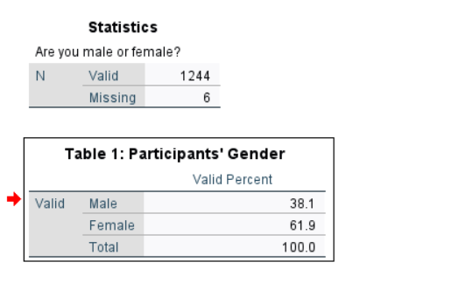

Gender + being a victim of an online dating romance scam
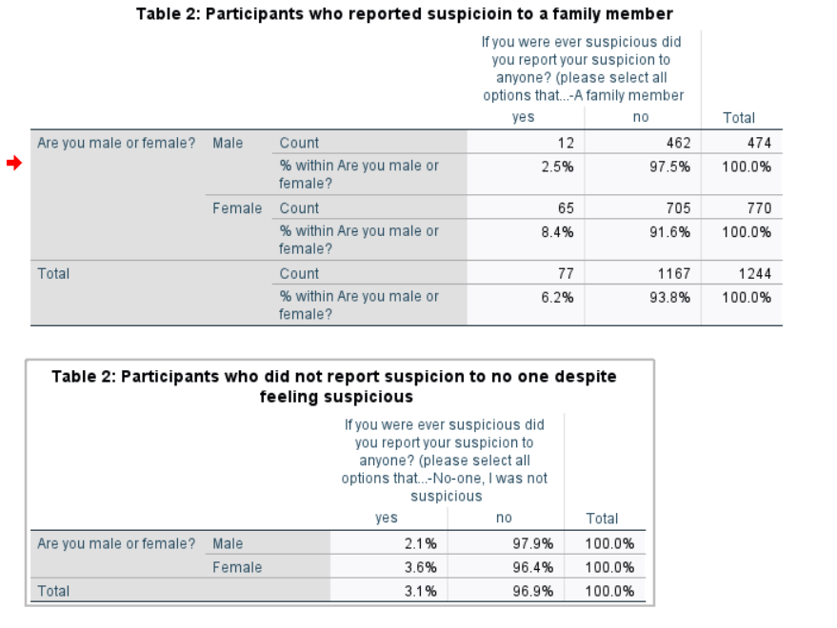
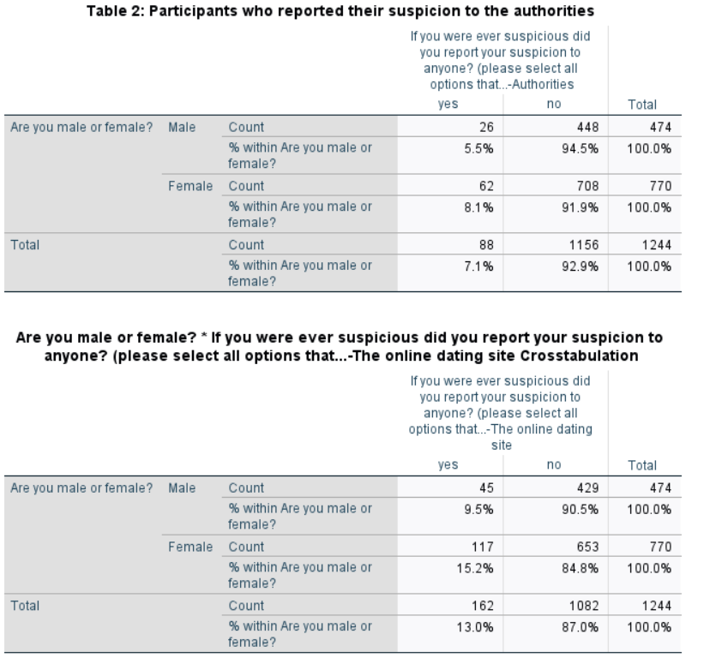
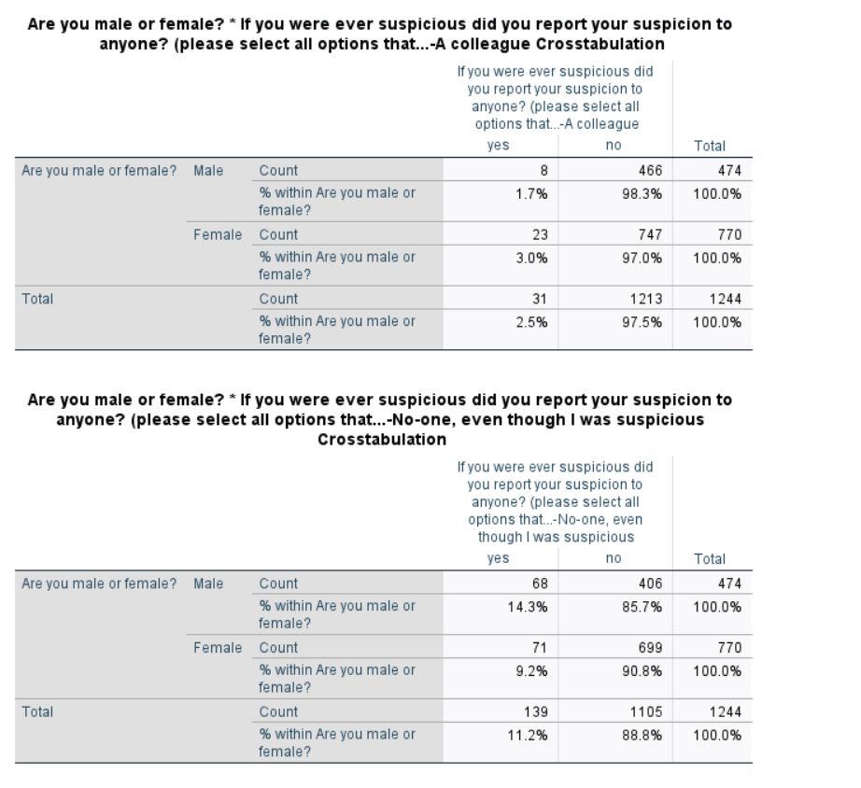

Beliefs about romance love (Univariate)
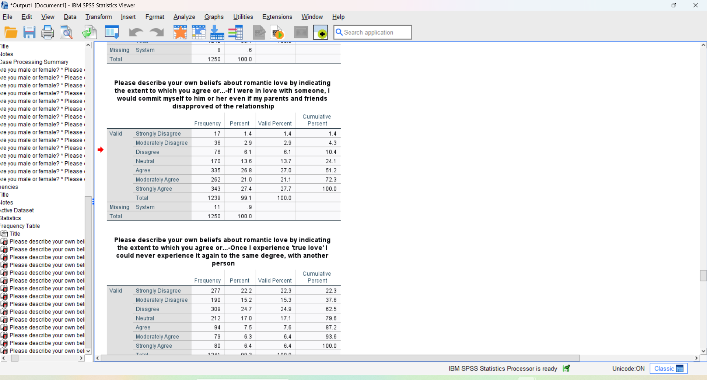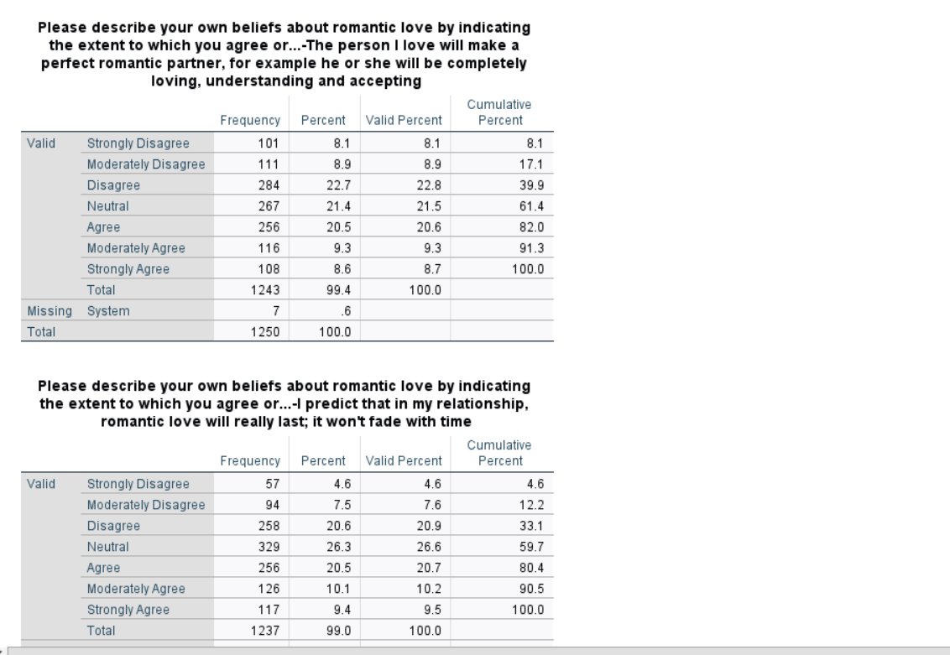
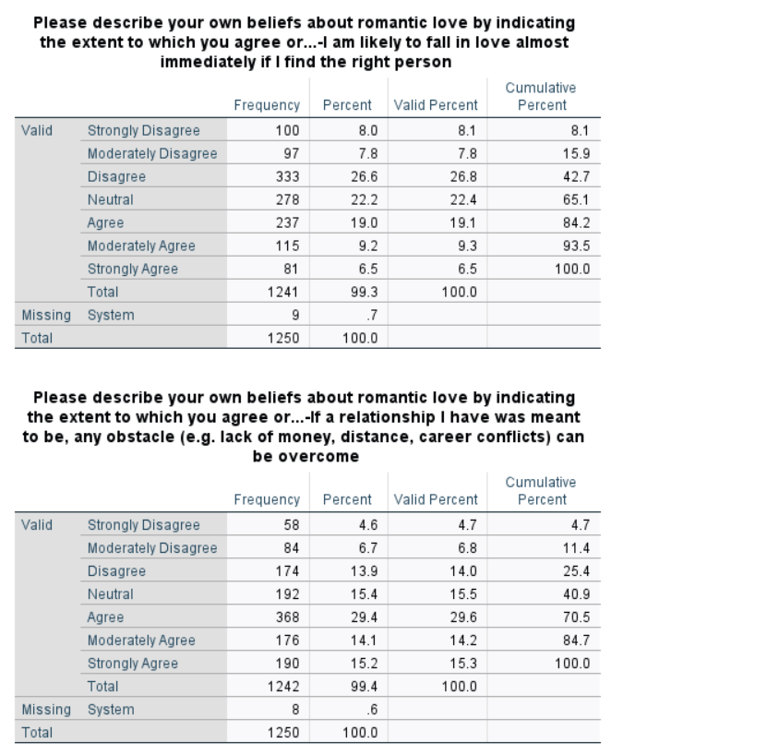

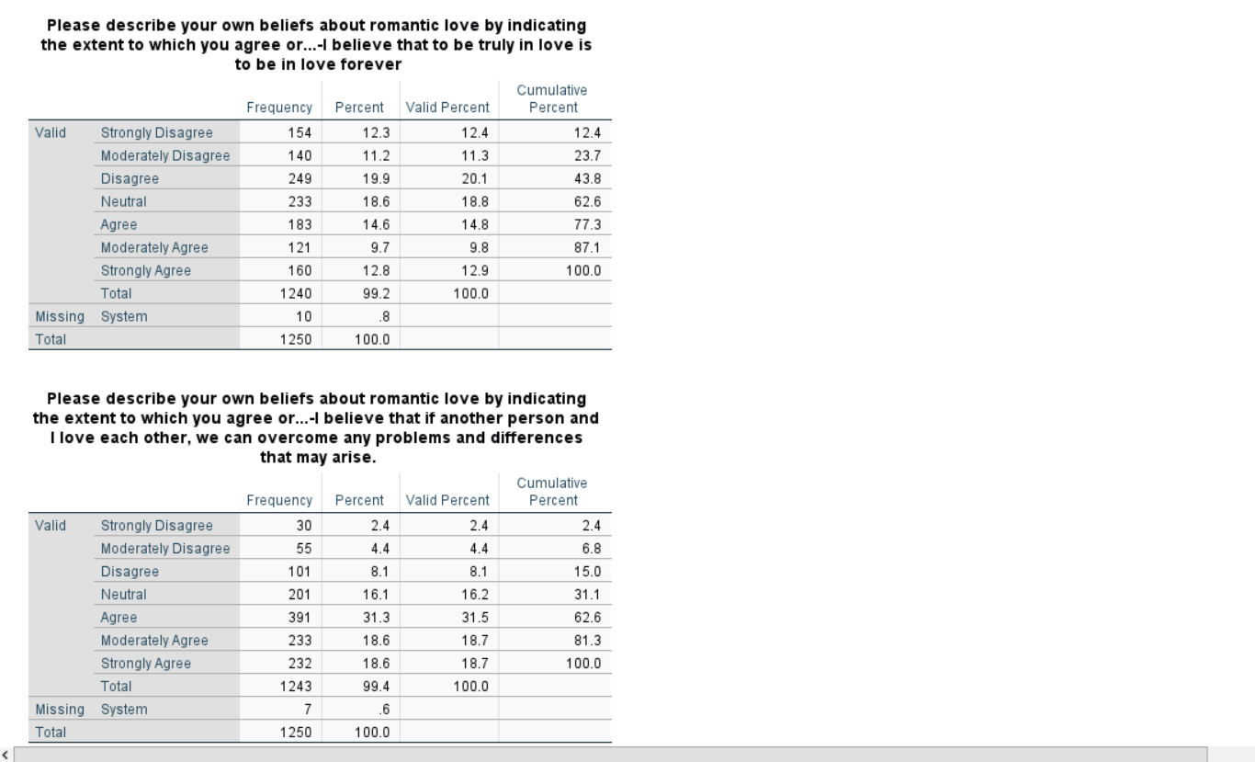

Beliefs about romantic scam + Being a victim of an online romance scam:

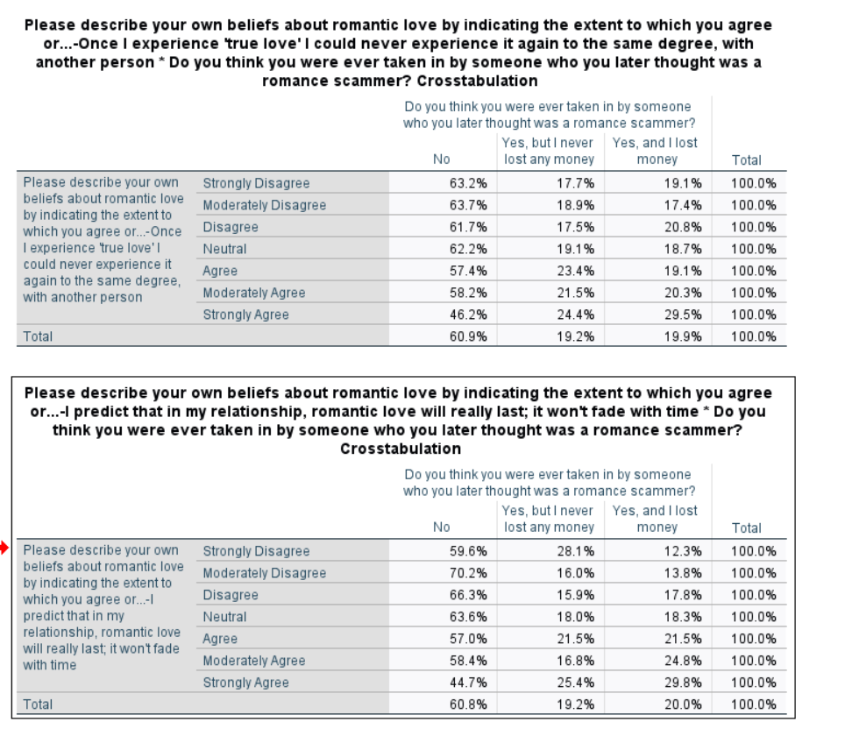

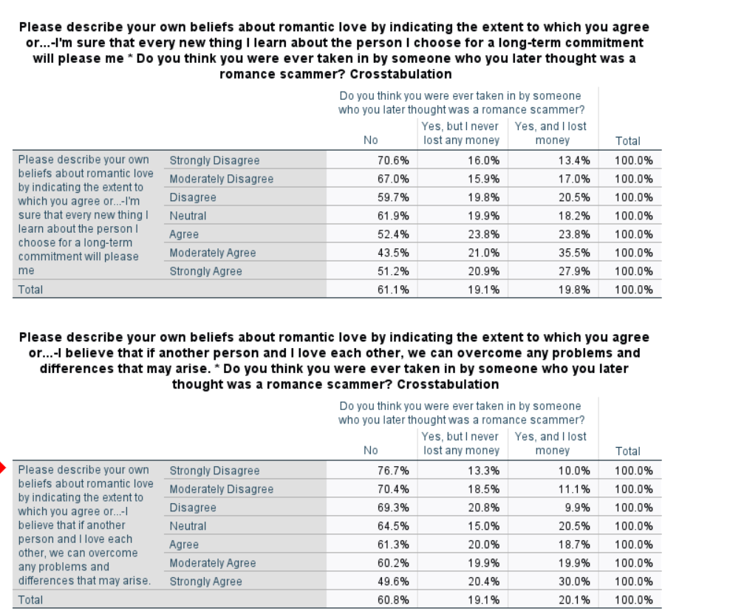
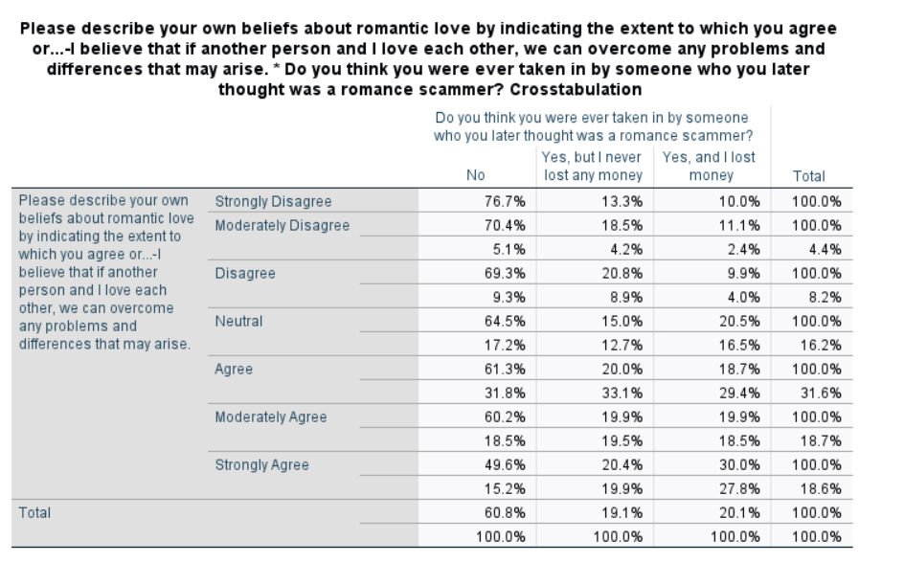
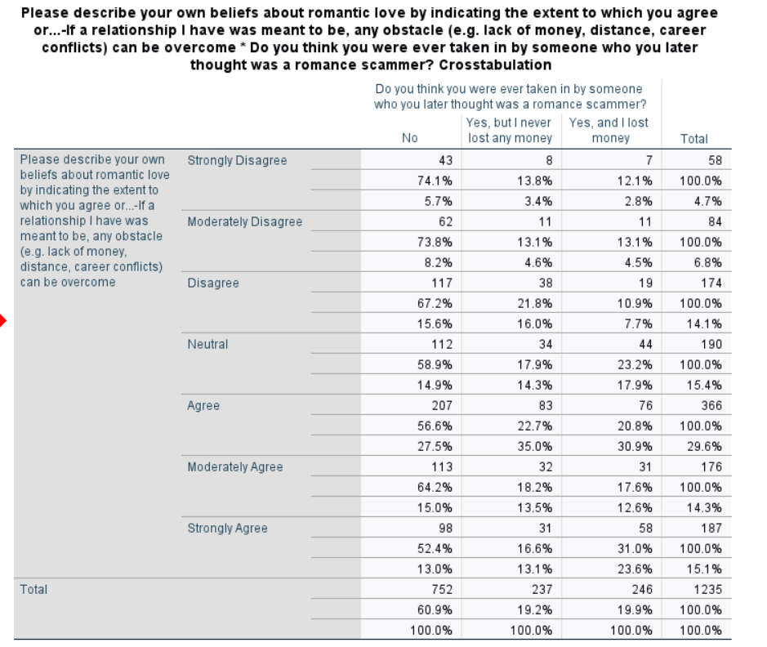

Appendix 3: 4 coded transcripts

Trish
Interviewer: OK, well I'm actually really excited to see your personal items. So would you be OK with starting with that.
With my poem. Yes sure [connection buffered] that is called Out of the shadows, want me to read it?

Interviewer: Yes, that would be lovely.
OK [reads poem]

Interviewer: Oh wow. Thank you so much. That's beautiful.
I've got loads of poems about addiction that I've written before. I don't know if you want to hear any more?

Interviewer: I would be super interested in how how this kind of connects with your experience of relapse. So it's super deep. I feel like it's super personal to you. And I wonder maybe you could tell me a little bit about how did this poem come about? Like how did you when did you start writing it?
I wrote that poem on the 13th of the fifth this year. And I write poetry a lot and especially in rehabilitation. Ehm we used to have to fill in daily diary sheets. Well, I struggled with those, so my head counsellor allowed me to write a poem every day. And I don't know, I just used to go to my room and it just flow. You know, I wrote Out of the Shadows in a couple of minutes.

Interviewer: Oh, that's so amazing. It's almost like it's it's already there and it's just waiting for you to be put on paper.
Yeah. And it helped me a lot because with using for so long, you know, I picked up when I was twelve and I didn't put down until ten months ago ehm you know, in and out, in and out relapsing, getting clean, relapsing, getting clean. I am very emotionally immature. So my poetry helped me to grow emotionally, you know.

Interviewer: Yes. To express yourself. Would you say to like express your emotions? That's amazing. So tell me about in particular when you relapse - would you say that kind of the poem is a product of everything that you go through in relapse?
Definitely. I mean, it's like addiction is the only disease that tells you you don't have that disease. So it's very hard..for me [emphasis] it's not getting clean, it's staying [emphasis] clean. You know, there's a big difference. Ehm, I've managed to get sort of like two weeks here, three weeks there but long term I've always relapsed because my head will tell me that I can just have the one crack pipe. I can just have the one injection of heroin. But past experience has proved to me that there's no such thing as just the one...you know once I pick up, I'm off and running again. All bets are off.

Interviewer: Yes. Yes. So, yeah, it sounds like you've had quite the journey. Quite the experience.
Yeah. Well I mean I've done everything... I've done geographicals: I mean I came out of one treatment centre early and ended up going to live in Israel. Ehm I was in Israel, in (city) for twelve months. The second night we were there, me and this other girl that I left rehab with we were walking down the promenade and there was a lad sitting and he looked up and it was my friend from CE and he was using over there so straight away I got back onto the heroin over there. And yeah, it took me twelve months to save up enough money to get a ticket home. Because all my money was just going on gear and heroin and crack.

Interviewer: OK. Wow. So is that sounds like it's almost like you kind of took you right back like you were you were ready to be, you know, you just got off treatment and rehab and then you were ready for something new and fresh and you went to Tel Aviv, which is a long way off. And then and it's almost like like it found you back or something like that.
Yeah like I have to be really careful because my head will tell me that I'm looking through rose-tinted glasses and how wonderful it would be to have that first pipe again after being clean for so long. Or the first injection again after being clean for so long, you know, it sort of like put it through rose tinted glasses. And instead of seeing how it would really take me, which is back to absolute desperation and no family, no friends, no money, no nothing. And, you know, sat in the bedroom on my own with the sharp needle in my groin, you know, that's the reality of it. But my head also like focuses on, 'oh, you've been clean for so long now, [name], it'd be like having the first pipe all over again, you know? And it's ehm, that's not...I have to really question myself and fast forward situations, you know.

Interviewer: Yes. Yeah. So it's an internal battle.
It is, very much so. I don't know if you're interested, but I wrote a letter to say about goodbye to addiction. Do you want to hear it?

Interviewer: Yeah, I'd love to.
[reads her poem] 'Goodbye to Addiction. As I write this letter, I'm slowly managing to suffocate you. You've crushed me for nearly 30 years, although in the early days you convinced me you were my friend, in some instances my lover. In the beginning we had some good times. You made me feel confident. You supported me when I was feeling lonely. You gave the courage that I lacked, especially when I was in groups of people. You promised me the world and helped me out of having to live with reality. Together we really are double trouble, a dangerous combination. At first you enabled me to be a part of but by the end you have me ostracized from all my friends and loved ones. You had put me in an emotional prison. You went from providing me with everything, taking away all that I have spiritually, mentally and emotionally. The morals and values such as empathy, honesty and consideration you stole from me. You turned me into a monster. Your self-centeredness and hedonistic approach to life destroyed everything in its path. You crept into my life from all angles and tried to destroy me. For many years you consumed all my thoughts in the form of anorexia and self-harm. You were never satisfied, always wanting more. No matter how much money I had or how many drugs I fed you, it was never enough. These days I'm so aware of how committed you are. Perhaps a hard pill to swallow is that you are me and you will always be a part of me. But nowadays I'm in control. It's up to me how much headspace I give you. In the past you've enabled me to justify things that were so wrong. Sticking needles in myself, stealing of loved ones and taking advantage of the vulnerable. I never realised you were out to kill me and so our love affair continued. But now I see you for what you are and I'm building a defence against you. You are part of me but you no longer define me. I'm gaining knowledge and therefore power to defeat you. Treatment is really tough and has revealed some ugly truths about you. It's almost too painful to put into words. I've gained strength slowly to start challenging the stinking thinking that you put into my head and I now question your motives and have the tools to fast-forward dangerous situations that you would love me to indulge in. You want me to see through rose-tinted glasses, but I see clearly now I know where you would take me back to: A life of misery, not just for me, but for all those who love and care about me. I don't need you anymore because I'm learning to like me and grow in confidence. For so many years. I truly believe I couldn't live without you. I can't live with you either, and I now know otherwise. I have the skill I've learnt in me to put you firmly in your place. I have a future plan with me based firmly in recovery. I have the support of other recovering addicts who will see you in me even when I don't and will support me with keeping you at bay. My future plans do not involve you. You are not invited. [connection buffered] But now I firmly believe that I am a survivor. Just one day at a time, 10 minutes at a time. You can't hurt me. But I have to keep vigilant. I'm starting to enjoy my life surrounded by people who love and cherish me. I see beauty all around me now within my friends and also in nature. The further I get away from you, the clearer my thinking becomes. The more I appreciate everything I have in my life today. Freedom from the obsession to use. Sometimes I still have amusing thoughts. That's all they are, thoughts. Today I have the strength not to act on them. And so this letter to you, the departing addict, is a letter of letting go. You are no longer my identity, just for today. I am clean and sometimes serene. Goodbye addiction.

Interviewer: Wow. I'm interested in, you know, how what does it feel like? What does relapse feel like?
At first, relapse is very exciting for me constantly. And also my relapse is the using part of my relapse is right at the end because it's my my head relapses well before I pick up the drugs.

Interviewer: OK, in what way is it a thought?
Yeah it can be, it can be little things like stopping doing meeting - AA meetings. Stopping connecting with other addicts ehm lack of structure and routine. You know, these things all start to dissipate and at the end it leads to picking up. And it can be very exciting, the thought of relapse. You know, you get the racing heart and anxiety and you know, that first first substance that you put in is quite pleasurable. But very quickly, when you realise what you've done, especially when you got a head that's full of recovery - and how to stay clean, your using is never the same again because you know that there's an answer and you don't have to be doing it.

Interviewer: OK, yeah. So that's interesting to me. So would you say the way you relapse then feels differently after you've been in treatment? So for example, your first two relapses in your life are probably felt differently than now. You're fifteenth, sixteenth relapse because you've got you had already full recovery and you've learnt so much.
Yeah, definitely.

Interviewer: Yeah. So tell me about kind of maybe you know what, what do you how do you feel about having relapsed twenty, twenty times?
It's pretty devastating, you know. And you think why people around me getting it and I'm not...you know why can these other people stay clean and live Life on life's terms, and I just can't seem to stay clean for any substantial amount of time. So then all the the self-loathing and disappointment and regret and sadness, that all comes into it. But with me as well, I've learned some people have a relapse and it may last a week or two weeks. When I relapse, I'm back out there for months. You know, I honestly don't believe that if I relapse again now, I don't think I'd get back. It will kill me.

Interviewer: So when did you when was kind of like your first relapse? And how can you maybe walk me through a little bit of your experiences?
My first relapse was when I was 19. Ehm I've gone to a detox centre and ended up like with this guy as well and we left together and we scored on the way back to his house. But in all honesty, I wasn't doing detox for myself. I was doing it to placate family and stuff. My heart wasn't in it. I knew I knew deep down in my soul that I hadn't had enough. So I went out and did more research and that took me back out for about three years.

Interviewer: Yeah. So when you relapsed, did it take you longer to get back into recovery? Or how did you get introduced to recovery or anything?
Well, the first treatment centre, not detox, the first rehab that I went into was in 1999 and they introduced me to Narcotics Anonymous meetings. We have to do a meeting every night in treatment. And I'll be honest, at first, I thought, 'oh, my God, what are they all talking about?', you know, a bunch of lunatics talking about God, how's that going to get me clean? And instead of looking for the similarities in group, I look for the differences to separate myself from these people. So I could tell myself that I wasn't an addict. And I was very resistant to it, you know, ehm nowadays I fully accept that I'm an addict. And, you know, using substances is just one area of addiction, you know, it runs right through my life on all different levels. You know, I'm a self-harmer. I've been anorexic. I've been obsessed with things very easily and tried to fix constantly trying to fix that internal void with external stuff, which doesn't work. You know, it's an internal job. It's about finding my higher power and filling myself with that.

Interviewer: Mm hmm. So I'm wondering, um has going through so many relapses changed the way that you see yourself when you compare it to back in the first couple of times?
I did see myself as a failure and a disappointment. Ehm I didn't believe that I'd ever get recovery. I didn't think I was worth recovery, to be honest. You know, I resigned myself to the fact that I was gonna be a heroin addict for the rest of my life...But things are very different today, you know, very different. Ten and a half months...I've been clean...yeah, ten and a half months. And I've done nine months altogether in treatment last year. And I believe I can't do enough for my recovery. You know, my using was twenty-four seven. So my recovery needs to be twenty four seven.

Interviewer: That's interesting. I've never heard that before. Yeah. That's a good way of looking at it isn't it.
Oh yeah. When you're in active addiction you don't get a day off. You don't wake up one morning and say, right today, I'm not going to use. So it's like every morning when I get up, you know my recovery has got to come first.

Interviewer: Yes. Yeah. So I'm assuming that now you're kind of looking at yourself more with confidence of of like it's really interesting to me that you said you didn't believe it's possible. And I wonder how you made that shift. Like, was that just another kind of experience?
Well, no. I just think, like, today, I've got so much in my life and I've realised I can either have crack and heroin in my life and nothing else or I can put the crack and heroin down and everything I've ever wanted.

Interviewer: Oh yeah. So you're actually it's an it's a choosing like you are actively every day you're choosing.
Well over the past, in the past when I've been clean I've had many reservations which were taking me back to using ehm and I couldn't see life without drugs being involved. But today, very, very different. You know, I mean, I don't I don't want anymore. I want a life. I want to live and experience everything that it comes with. No, because when you're using or drinking ehm life just passes you by, you don't notice anything. You don't feel anything.

Interviewer: There's this song, I don't know if it's Macklemore, but something like everybody dies, but not everybody lives. Just like you actually choosing life, you choosing to live fully like rather than letting it pass you by.
Relapse actually fills me with fear today. I've got a very healthy respect for the disease of addiction, you know what I mean? And I'm under no illusions where I, I haven't got another recovery in me, you know, I really haven't. I have to do this this time. Ehm one thing I do every day is just live for the day, you know, because if I look in the past, the past is painful. If I look into the future too far, it's frightening. But keeping it in the day and being present in the moment, you know, days turn to weeks - weeks turn to months - months hopefully turn to years. You know, but like my parents will say, 'oh, promise me you're never going to use again'. And I can't make that kind of promise, but I can promise them that for today I'm not gonna use.

Interviewer: Yes. Yes. Yeah, that's right. You're not setting yourself up for failure. And has anybody else, like maybe around you, your family, your friends, have they noticed a change in how they view yourself after your relapses?
Oh, massively. Massively, yeah. My mum and dad can put the head on pillow at night and go to sleep without fear of police ringing them to say I'm dead or something. Ehm people have said that the light is back on in my eyes, you know, and yeah, generally I'm a really, really positive person. You know, obviously I have my dark days, but I live in a recovery home with three other addicts who are absolutely amazing people. We've become really, really close, like a little family, and we support each other. When one of us is having a wobble, we support each other. And that's what it's about, you know, because for me personally, I need to be around people who understand the disease of addiction. I need to connect with people on a daily basis, who understand how my head works.

Interviewer: Yes, that is so that is good. OK, so um can you tell me a little bit about how, how you felt. Maybe you can just think about a few relapse experiences, but how you felt before you relapsed or right after so kind of walk me through what it feels like to go through relapse?
Well, I felt initially I felt really good, and that was the time that was my problem. I kind of got a bit complacent and I thought I didn't need Narcotics Anonymous fellowship meetings anymore. And I stopped ringing my sponsor and for a while I was fine without doing any of that. But slowly but surely, you know, it came back 'oh I just I won't use heroin and crack' but I'll use pregabalin and Xanax and OxyContin and morphine and stuff. You know, I'm not I'm not 'I'm not an addict anymore, you know, I can control it, I'm not using class A's'. And then and then within a few weeks, you know, I was back to square one using class A's, injecting again and, you know, neglecting all my responsibilities, you know, I've got trouble because I didn't pay the council tax doing because I could spend all the money on drugs ehm and end you know, very sick and in a very bad place very quickly.

Interviewer: Yeah. So it sounds like a little bit of a there's a part of you that's a bit overconfident, kind of leading you into it.
That's why I need to check myself all the time, you know, because when you do get overconfident that's and you start thinking, 'I don't need meetings anymore', you know, I know my own head when my head tells me not to do a meeting I know I need to do a meeting [laughs].

Interviewer: Yeah. That's yeah, that's right. That's amazing that you kind of put that into place. You've learnt that about yourself. You're like checking yourself. Yeah. So in terms of when you, you know, if you had to describe what relapse means to you, what would you say.
Wow. Ehm for me, it's giving in. It's giving in. You know, and that's what the addict inside of me wants, it wants me to give in, it wants me to isolate it wants me to be in self-pity mode. Yeah. It wants me to harm myself, you know, it wants me to be isolated from all the people that care for me. Ehm just a crappy existence basically. Because that's what it is, it's an existence, it is not a life, you know, because, like, it doesn't matter how much money I've got or how many drugs I put into my system, it's never enough. Never enough. It's like Groundhog Day.

Interviewer: Yeah, so that is so interesting, so it's it's almost like like I think even you said in your poem is this this kind of dark where it's like a force that kind of really drags you down, like really wants the worst for you, yeah.
Yeah, I don't buy into all that, you know, the dark side. You know, sometimes if I'm if I'm honest, sometimes I miss the chaos and madness of using, you know, the thrill seeking behaviour. I still find it quite exciting but is dangerous. You know.

Interviewer: You kind of are aware of the consequences.
That's why the most important tool in rehabilitation was to fast forward things. So when my head is telling me, 'oh yeah you can, you've been clean, now you've got control, just have the one' I thing 'wow' fast forward it and think where would that one take me? Because it wouldn't just be one, it would be one. And then two, three, four, five, six off and I'm running again, you know. And who knows when I'd get back if I ever made it back.

Interviewer : Yes, that's right. I think that's even my next question. How would you how would you define relapse?
For me, I call it 'hit the fuck it button', you know where I've had enough and I think 'screw this' and, you know, you can seem more appealing than being straight, you know, free to be in recovery. And there's a difference between being in recovery and just being abstinent. Big difference. And you have to make life that's worth living more than the life you had when you were using. Otherwise, you're going to end up using again. Simple as that.

Interviewer: So I wonder, you said there's obviously a lot going on in your head and you said you kind of already relapse previously before it actually happens in your mind.
Yeah. Relapse starts well before you pick your drink or drug up. It's your thought process.

Interviewer: Yes. Right. Exactly. So would you say that you're kind of when your thought process starts like this, it's kind of you do you would you remember all the things that you learnt in recovery about, you know, you know, choosing the life and not being empty and all of these things that you just said?
I think I do remember all that ehm but when I have relapsed in the past, despite knowing all that, I just end up using more because I know the answer is there, you know, and how to get clean and stay clean but...my head just thinks once I've had that first one well fuck it, I've relapsed now might as well carry on.

Interviewer: Yeah. OK, so it is if you, if you start using once it's you would define that as a relapse for you?
Yeah. For me there is no blips or small lapses. Relapse is a relapse you know. And people are lucky to get back from it a lot of people don't you know. It kills a lot of people sadly. But I think today I genuinely do have a healthy respect for relapse. You know, I have a healthy respect for the disease of addiction. And like I said, using is just one of its...[pauses]...One of its characters. Yeah. Ehm, you know, I get obsessed and compulsed around other things, self-harm is the prime example. Ehm self-harming to me is like using you know that obsession comes on you to do it and you can't you can't not think about it, you know, and it all gets out of control.

Interviewer: Yeah, yeah, yes. How did it feel for you to go back into treatment?
I was relieved. This last relapse was like two and a half years. And I was using against my will every day. I did not want to be using, I wasn't enjoying it anymore. I just could not stop, I just couldn't stop. And the drug team were really fantastic because I was actually peer mentoring whilst I was using pretending to be clean and I came clean to my boss and within five days they got me on a methadone script. Within four months they got me to detox and into rehab and I couldn't wait for the day to go into detox. I knew it was going to be tough and I did a four and a half week detox in Liverpool and they wanted me to get off the crack and reduce my heroin intake and go to weekly detox public meetings at the Inspire service in Blackburn and I had had to say to the doctor, look, I cannot reduce my crack use. I can't do it in the community. That's why I'm asking to be taken into rehabilitation. There was just no way I could even reduce my crack using you know, you can't you can't do that. If I could do that, I wouldn't have been trying to go into detox in the first place, you know?

Interviewer: Yeah, right, yeah, so so that's interesting to me, that is it's like almost this instant relief of like it's going to I'm going to feel better soon.
I hit I hit an internal rock bottom and, you know, and the day I went into detox, I have the gift of desperation. You know, I got to the point where I was, you know, it took me to my knees and I had to surrender. I had to accept defeat. You know, I tried using successfully so many times unsuccessfully. And, you know, it completely beat me. And I know that that's going to be the same in the future. If I relapse, I'm never going to win. I can never use successfully. Some people can. I just can't, you know, and I've accepted that today. Don't get me wrong. Sometimes I can play with it in my head and and play with the thoughts in the room with them for a while but more often than not. Like I said, I used the fast-forward method. And, you know, I'm able to sort of like bat them off and almost laugh at them, you know, because that's the addict in me. That's the part in me that's the addict. And that's what I'm up against on a daily basis.

Interviewer: Yes. Yeah. So would you say that kind of the way that you were feeling this relief of going into treatment? Was that always the same or did that change with having had more relapses?
It changed with having had more relapses!

Interviewer: OK, how was it before?
Well, it was just for a bit of a break before, you know, I had no intentions of staying clean. It was just it was just a break. And then, you know, I thought I'd go and get myself sorted and, you know, come out and be able to use, like, other people who use successfully do, you know. I'm fortunate, you know, and I used to be bitter and resentful towards people that could use socially without it affecting their life. Well, that just leads that just leads to, you know, resentment and hostility to people. You know, I've just got to accept that's something I can't do or I'm I'm I'm probably just as crazy, if not crazy clean that I am using.

Interviewer: Yeah. So I'm really interested in how you said using successfully. So what, what gives you the impression people use successfully. What is that.
Well for instance people who, who have, you know, nine to five Monday to Friday jobs, you can come home on a Friday evening and enjoy a glass of wine or a bottle of wine, you know, maybe go to the pub and have a few pints or go to a nightclub and have a couple of ecstasy or sniff a bit of coke at the weekend. But financially, emotionally and socially doesn't doesn't destroy them. You know, they're able to function. They're able to meet the responsibilities. I can't do that because I don't have an off switch.

Interviewer: Right. So, what makes you think that it doesn't affect them? Like I get the point that they can meet their responsibilities and maybe to the outsider seem to be able to do all the things they need to do. But like, how do we how do we how do you know it doesn't affect them?
Well, it may affect them but not to the extent that it, you know, it spiritually bankrupts me. You know, it robs me of everything. You know, I'm not able to function as a daughter, a sister, lover, a friend, you know, all that goes out the window. Because the only person I'm concerned about is me, and where I'm getting my next hit from. And I don't care what I have to do to get it, you know. And, you know, I resort to shoplifting, I resort to selling drugs and my behaviours are all over the place. I can't even look after myself. So, these other people who I would class as successful or social users. You know, it doesn't affect them to that extent.

Interviewer: So what effects would you say did have the number of relapses. So, 20 is quite a lot large number. What effects did that number have on your recovery, like maybe on your motivation for recovery?
I've been in and out of Narcotics Anonymous since 1999. And, you know, and I've attended groups in all sorts of states. Obviously have attended them clean, but I've attended them under the influence as well. And I've lied to my peers about how clean I am. And you know, I've got up for [connection buffered] knowing full well that I've been using ehm but in total denial, you know, and it gets harder each time you relapse. It gets harder to get back into recovery because the shame and the embarrassment and the guilt, you know, they cripple you really you know, I've taken people through the 12 steps whilst I've been using. That's how much in denial I was about my using. You know, like I sais, a peer-mentored for 18 months whilst I was using. And then when I came clean to my boss that I'd been using, I ended up back in the group as a client with the very people that I've been mentoring. And that was really difficult...really difficult. But [emphasis] having said that, ehm I got a lot of respect for my colleagues for being honest in the end and, you know, and and going back to those groups as a client rather than a teacher. You know what I had to show humility. And and I did.

Interviewer: Yeah, that is unbelievable. Yeah. I cannot imagine that that that does show that to show character as well. Like, like you said, humility and in character that you actually you are able to show up and yeah. It's all part of you, you're part of the group.
Yeah. Yeah. You know fortunately for me the rooms of NA, they welcome you back time after time after time. You know, they never shut the door on you or people and never you know, people never judge you or downgrade you for relapse. You know, they are just glad that you keep trying.

Interviewer: OK. Actually, yeah, so did you always kind of think about relapse the same way or the way that you understand relapse? Did it kind of change from having had so many of them? Or did you always say relapse is using again, kind of. That is the the thing from your first time using and then from your last time.
Yeah. Yeah. Ehm. I just think I think it's the more the more knowledge you have about recovery and knowing what you need to do, the harder you relapses get because you know that there's a solution out there. You don't have to be doing it because at the end of the day, you self-harm. You know drinking and using is just another form of self-harm. And each time it gets harder, you know. You can't fool yourself anymore. You can't keep yourself, you know. You know, you know, the answer is, you know how stay in recovery and you end up using even more to block those thoughts and feelings out.

Interviewer: So what would you say, does it feel like to I guess when you were in recovery and you were back after having used for two and a half years, your relapse kind of lasted two and half years, and then you went back to treatment with that group that you even supported, which is amazing in and of itself. And like can you maybe explain just a little bit about how that felt to you to kind of then move forward and then kind of getting back to, OK, I know I know what I need to do.
You know what it is? I was a grateful addict. I was grateful that there was a programme out there for me to use and implement in a life that could keep me clean. And I've seen it working in others in the rooms of Narcotics Anonymous. And I'd seen the light in the eyes of the people that were in the rooms who were clean and sober, you know, and they were all working a programme on a daily basis. So, I knew I had to do and I knew because I used with some of these people and they used to the extent that I used, you know, and they were clean and they've got things together. They got family back in the life. They had jobs or studying, you know, real quality of life, good relationships with family, lovers, friends, all that kind of stuff. And I knew it was mine for the taking if I put the work in like I said to you before about where recovery needs to be 24/7, you know, because it's true, you get out of recovery what you put into recovery, you know, and it is no coincidence that when you work in a programme in your life, life gets easier.

Interviewer: Yeah. So I'm just looking at the sheet. So another question I had was, what would you say you learnt from relapse? Like, would there have been anything that you would have done differently, knowing what you know now kind of looking back at you relapse?
Yeah I wouldn't have relapsed at all [laughs]. If I had know back then what I know now, I could've saved myself many, many years. But I mean, I was thinking about what a waste of life I'd led but, you know, that's made me who I am today. And yeah. And I'm kind of OK. I'm kind of at peace with that, you know.

Interviewer: Yeah. I remember you said something about in your first couple of times that you relapse, that you kind of didn't feel like, just like this inner drive to wanted to change like this. You weren't quite ready or you weren't like deep down you just didn't want to change.
Yeah. The bottom line was I wasn't ready to change. I hadn't fully conceded.

Interviewer: Yeah, yeah, yes. It's almost like it's almost like you kind of need to get to that point and then you're yeah. I guess just kind of looking backwards from it.
You have to hit...rock bottom and when I say rock bottom, I don't mean about like all the extras in life cause jobs part is blah, blah, blah. You know, it's an internal thing. I think when you reach that that pure rock bottom and the like I said, the gift of desperation. I don't know any addicts or alcoholics who stay clean who haven't hit a rock bottom. You know, you have to lose everything to realise just how much you want life.

Interviewer: That makes sense. So I can yeah. Like an internal awakening, like looking at it with different eyes. Fresh eyes like this needs to change.
I was, I was spiritually bankrupt. I had nothing, I had nothing left you know.

Interviewer: So interesting. And so I guess on like a day to day basis. Now I know that you're going to meetings which is amazing. So how would you say how else would you protect yourself from relapse?
Ehm keeping myself out of dangerous situations, not associating with people who are using or drinking. Ehm, keeping it in the day. That's a big one. I'm trying to look after myself, not get too tired or not get hungry. You know, the little things in life. Cuz they say, you know, when you feel restless, irritable or discontent, check yourself. And it's usually because you're tired or you're hungry.

Interviewer: Yes. Yeah, did that kind of change with the number of relapses you've had? Like did you do this differently?
Yeah, I can't be around people that are using because just...Well, it's just the danger zone, you know.

Interviewer: Yeah. Yeah, yes. So did that kind of change they all the things you're doing now to protect yourself from relapse, did that change with the number of relapses you've had?
Yeah it has changed because I thought that I could get clean and carry on doing a living the way I've been living, but without using drugs. And it's just not at all. You know, you need to change your playground. It's changed members. You need to change behaviours. Because if you not doing those things, eventually you're going to pick up, it's as simple as that, you going to pick up.

Interviewer: So, you know, in a way it would be like, you know, almost like when I asked you, you know, what could you have done differently? It's almost like putting all of these things in place that you're doing now.
You can't. You can't because it's like wearing a comfy pair of slippers, you know, for so many years. The people that I associate with who I did class as friends obviously they are not, they were just using associates but at the time they were friends, you know, and I still wanted contact with these people. And an ex-partner of mine as well. And I just had to change everything. I got a new phone, a new number there's nobody having my number anymore. I had to walk away from the home of 16 years. I had to walk away from my partner of three years. You know, I had to change everything because if you go if you've got one foot in the past an one foot in the future, you pissing on the present.

Interviewer: Yeah. It's almost like you had to kind of go through that to like get to that point of...
You can't, it's all in the past. It's like being a dry drunk, you know, you're not in recovery. The only thing you're not doing is drinking or using or everything else remains the same. And eventually that will lead you back to drinking or using. It will.

Interviewer: So, um, is there in terms of your experiences with relapse and all of this, is there anything else that you would like to say or anything you think is important for us to know?
And just like I said, not to let complacency slip in, because that would take you back as well. But like I said, the fear that I have around relapse. You know, I had a friend wobble a few days ago and the thought of fucking that person relapsing you know, it was horrendous, you know, because I don't want it for myself, but I don't want it for anyone I care about either, you know?

Interviewer: Yeah, yeah, yeah. How are you managing that thought of like there's a healthy fear or respect. And you also do know in your head what you need to do for yourself to protect yourself. So how do you like... What does that make you feel?
Ehm like I said, if you work in a programme and you put your recovery first, they say a grateful addict never relapses. And I'm grateful for so much today. You know, every morning I wake up in a nice, warm, comfy bed with a roof over my head, bit money in my pocket, food in the cupboard, surrounded by people that love me. You want nothing from me. Those kinds of things are priceless. I mean, it's nice to have the shiny things. Don't get me wrong of them, I'm bad at fixing my internal with external stuff to fill the internal void but I'm getting better, you know. And trainers aren't going to kill me, crack and heroin will.

Interviewer: Thank you so much for sharing all of this with me.

Rick
Interviewer: Ok, maybe we can start with your personal item and just see where we go with that?
Yes, this is a hoodie that I used to wear when I was homeless and begging. I've no idea where I got it from...none! I cannot remember where I got this hoodie from in any way, shape or form or even why I kept it. But I like it [laughs]. But yeah, I mean I was surprised to find...I was washing it not so long ago and surprised to find that on the inside of this bit that's on the arm [shows arm of hoodie] there's still blood stains on it and everything ehm...from when I used to inject...little bits in here. Ehm which I was surprised by you know...Yeah, it's like I say, I don't I don't know where I got this from, I've still got the trainers I had when I was homeless as well, because they were brand new when I got them. So ehm I'm not into wasting...I grew up in a family, in a house with my gran who grew up...during the Second World War when everything was rationed. So, throwing things away, that don't need throwing away is not the done thing in my family [laughs].

Interviewer: Yeah, yeah.
I've still got...because they were you know, they're still completely wearable, you know, they were literally brand new when I got them, and they were being thrown away. So, I've still got stuff that I still wear occasionally. So I had...when I was homeless, I don't know how I acquired it in any way, shape or form, but it, it does remind me of where I end up or where I ended up after the last one because... I mean the whole relapse thing for me ehm...I, I didn't relapse often because I was using all the time pretty much. But there were little...I had short spells a long time ago ehm...where I couldn't stay off, you know, after a few weeks ended up back on the drugs. But the last, the last time that it happened, it was quite spectacular. And that's when I ended up being homeless, so. Yeah. I mean, everything went properly, pear shaped very quickly. So, I kind of keep that top to remind me of where I'll end up...if that happens again.

Interviewer: Yeah. So, you still wear it?
Yeah, occasionally. Kind of like ehm...I'm going to say a gym top type thing. And you know, at the moment I work in construction so it's even when clothes on, sort of clothes you wear out and about often you know, they can still go through this progression of being workload. So, it's got that sort of potential. It's a nice top, there's absolutely nothing wrong with it.

Interviewer: Yeah. So it's almost like it holds a special kind of memory of you know, this is where you ended up and you made it through, obviously, so yeah...when you wear it and you kind of think about where you were and where you are now, does that ever kind of hinder you from moving on? I'm guessing there's a sense of attachment to the item. You don't know where you got it from, but it holds a special memory?!
Yeah, well, I mean, I'm quite...I don't know if sentimental is quite the right word...but I suppose it probably is..ehm so you know...so for instance I' ve got a shirt that I had from before I was homeless, that's been all around the world with me and it doesn't quite fit anymore. And I don't, I don't want to get rid of it [laughs]. But the good thing is it doesn't fit. It's a bit too big. So, there's always the possibility. So yeah, I do get attached to items and I think sometimes the craziness of ...so well the way my head works anyway...is that sometimes when I'm finding things a bit difficult and you start...your brain starts remembering all the good stuff...because I'm not going to lie, there were a lot of times when I was homeless where it was fun attached to it, you know, so I was homeless in CE, which is obviously quite a big university town. And, you know, being in CE on a Friday and Saturday Night, as a homeless person...could actually be quite amusing sometimes...like all of that carnage that people see on a Friday night out when they're out with their Uni mates...and, you know, I lived in that for four years [laughs]. So, some of the stuff that we saw was quite funny. I got to meet some nice people, you know, and even though it's very easy for my head to forget all of the other stuff that was going on and how difficult it was. So, you know, it's it's handy to have a reminder of a share of the evil. And you know, you can sort of wear that and remember not washing it for six months and you know, where you were at when you were wearing it, the things you were doing, do you know what I mean, and how tough that was.

Interviewer: Yeah, right. So, I'm getting I'm getting this kind of word. I don't know if this fits with you, but like honour, does that kind of fit with you?
I mean, you know, not everyone not everyone makes it through that experience. You know, I've lost...when I was homeless those four years, I think in the last couple of years, so since I came to treatment facility and have since left, there's probably like twenty five people I know that have died in either through something like suicide or overdose or, you know, other complications, you know, liver failure stuff like that...yeah. So unfortunately, no one makes it through that. And, see to me it's just normal like because that's kind of what I did. You know, it was kind of like sort of normal to them, isn't it? But when I tell some people about, you know, I was homeless for four years, it's the reaction I get reminds me just how abnormal that is. I mean, and I don't know if I'd say there's a feeling of honour about making it through. It's an interesting way of putting it. I haven't really thought of it like that.

Interviewer: No I mean, it might not it just it kind of just came to my mind when you said, you know, you you're wearing your or you are remembering about your sweatshirt and how, you know, all of the stuff that you've been through.
I suppose it's honourable if you use that experience for something good. I'm not one of these people that wants to, you know, some people and I totally respect that, some people I know that they want to put it all completely behind them and move forward. And I understand that and I respect it, you know, but for me I think the, because I've spent all of my adult life as an addict, one thing or another, if I don't try and use some of that experience, which is vast, for something good, then it's a complete waste of time. And I don't like the idea of wasting half of my life so far.

Interviewer: Yeah, yeah, yeah. No, I totally get that. Yeah. So maybe share a little bit about your history of your drug use and your relapse and maybe how many times you experienced relapse?
So, I mean I started I mean, how far do you want me to go back? Because it's a long way [laughs].

Interviewer: Yeah. I mean, whatever you want - this is your story. So, whatever you feel like is needed for me to know.
All right. Well well, I mean, I'll go as far as the substance misuse that started when I was 12, so. I was quite I've always been able to associate easier with people who are, certainly as a teenager, with people that are a bit older because...in my family, there's no one that's even remotely close to my age - everyone's either at least ten years older than me or at least ten years younger than me. So, I mean, no one even no cousins, no nothing are even remotely close to my age. So, you know, going to family events and whatever there is, it wouldn't be unusual for me to be the only child there. So, when I hit secondary school and I had the opportunity to hang around with the older kids. Not only did I feel like I fit in a bit more with them because I was really tall as a 12-year-old, I was like five foot eight. And, you know, they, you know, they were all smoking...things like hash and taking speed and drinking and all that stuff that you think it's really cool when you're a teenager. But I never really felt like I fit in with those guys because I was a lot younger than them and I used to get sort of picked on because I was the youngest, you know, but I was willingly putting myself in that position, because that was sort of what I thought I wanted to where I wanted to be. And yeah, you know, my idea of fun was going down to the local park and just getting completely smashed.

But I had...my mom was an alcoholic, so she she was at home and she wouldn't drink during the day so much that I'm aware of. She wouldn't drink excessively during the day, but in the evening, she'd be an absolute nightmare. So, I'd much rather be out of the house with my mates getting high all the time than I would being at home. So, you know, I started off just doing what teenagers do, I suppose, getting high in the park and whatever. I think by the time I was 15, I'd sort of found class A drugs, things like speed and ecstasy and things like that. By the time I was 17, I don't think I don't think there were as many class A drugs that I hadn't taken at that point, started going to raves and all the rest of it. And by the time I was 18, I think I'd sort of been introduced to heroin. And obviously that's when things went went downhill properly because I'm already long before that I ever came across that substance, I was already using it effectively because I would use as much as, you know, as often as possible, because that's that was what I enjoyed doing. I enjoyed getting as off my face as I possibly could as often as I could. But, you know, back in those early years, it it was fun. You know, a lot of people say was it was quite enjoyable. I used to do a lot of raves, things like that. But even that was a complete mess. The way I used to fund all of this was by selling it, you know, so I could...because I had all of the older friends I very quickly caught on to being the one that could get hold of stuff for the people that were my age.

Interviewer: OK, yeah.
And you know, and so it started off being quite a small, you know, just literally getting some money off of people, getting their stuff, being able to get it cheaper. So, I bought my stuff for free. And it just might be a bit of hash or, you know, weed or speed maybe, you know, but of course that just continues and by the time I was 16, I was involved in all sorts of things that I shouldn't have been involved in at that age. Some quite serious stuff as well, to be fair, because things were looked at a little bit harsher back then. So it was, I was involved in a world that I kind of thought I wanted to be involved with. Exposed to a lot of more adult stuff than someone in that age wouldn't necessarily have been involved. You know, I used to...even at that age, I used to use with people that were in the mid-20s, you know like the older I got, the more, the easier it became to hang out with older people. And of course, they were all been exposed to a lot of other different bits and pieces. And you see that, and you think 'aha ok cool well that doesn't look as bad as everyone made it out to be, so I'll give that a go.' And that's what led me to taking heroin for the first time was a couple of my mates that I lived in a hostel with, that were good friends ehm they weren't addicted at the time. I think they both still are now. But, you know, they had a beer and it didn't look as bad as people have made out. But yeah, but in the end, I ended up being addicted because I was sort of reintroduced to it a year or so later. So eventually I ended up doing exactly what I knew how to do, which was to sell that to get mine for free. So, I worked for this guy and I think by the time I got to that point, so I got put in prison when I was 21. By the time I got to that point, I'd had a couple of attempts of getting off the stuff. But I didn't really understand what recovery was in any way, shape or form. I just thought it was as simple as being abstinent from whatever your substance of choice was.

But I went through the whole process of rewarding myself for staying off of it by taking some [laughs]. You know, I'm going to say, you know, I wasn't really putting any effort into it. I wasn't doing what I do now. I wasn't trying to understand with recovery I wasn't trying to get into rehab or trying to go to any of the not the anonymous fellowships where I just thought you just had to stay off of it and that was enough, you know. So, I'd be on some form of substitute like methadone or Subutex or something and then. Yeah, I, I'd only last a few weeks. Let's be fair. Well on one occasion something pretty horrific happened to me. So, whilst I was attempting to get clean, I, you know, I was that bloke in my twenties, I wasn't going to listen to anyone else because I thought I knew best. But yeah, it's yeah. I had no idea what recovery was. I wasn't really trying to recover. I wasn't interested in being completely clean and sober. But I just didn't want to be a heroin addict any more, but would reward myself for that by taking heroin, you know, so I ever only lasted a few weeks, like I said. Then I went into prison and then, I mean, I couldn't even stay clean in there, you know, like, this is surprisingly easy to get a hold of drugs in prison. Yes. I had I've had a lot of support financially over the years for addiction from my family. So, I was able to bring up my mom or my gran, getting them to send some money somewhere externally outside of the prison so that I could get some whilst I was in there. It was very easy for me to get hold of drugs. So, I think the whole the whole year that I was in prison, I kind of I probably had a sum total of about two or three months where I was actually clean in there. But it's you know, it’s unfortunately drugs are very, very good way of making that time pass quicker. So, you know, and everyone else around you is using and very few people that are in there really are very interested in getting clean. So, I never lasted long. I mean, I walked out of there having not used for about six weeks I think...and then relapsed immediately as soon as I got out because I was still associating with the same people.

I was on tag so for four and a half months with a thing around my ankle I had to be in at like quarter to seven. And all my mates that had come out were all using so I sort of, you know, relapsed like immediately. So, I mean, so I have been through the cycle of doing I mean, not that, but when I came out of jail, that was probably until...so I came out jail when I was 22, I think I was using pretty much every day, you know, probably every day. So up until I was in my early 30s. Yeah, it was 18 years I spent as an addict in total. Like I say, were very, very sporadic times of being clean and sober. I mean, to be fair, the two years I've been clean recently, it's probably the longest I've been without any form of substance whatsoever. So, if you include alcohol since I was a child, because it was acceptable in my family for a kid to have a beer at Christmas or to someone, someone to give you a little bit of their drink. So, I actually can't tell you how how young I was when that sort of stuff was going on. So, the last two years has been the longest. It's been the longest I've been without any form of substance since I was a very small child.

Interviewer: Wow. That's incredible. Yeah how would you define a relapse? How do you understand what, what a relapse is?
Well I think what it takes most people back to the I mean a lot of people go through the whole cross-addiction they don't necessarily count those as relapses, especially if you don't understand what addiction really is. So, and I did that, I, I've got a three and a half years where I was on methadone, but I also used sporadically as a treat. But I was drinking every day, you know, so I did the whole cross-addiction thing. I think most of the time when you when, when a lot of people I know relapse. And I think, you know, it's probably true for me as well, is your own life is comfortable and it's you know, you get clean and all of a sudden your feelings are really, really, really uncomfortable because you get them all back. Sometimes it can be really, really tough to deal with them. I mean, I struggle with anxiety quite a bit. I get quite...I enjoy being around people, but I do get a little bit shy and a bit nervous in those situations sometimes apparently, I mask it relatively well. But, you know, it can be. Yeah, it's you know, it can be very difficult. I know since I've got clean, I've noticed myself being anxious about various things quite a lot, especially recently with this whole lockdown thing. So yeah, that back can be really, really difficult to deal with. And of course, as addicts, we all know exactly how to take those feelings away, like immediately. So, yeah, you know, when things when things get a bit tough, you end up going back to what you know how to do, which is use or drink or whatever whatever your choice is. And then, you know, almost immediately you become mentally dependent, if not physically dependent on it. You know, some people I know reckon that it takes them about three days to get a habit back when you take heroin. I'm not sure if that's a physical dependency that's come back at that point, but it's probably definitely a mental dependency, you know.

Interviewer: Yeah.
Yeah. So, it's it's a tough place to be.

Interviewer: Yeah. So I wondered how so would you say that for you any time that you stopped and then gone back to using is a relapse, or is it when you actually consciously know what recovery is and then you go back to using?
I think I was probably both ehm...having had the sense of your having had some sort of experience in recovery now, when I look back, you know, even when or even at the time, I would have identified it as a relapse, which is not necessarily in that way...not really unless someone's, as a user, unless someone's been fully clean, ehm we don't really like defining it as a relapse with that word. But you just call it getting back on your pills.

Interviewer: It's good to know. So how many times would you say did you have of getting back to that then? How many times?
Probably three or four over the years. I was I was happy for quite a long time. But the thing is, because I grew up in a house that had a lot of addiction in it and you have no other way of socialising without having a drink or using some sort of substance. And I chose not to drink so much because I didn't want to end up like my my mum or my auntie or my uncle. So, yeah, you know, I thought 'I'll take drugs because you clearly gotta do something to have fun and socialise and whatever'. So that's that's what took me down the route of taking substances rather than drinking. But then when I stopped taking substances, I ended up drinking like my mom anyway. Like exactly, but my mom.

Interviewer: OK, yeah. So maybe you can tell me how, you know, what what does relapse feel like? Like what did you feel when you were relapsing?
Well, I think the times before. So the ones that happened a long time ago, I was never really interested in being completely clean, ehm you know, so the idea of taking some coke or have a drink or whatever, was still very much part of my world, but the last time that it happened like properly. So, I had 3,5 to 4 years where I was just drinking instead of using. But it was it was it was quite unsatisfying because I had the experience of what my mum was like and I knew what I was doing was exactly like my mum. I wasn't quite happy with that. So, I ended up in a situation where the drugs were very easy for me to get so the three or four years where I was really using sporadically the sort of stars had to align for that to happen. So, I'd have to be dropped off in a certain place in the town and see someone I knew that was going to score whilst I had money. That had probably happened like three times a year, maybe four times a year. So I was never really properly interested in staying completely abstinent, but then ended up pulling back on the drugs and I ended up stealing a lot of money because I was married at the time, hid the addictions from my now ex-wife the entire time we were together, which was about 10 years, and sort of sort it out, not really because I was drinking still and then using occasionally.

But I didn't have a drug addiction at the time. I ended up getting back on the drugs, having stolen thousands of pounds out because I had a lot of money from her inheritance. So, I managed to work my way through like 11 grant in three months. And yeah, I knew I was going to get caught for that...having fully relapsed and I made some horrific decisions on sort of how to deal with that. I never went home, didn't tell my ex-wife what was going on. It was horrible. It was such a dark place to be. And that's when I became homeless because ehm I was just running away. You know, I felt the need to the drugs weren't helping, you know, it never matters. And I had access to quite a lot of substances at the time because I got back into selling again like I always do...so. No amount of drugs that I was putting into my body has taken away the feelings of guilt and shame. And remorse I suppose ehm...with what I've done with my ex-wife. So, it was horrible. It was I mean, it, the last time it happened, I battled through properly suicidal thoughts for about six months. It was a very, very dark place...dealt with a lot of things really badly made some seriously bad decisions, owing people money that you don't want to owe money to, stuff like that. And then yeah, the only thing I felt like I could do was run away. So that's when I ended up living on the streets of CE. Because I didn't think that I had any other option what to do. So it took probably a couple of years of me being homeless, living in the chaos that is that world, before the, the sort of feelings and guilt and shame that subsided a bit to the point where I'd noticed, you know, so the last time I relapsed, it...it almost made me kill myself.

Interviewer: Yeah, OK like a very strong sense of despair.
And a lot of other feelings mixed up in that as well because I felt awful about what I had done with my ex-wife you know, she didn't deserve...she wasn't you know, I used with her occasionally, you know, so you know, she still does now, but she would do a bit of coke on a night out occasionally. But rarely, you know, it wasn't it wasn't unacceptable for her to do that. But she wouldn't do it effectively, you know. I hid my heroin addiction from her. The entire time we were together, she didn't know. She thought I got clean when I left prison, because I got religious before I went to prison. So, the entire time she thought I was clean. So, I kind of knew what I knew I'd done...living that double life broke me in the end, like properly. And of course, the addiction is always going to be well...my addiction pulled me in that direction rather than putting me where I should have been which is being honest and upfront with what was going on. It made me feel absolutely horrendous. She didn't deserve it, you know.

Interviewer: So how do you feel about having relapsed three or four times?
Ehm I wish I'd ehm...suppose I'm a little bit disappointed with myself, knowing what I know now, you know, like the...because I never really...it's one of those things that if I knew now or if I had only then known what I know now, I'd have done things very differently in hindsight. And it it does make me feel a little bit disappointed that I've done, you know, so many years in my life with this stuff. Like heavily affecting everything I've ever done...so this is part of the reason why I do some stuff I do because there's nothing saying that I can't use those experiences and use them for something good. But I think I'm going to reach a point where I forgive myself, which I haven't done yet. I need to use that stuff for something for something good. You know, I can't I can't help, you know, my addiction and the selling drugs and the things caused me to be involved in some horrific stuff. I have also been the victim of some quite horrific stuff, but it was, you know, the addiction that put me in those places every single time, you know, and it's quite painful, all that sort of stuff. So, if I think if I don't use those experiences for something good, they could just be a little bit of a waste of time. And I think I think I'll be even more angry with myself if I didn't try and use some of that stuff for good. It's the only education I've got, you know, I never really tried at school. That's you know, it makes me feel really sad when I think about it and angry at times. Disappointed. Frustrated.

Interviewer: Yeah, of course. So, has going through three or four relapses changed the way that you see yourself?
Ehm...I think the last one has kind of shown me what what I'm capable of taking. Just being homeless for years is a tough experience. You know, I don't view myself as being a particularly tough person. I think my my view of myself is always quite negative. So, you know, generally whenever I bother to compare myself to people, I'm always looking at them and thinking that they're doing better than me. Doesn't really matter where they are...so if I'm comparing myself with someone else who's in recovery, I'll be going, 'oh, I wish I was at that point, but I don't have as much clean time as them' you know, so self-acceptance is quite difficult for me. But yeah, it's it's definitely opened my eyes so having been clean now for a couple of years, it's definitely opened up my eyes to probably why I relapse on the occasions that it happened, because dealing with feelings is really difficult for me and I never really knew that was the case before. So then of course, you know, I try and spend time looking into where these feelings are coming from...which of course, I've never done before. I wanna avoid, I wanna avoid relapsing again. Because I know where my head went the last time it happened and it's really, really scary like really very scary. I don't want to end up homeless again and I don't want to feel the way that I felt because it was horrific.

Interviewer: So did you, would you say that the way that you kind of saw yourself maybe the first time using, would you still say it's more of a negative kind of view you have on yourself or has it changed since then?
I still got quite a negative view of myself. The ehm...but before I don't think I tried to, I think I was probably, one of the things I was trying to avoid was, the way that thought process was, because I've never really felt like I fit in, you know, like there are so many so many things in my past that were a bit abnormal. So, I was born virtually deaf in one ear and almost all deaf in the other. So, when I was young at nursery ehm just being me wasn't enough because one of the people that worked there were talking to me behind me and I couldn't hear them, so I'd get in trouble just for doing nothing. You know, things like that. So, I don't really remember that. But there are quite a few stories in my family about that sort of thing, you know? Then I grew up in a house without my dad. My mom was only 19 when she had me. I don't know where my dad is. So then at school, everyone else has got families and whatever. And, you know, I used to get asked by the other kids, you know, 'what happened with your dad' or whatever. And I had no answer for that you know, because I didn't know. I still don't know. So, yeah, I've always, always felt a little bit different. I think but I didn't know that at the time, so the only way that I felt like I could be at ease and comfortable with myself was to be completely off one side of something.

Interviewer: Yeah. So, do you feel other people, like friends or family members, have seen a change in how you are since you relapsed?

Well, the...like I said earlier, my, a lot of my family supported me, but financially with the addiction and knowing that that's what it's for ehm, for quite some time. So, the the time when things went properly, pear shaped was the only time that I wasn't able to get financially supported and then that lead to me being homeless. So, without them, without that relapse and without being supported by my family, I wouldn't have ended up being homeless. I don't think I would've thought 'you know what, I've had enough of this.' The interesting thing is, quite a lot of people I know that I've used with, have always said to me that they don't really see that much change when I am using you know, some people get really, really horrible when they're using. It's not to say that that doesn't happen to me. It's just I think that the levels that I take it, too, aren't quite as severe as some people. And so, yeah, I mean, since since the last relapse and since I've got clean ehm...I've had people in my family telling me that they're proud of me and stuff like that, no one's ever done that in my family before because I've never done anything to make them proud. I never, never been getting into anything other than getting into like bad situations and. So, there's no, you know, it's not necessarily their fault because I've never done anything to make them proud of anything. I think it's funny, I still find it very, very difficult to deal with. I don't quite know what to do with that because it doesn't happen very often. So, you probably could say that they have seen a bit of a differences of relapse and of pain because they've done things like saying they're proud of me.

Interviewer: Yeah. Right. So, can you just maybe walk me through exactly what you like, what you thought or how it felt right before you were relapsing or right when you were about to use again and maybe also right after? Can you kind of walk me through that experience a little bit?
Well, like I said before, before I'd properly relapsed on the drugs the ehm...that I had a drinking issue that was really, really unsatisfying. So, you know, it's it starts you know, generally speaking, I am sure I have been quite so dissatisfied with life. I come from a bit of a weird family. So, a lot of people in my family are successful one or two are relatively famous. So, you know, I have one side of my family that are great at everything and very successful people, very hard-working people. Then I've got another side of my family with my father where I'm being told that, you know, we're not good enough for that. You know, we can't afford things like university and that sort of stuff, so but then on that on top of that, they've also always told me how special I am, and I don't quite know why they say that sort of stuff. But there's definitely something more that I don't know about, this surrounds like my mom being pregnant and all...so ehm, the whole thing of people telling me that I'm intelligent, but we're not good enough to go to university and all this sort of stuff and you're not, you know, you don't get your head around the fact that the kind of job you're going to have aren't going to be good ones necessarily. 'You're not going to be like these people but you're really clever', you know. So, like...just kind of doing normal life became a bit unsatisfying to me, really, because I get bored quite easily because I'm not you know, I'm I'm not particularly well-educated, but I'm not unintelligent bloke. So yeah, I get bored very, very easily of things. Just stuff. Talking is about the only thing that I am developing [laughs]. So, you know, life is unsatisfying. And I sort of attempted to reach that satisfaction by using or drinking or something. So, I was drinking and that became unsatisfying.

Then I had the opportunity to get hold of drugs quite easily because I was being dropped off from work by, right by someone I'd known for a long time who was having someone in there selling drugs. So, I sort of treated myself to to using because it was a treat at the time, but then I got into treating myself like two or three times a week. And then it was five times a week, you know, and then it went back into being every day. And it's because everything else that I was doing was quite unsatisfying. Ehm but it crept in slowly, not that slowly, but I do the whole thing of, 'oh, I'm just going to pop round and say hello, I haven't got money on me so I'm not going to score.' And then about half an hour after I've gone round there I find myself going up to the cash point, getting some money and coming back and scoring, even though I told myself I wasn't going to, whereas in reality what I should've done is just not going around there and I might not have done...because I lived quite far away from where I was getting dropped off. So, you know, I think even though I didn't recognise it at the time, secretly I was going round there because I wanted to use and and I was just going back to my substance of choice that I've had an issue with for a long time by that point. But when I say crept in slowly, I mean, it didn't take that long. It's just that I didn't start that process and then immediately get an addiction that...physical addiction, I would you know, it took a few, a few weeks of me using every day again. But I think I did it just because I was unsatisfied. I wasn't being a particularly good husband. Things weren't exactly moving forward any direction, because everything I've ever done until recently has always had the act of addiction in the background, you know? So, I'll be thinking of, you know, I really want to try that sort of job, but I can't do that sort of job because I might not get back until after the pharmacy closes. So, I wonder how to get my methadone, or I might not be able to score, you know, there are many, many reasons why. And also, because I've got this negative view of myself, I think I'm going out on an opportunity and I still do that. I think it was just because I was feeling really, really unsatisfied and the only form of satisfaction would be to take drugs.

Interviewer: And then after you took drugs again, how did that feel like?
You kind of know you're messing up, but you don't really care. Like I say I've not been fully abstinent from the drugs, but it was it was sporadic. And they do ehm in the beginning they the means that you have of...I mean, they're still at that point, there's still a lot of fun attached to them you know like, getting high with your mates still fun...when when, you know, you've got the physical addiction back and all that sort of 'oh man, I've gotta go through this every day', you know, so I've gone from doing it for fun to having to make sure that I've got something there for every day that I wake up. So if you're going to work or doing something with my ex or whatever and then try to hide all that as well, it's a really, really tough place to be...you kind of get a feeling of dread that comes with it when, you know you've got started doing that stuff again and then of course you're angry with yourself. You've got to that point again. And, yeah, especially when it's all being hidden. I didn't want, I didn't want it highlighted by anyone how much a mess I was because I knew I was a mess. So, I hid it from from a lot of people, not very good people, but I didn't feel that I wasn't being honest with myself. So, I wasn't going to be able to be honest with anyone else. I didn't realise how messed up everything was because it had become normal to me a long time before that happened, you know, like living in that way had become the way I lived for years, by that point, years and years.

Interviewer: Yeah, I'm I'm almost getting the sense of like that for you to, but I'm almost getting a sense of like one hides things in your family. It's not being talked about. Things are not being brought into the light. So, it makes a lot of sense that you would accept that into your adult life, you know.
And yeah, for years my mom's addiction was never spoke about. I didn't feel like I could tell anyone. I wasn't even sure how to tell anyone although I could, I wasn't even, I didn't even feel that I had permission to talk about it. So, I started noticing her drinking being really bad when I was like eight or nine, I think... she wasn't drinking often...she died recently and I was at the funeral. And my cousin was saying how she she would be around during the day but then she'd always be working at night and she always worked in a pub. So, she might have had a drinking problem long before I ever recognised it. But it got to a point where I wouldn't know what version of my mom I was getting when I walked in. But I didn't I didn't wasn't able to talk. I hid that from everyone. I hid the way that that felt. I mean, I was a teenage boy. I didn't even know how I felt about that stuff. So, and the one time I did try and bring that up with my family, no one believed me. So, I didn't bother talking about it again. And that was in my late teens. And you know, it was people in my family thought I was trying to blame my addiction on my mom. I'm quite fortunate in some respects that right from the beginning, I've always known that taking drugs has been my choice rather than blaming it on my mom, you know, I mean, I did take drugs because I didn't want to be like my mom, but I knew that it was my choice to do that. I can even remember where I made that choice. I was 12 years old when I made that choice. You know, I'm still stuck with the choice I made when I was 12 to this day. And I will continue to suffer from that choice for a very long time. Yeah it was it was all hidden and then my mom moved back into my gran's house. This is where I was living at the time. And it all got highlight then how bad it was. And yeah, it was it was quite a relief to not have to hide that anymore.

Interviewer: Yeah, I was going to ask how, having gone through three or four relapses or going back to using, did you feel when you went back into treatment?
No this is the first rehab I've ever done.

Interviewer: All right. OK, so right. So maybe you can just tell me about that one experience of how it felt like to go into treatment?
When I when I walked into treatment center on the first day, I was so scared because I didn't know I didn't know what to expect and I had no idea what I was going to do without drugs and alcohol, because that's what my entire adult life in my entire life has been centred in some way around some sort of substance use...all of my family as much as the only the only people that have got proper addictions, that I'm aware of in my family, are my mom and her brother and sister, so my aunt and uncle and all the rest of the family seem to either manage it very, very well, you know, so I'm not suggesting that they don't have cousins or whatever don't have a beer every day because they might go, I don't know. But they don't they don't have the same issues that the people in my part of the family have. So, I have no idea what I was going to do without being able to drink or use. And I was really, really, really, really scared. I think now I'm more scared of having to walk back in those doors knowing that I've messed everything up. You know, it was it was a tough experience going into especially seeing the detox there. It was a very difficult experience for me to walk, walk into that rehab because I'm quite nervous because like I said, I was fearful, quite anxious. And yeah, I was mainly afraid of what what I didn't know what was involved. But the only information I'd kind of been given about what was going to go into rehab was that it was going to be very difficult, might not be the only advice that was given. The only thing I heard [laughs] was it was going to be quite difficult. I knew it was going to be hard. I didn't know how or in what way.

So, I know that statistically speaking, most people relapse and have to redo the programme again, whatever that programme might be. So, I really don't want to do that because the last time I relapsed it almost made me kill myself. So, you know, I don't want to I don't want those feelings of letting everyone down and the guilt that comes with it and all that sort of stuff, I don't want to repeat that. So, it in some ways is in some ways especially once I was on the programme, it was quite a freeing experience. I really, you know, as difficult as it was and it was tough at times, I really enjoyed it because I never put any effort in myself at all. So, in some ways it was quite enjoyable. But since I've left, I know because I'm in one of recovery houses at the moment. So, yes, since I've left a lot of stuff has gone on, you know my mom has died ehm I've had various other things go on. It just just kind of like life stuff is difficult to deal with. And then you got to throw in the whole pandemic business as well. So, things have been really, really tough since I've been in this house. Really tough. Yeah. Dealing with those feelings and emotions can be quite difficult at times, but I don't I don't want to repeat the experience of having to walk back in there.

Interviewer: How did you make the choice of going there? Like now I need to go into treatment...
It is not a short story [smiles]. So I was homeless and I got into a friendship with someone that was quite a dangerous person to be fair and me and him fell out and this was this was I mean, the interesting thing about my being homeless is it was almost four years to the day like so I became homeless in like I think it was April 2014. And I stopped living in CE on the street in April 2018. And I've gone from CE back to my (lost connection), which is just up the road, and decided that that was crap as well. I didn't want to be there either. And I just kind of had enough of dealing with the stress and the carnage of being homeless. So that took me back to my hometown. And then things weren't quite the same there either. My gran had recently moved from CE to SWE, where the houses are a lot cheaper, like a lot cheaper. So, she had quite a bit of money kicking around. And she said to me that she would help fund my habit as soon as I agreed to go to rehab which she was going to pay for. So, I got ridiculous in the end. I really, really took the piss [smiles]...but it started off with me only I wasn't interested in going to rehab, to be honest. I was I was just interested in getting the money out of her. So ehm and I've told her this as well, so. I was kind of halfheartedly looking at all these treatment centres and whatever, and some of them were really expensive, like stupidly expensive. And they're like 'oh yeah, we only do twenty eight day detoxes here' and I'm thinking, I know because I've, I've come off of methadone before, I was like, 'there is no way that I'm going to be feeling on top of things after 28 days. No way'. And 'you're you're going to charge us 15 grant for those 28 days or whatever it was', you know. So, it was yeah. It didn't really seem like a viable option. Like I said, I was only really halfheartedly looking anyway because I just wanted to get money out of her.

But I was having to come from SWE back up to CE and I'd buy like 300-400 pounds worth of drugs, come back down to SWE to stay with her. And when those drugs went out, I'd come back up to CE, buy a lot more and came back down. So, I mean, and I was doing that, you know, going through about 500 quid like every three days. So. Yeah. And, you know, I wasn't buying this off a normal street dealer either. I was buying off from someone a bit further up the chain. So it was, you know, you were getting quite a bit for all that money. And I was moaning about my gran [smiles] having, that keeps banging on about me going to rehab with one of my friends, as I'm walking into someone's flat that I'm just about using. And he was like, 'oh, you want to check this place out?' And handed me the newsletter from treatment center, which had all their open day information on it. So, I didn't know that he'd been to rehab. Or that he'd been to treatment center. I've always been aware that there is supposed to be this rehab nearby CE somewhere, but kinda didn't really believe it because I never really heard anything about it. Or known anyone that's been there, which makes sense that I would go because apparently they didn't used to take people of like locally based, you had to be from somewhere else, you know, because some rehabs don't like people being near where they were from. So, yeah now knowing that it doesn't surprise me, but I was like 'alright I'll check this place out' because he kind of sold it to me, you know. He was like 'it's a Christian place, but not overly Christian' and that sort of stuff. So, I was like 'alright I'll check that out' and it was remarkably cheap compared to some of the other places. And it's also got one of the best success records in Europe. So, you know, and the fact that you could be there potentially for a year and possibly a year in one of the houses really appealed to me. So, you know, I was like 'alright, I'll go for an interview with them'.

And just before I went for that interview, I had like one of these moments of clarity that you often hear people sort of talk about in recovery. I was in my like what was my bedroom that is in my gran's house, but there's no bed, I've just got like this covered type thing to lie on, literally surrounded by needles like they're everywhere. And I've got to a point where I was using so much that ehm half of what I was using would have killed people. You know, I was looking at a syringe and it wasn't like you see on the films where you could see through it. This stuff looked like coffee [emphasis] it had that much heroin in it you know. And I thought, you know, half of that could kill anyone you know, you're going to take twice as much as what would kill them. And in about ten minutes, if that doesn't kill you, you can have another one. You know, like because I was using like constantly [emphasis], because whilst I was homeless, I got like into injecting heroin and crack together. So before before I was homeless, I was only ever into smoking the two. Then I got into injecting heroin cuz smoking heroin wasn't quite doing it for me. Smoking crack or something I carried on doing. Then when I became homeless, everyone was injecting the two together. So, in the end, that's what I ended up doing. But I couldn't afford to do that whilst I was in SWE. So, I was just injecting heroin. And it was really, really unsatisfying. It was like...just not fun. So I ended up just coming to a point where, and it's weird when you when you sort of have one of these moments, you can kind of feel it, you don't just think it, it's like a feeling as well. And I was like, you just got to do something about this. You've got to try, you know, because all you're doing is killing yourself probably quite quickly because it would only take a what I was using to be a little bit stronger than I was expecting and I would've been in trouble. And no one would have come and found me in that room for a long time. So, the possibility of overdosing and dying would have been substantial.

Interviewer: Yeah. Yeah.
So, yeah. That's what led me to get into the interview up at treatment center, you know actually attending the interview because again, before that happened, wasn't really that bothered about trying to sort something out. I didn't really know that I could, you know, I didn't know how to do it. So, I went for the interview. And just before I was due to go in, I had another moment similar where I sort of realised that the fear of never doing anything in life - or just fear, I now know it probably was just fear what was causing me to use - but you're never going to do anything in life, which is what you're afraid about, but you're not going to do anything in your life because you're using but you're using to kill the fear of never doing anything, you know [smiles]. That's just feeding itself. So. Yeah. And that's what actually made me, made me go.

Interviewer: It's amazing. I wonder, you know, connected to your hoodie, wearing a hoodie and having something that is always there during a very difficult time. In what way is it special other than it reminds you of where you've been?
Well, I mean, I was one of these people that would never wear a T-shirt because the scars on my arms were horrific. You know, it was if I if I was, it gave me the opportunity to hide [emphasis], that's what it did, because I could put my hood up and hide the fact that I hadn't had my haircut for two years or and you know it kept you warm because I mean, I was out and about in some horrific weather. So ehm a sort of sense of hiding and security I suppose. Because, you know, ehm you're aware that you look like a mess, I don't think you're aware of how much of a mess you look, that you're aware that you don't, you're aware that you look homeless, do you know what I mean? I think now, because occasionally I run into some of those people, I don't go into CE unless I absolutely have to, but occasionally I have to. So, I'll run into someone I know, that's begging or just on the streets or whatever. And I noticed how sort of bad they look. Sort of reminded that, I used to, in my head at the time I thought that I looked worse than them. So, you attempt to hide how bad you look in the best way you possibly can, I did anyway, in the best way you possibly can. Which might involve putting the hood up. I always wear hoodies. I rarely wear anything else now.

Interviewer: Yeah. Why do you think that is?
Well, it is probably a security thing, you know. When I was in rehab, when I was doing the detox, it was that summer in 2018, where it was like thirty degrees like every day. And I'd still be sat out on that back patio with the hoodie on and my hood up, just feeling like death you know, like I was so ill. So, everyone else did in t-shirts. And me and me and the other guy that started the same day as me, we both be there with hoodies on, you know. It gives it gives you a sense of security, you know, it's weird.

Interviewer: Yeah. So, having gone through all of these experiences, what would you say does relapse or going back to using mean to you?
Well, I mean, I've heard so many people say that every time you relapse, everything just gets worse, worse and worse. So, you know, I don't I don't want to find out what things are like worse than the way they were the last time it happened. You know I really don't want to know what that's like. But it's still, you know, recovery still really difficult. Like I said earlier, the last time it happened it almost made me, you know, I had suicidal thoughts. So, I don't want to know what it feels like for it to be worse than that.

Interviewer: Yeah. So, it's almost like relapse kind of means going back to that place of almost death, if you will...
Yeah, the problem is for me, ehm I'm one of these substance misusers that if I'm in I'm all in, you know. But someone I said someone I know and have known for some time, but also has done the programme the same time as me, said to me that, you know, you relapse, you will kill yourself.

Interviewer: If you are that sort of person, then you are also doing a recovery 100 percent, don't you?
But, you know, sometimes it doesn't feel like that [smiles]. Sometimes I do feel like I could be, I'm quite laid back - when it comes to everything else apart from misusing substances, I'm pretty laid back. I mean, I've got pretty laid back towards acquiring drugs. Some people get seriously impatient when the drug dealers are taking too long or whatever. I try and take a bit more of a relaxed attitude towards it. Doesn't mean I always do but I try to be. And I've got a pretty relaxed attitude to sort of everything. But because the substance misuse has been so vast, you know, that's where my head goes back to, you know. It's not...if I'm thinking about using, it won't just be using a little bit, you know I'll be like, 'oh, you know, when I had that [emphasis] much, that was fun'. So that's what my head is associating with using again, it's not just having a little bit, it's just going back to where I was, which was ridiculous.

Interviewer: So it does it does sound like, kind of recapping a little bit, like the first couple of relapses you had where you have maybe a week off and then you went slowly but surely back into using a couple of days first and then five days a week, and then every day week, like you were unsatisfied with your life and you kind of saw the benefits of using again. Whereas that one last relapse you had where you ended up homeless and you ended up having suicidal thoughts, then you kind of had that internal drive or feeling that kind of pushed you to saying, 'OK, I think you need a change'. That's a huge shift from the first couple of times to relapsing, more seeing of like 'OK, how do I mask this unsatisfaction?' I feel it versus now thinking how do I not die because relapse is going to kill me. There's a huge difference in how you view that.
Yeah. And like I said, It hasn't happened to me yet, but a relapse is part of recovery, as far as I understand it, because you have to beat yourself out of that whole that whole mindset of you know 'I can do everything and it'll be OK', you know, so it always gets worse always. So, you know, sometimes you have to go through that process again just to realise that you can't have a go anywhere near any of it again, because it's just going to be worse. Of course, once you know that ehm once you had an experience of some sort of proper recovery and you go back to using again, you're beating yourself up about the fact that you're using again and the way that you mask those feelings is to use on top of them [laughs].

Interviewer: Yeah. What would you say you've learnt from, from your relapse experiences in terms of what could you have done differently?
I sort of now know that I've got absolutely no control over my substance misuse in any way shape or form. I've got no control over it at all, you know everything becomes around, I mean like the four years that I spent being homeless was ehm, in some ways quite ehm, in some ways it was kind of where I needed to be because...all I wanted to do was use and I was surrounded by people that were in that same place. It just highlights to me that when I'm back out there, that's all I want to do, you know, is...I know of no other way or, I don't even want to do anything any other way than just fill myself with substances, you know? So, having got that information now, it can drive me to...because I don't want to be in that place you know what I mean, it's ehm...it's not a nice place to be. It's put me into some really dodgy situations [smiles] with some very weird things which I can sort of think about some kind of humor because I know that those things actually turned out at the end. But some of the stuff that I've been through had the potential to end very badly [laughs]. But, didn't, you know. Like I said, I've got some crazy stories when I was homeless. I don't want to repeat that experience, you know, I wish I didn't know some of the things I knew. I wish I hadn't seen some of the things that I've seen. I wish I hadn't didn't I wish I didn't know that I'm quite capable of making enough money to support my drug addiction by doing things like begging, but you know I do. I can remember saying to someone at some point during my addiction, 'ah I'd never end up homeless and all that sort of stuff' but you know, in the end that's where I ended up...so it's sort of, this information can push you on to do what you need to do.

Interviewer: Yeah. How do you manage your relapse? What do you do to protect yourself from relapse now on a day to day basis?
Just telling people how I feel. So ehm reaching out for as much support as I possibly can. I [smiles] make a conscious effort not to let my pride and my ego get in the way of my life being made simple by receiving help from someone else. I try not to make it like oh everything's about...but if something comes up and there is the offer of help for that particular situation. Ehm I've various things at work, you know, I've got the opportunity to say ' do you know what? I find this particular thing difficult or I don't like doing this, you know because I find this quite unsatisfying or this is physically demanding for me because I've got a physical issue'...ehm 'so can we try and do something about', you know what I mean, because if I start getting bored, frustrated or angry with work, for instance...ehm everything becomes really unsatisfying again, you know. And, of course, a lot of the lads where I do all the construction stuff I do, ehm they have a bad day they can go down to the pub. I can't do that! [laughs].

Interviewer: Yeah, yeah, yeah. And that's something that's difficult for you anyways isn't it? Like it's a it's a learning of opening up about how you feel as that was not quite easy for you, so that's really good.

No feelings aren't…even though I grew up, I grew up in a house with a lot of women in it. But ehm feelings aren't necessarily discussed very much in my family. So, yeah, you know, I had no idea that I was gonna have to spend a year and doing what I do now talking with twenty other blokes about feelings you know [laughs]

Interviewer: Yeah how much would you say you think about it relapse?
I've lived with a lot of people that have relapsed. So, when I was in the second part of the programme, a lot of the guys that I lived with, relapsed. Everyone that I've lived with in this house has relapsed at one point or another or back in prison. And the main thing I see with those guys is that they don't talk about what's going on or they think they've got it all sorted. And I generally don't feel like I've got it sorted at all, to be quite honest. Ehm because of everyone relapsing, I've ended up spending quite a lot of time on my own in this house and being on my own really is quite difficult for me...ehm like I said to you earlier, I get sort of bored. There's only so much TV I can watch. I've been I've been set on ehm...so I was doing some 12 step stuff with my sponsor and I was getting the train back here, and it was a Saturday night at like half 7 and the train was quite dead because there's none on trains these days...and ehm I was just sat there and I was like, 'this is shit'. And it's because...sitting around in a house or whatever is just not fun for me. I like getting out and about...as nervous as I get around meeting new people, whatever, I do enjoy you know? I need things to be kept interesting you know and being on my own in this house was really, really boring for a very long time.

I literally have, like, this internal thing going on in my head where like something would pop in and like 'ah this is rubbish' and then the other part is going 'shut up!' because I know where those thoughts are leading so, yeah, there's kind of a proper internal internal battle that goes on between like the part of me that's the addict and the part of me that's clean. But at least I'm able to sort of recognise that certain thoughts lead down a certain path, you know. So yeah, sometimes it does [laughs], sometimes it does feel like I'm sort of gripping onto the whole recovery thing for dear life. But there's a lot of big changes sort of happening in my life at the moment and...or there's a lot of possible big changes and not necessarily happening but I'm at a point where a lot of really good stuff is going on and I'm not used to it. I'm not used to things going well. So then because I've got such a negative view of myself, I've got this voice in the background going 'you're going to mess everything up'. But just kind of being armed with the the knowledge that you don't have to listen to that. Doesn't make it easy. But just knowing that there is another choice, you know, it's it's a choice to...like I said, these days I do. I have a choice. I can choose to go back to the drugs, or I can choose not to. But, you know, you've got to try and keep things healthy. To choose not to go back to drugs [smiles].

Interviewer: Yeah. I wonder, have you ever heard about neural pathways and core beliefs and...it sounds like you have to completely rewire your brain and make new neural pathways?
I'm one of those people now that, you know, if I'm in a really, really bad place, and someone goes 'are you alright?', I would tell them how I feel. Don't get me wrong, it still very much depends on who I'm talking to [laughs]. But yeah, for me there's always got to be someone there that I can talk to. At times, it's probably one of the few things that's kept me clean like in recent months is just being able to talk to people and say that, you know, this is how I feel. Some of the stuff I've been through...you know of a charity called Adfam who support family members of people with addiction?

Interviewer: Yes.
Yeah, it's quite a big charity you know. And I didn't expect to meet this woman [person in Adfam] again but thanks zoom and lockdown, I've been able to be involved with one of their support groups like every week. And [founder] tells me that I've basically been adopted by like 15 women who are with me [laughs]...so ehm it started off with me going along with just kind of giving them some sort of insight into what might be going through their son or daughter's head with the addiction, and it's like now, you know, I ended up talking about how I am with those guys to give off as much information to them as I can. So that's one thing stopping me from relapsing is that I've got about 15 women from CE hunting me down [jokes].

Interviewer: Yeah. There's no there's no possible way! Well is there anything else about your personal experience with relapse that you think is important for me to know?
Well, that I don't want to do it again. For a start, you know, it's ehm it takes you to such a dark place ehm...it's really difficult, it's tough. Ehm but the crazy thing is, about getting clean, is your brain conveniently forgets about all the crap that's gone on as a result of relapse, you know, so you're just starting you know, you start and you choose your brain, obviously, chooses to remember good stuff. Yeah, it's so easy to forget this stuff...the sort of chaos and the carnage and the feelings that come with going back to that. Sometimes it can be quite appealing and that can be frustrating in itself...

Interviewer: I mean, if your brain is only telling you about the great things about using, then you've still got those blood stains on your hoodie which can remind you of how crappy it was.
Yeah, I was an absolute mess when I was homeless...without washing myself and all the clothes I was wearing for six months...So yeah I sort of know how poorly I take care of myself when I'm using, you know, when I'm in that really, really dark place. And I do. I generally don't care about myself when I'm in that situation which is why I've got no veins left...I'm covered in scars. When I relapsed and I don't want to repeat that again, because if it gets worse than that, I don't want to know what I feel like.

Tristian
Interviewer: Ok. Ehm awesome so so what was that like for you for you to like what did you think about this research when kind of when you were asked to participate what were your initial thoughts?
Curious. No at the end of that day my curiosity know what I mean in as you said before but in being a voice but in for but in the recovery community. But in the thing about relapse is (.) I mean people think that relapse is part of recovery but in but its not. Its not it happens to be but in part of their recovery but its no [not] part of everyone’s recovery. Cause like I’ve seen people nut in that have been long term in recovery that haven’t relapsed. But in and when people do relapse but in they always get told but in its part of recovery but they forget to tell them it’s part of your recovery. Cause everybody’s recovery is different.

Interviewer: Yeah (.) so would you say that for you relapse is kind of part of ehm so you kind of cause you keep it very separate from your recovery so its not something you look at that will just happen. Is that right is that how you see it or?
Eh In (.) it doesny [doesn’t] it happens know what I mean unexpectedly. (inaudible) in the behaviour nut in, the pattern (.) I mean some people call it a dry relapse that you don’t realise until you’ve actually relapsed. Not in once you’ve come out of that relapse nut in and you can look back and say well I wasny [wasn’t] doing this and I wasny [wasn’t] doing that I can actually see why I relapsed

Interviewer: Ok, yeah yeah yeah that’s interesting, em how ehm how would you define a relapse from your own kind of (.) experience or how would you define it?
How I would define a relapse? Basically, a relapse for me is going back to my crutch, going back to my coping mechanism but in because I know but in that the drugs nut in temporality nut in take away my inner feelings and emotions that I’m feeling at that present time. My em they do some people say that there is a difference between a lapse and a relapse. But em to me em there is nae difference nut [no] a relapse is a relapse whether you take it once or everyday (.) I guess everybody’s got their own definition

Interviewer: Ok that’s interesting yeah (.) yeah yeah yeah so em I’m curious so uhm you do you want to maybe share a little bit about your kind of uhm history of so you said you used eh opioids and cocaine is that correct ((yes)) and probably some more so uhm can you maybe just share a little bit about your your times in treatment or your relapses or you know how maybe when did you start using kind of your background a little bit.
Yeah em I started using drugs when I was 9 year old (.) and that because I was in a children’s home nut in in with older kids who were teenagers but in because the social work department thought n that the older kids with be an influence (.) but and so I obviously I started dabbling in way in insolvents but and then onto cannabis (.) nut in and because I was young I started (.) started getting into crime but in and stealing out of shops but in and breaking into houses nut and as the as the crime started nut in the drug use escalated n I was I was sent to prison but for the first time when I was 15 years old (coughs)aye I was addicted to methadone nut in for 23 year and obviously I was using heroine, heroine and crack on top of that but in but I was institutionalised right ((ok)) I was caught in a revolving door but in getting caught doing a crime going to prison not in and then going to prison not in for two or three months not in then going back oot [out] not in as my as my sentence was finishing n I was full of good intentions always phoning my mum up saying mum I’m gonna to do it this time I’m gonna to try my hardest but as soon as I got out I was released for prison na end it after nut that the novelty of getting released wore of I went straight back to my crutch, which was heroine but in that was my coping mechanism it was more to do with, I was clinically allergic to responsibility I couldny [couldn’t] handle it (.) nut then in prison I didn’t have to be responsible I got everything done for me. My washing my cooking my cleaning I didn’t have to do nothing, n that plus know what I mean I felt safe in prison. No but em I was safe. But em em plus in prison nut in I was somebody. N I thought the bigger jail sentence I got the better it made me look but its only em now looking back I can realise nut in how much of an idiot I was n but I had to (.) I got told not in that I needed rehab nut but I didn’t believe it I thought was alright but and I can remember I come to treatment centre for an interview and nut I still didn’t l believed that I dinny [don’t] want to come here I dinny [don’t] need help I can do it own my own aye [yes] but I ended up I ended up arriving here but in a broken man ((yup)) and that was 6 years ago but in but as I went through the programme, treatment centre works in four phases but in in phase one and two is basically you’re living in a bubble and phase 3 is semi- independent living so as I went to phase three n where I was having to cook for myself and clean for myself, do everything for myself I went back to my crutch and I relapsed. ((oh right)) and in sort of time in not in treatment centre they have a zero zero zero drug policy and I got asked to leave but by rights I should’ve waited 28 days to reapply, but they broke that rule for me and asked me to come back within two weeks. And two weeks later I come back and when I relapsed at that lodge nut in some people would say a relapse were a mistake but that particular relapse, I didn’t see it as a mistake cause I learnt from that relapse. Naw [no] it sounds it sounds weird, but I did I realised that the reason why I relapsed was because I wasny [wasn’t] being honest with myself I wasny [wasn’t] being honest with my peers I wasny [wasn’t] being honest with anybody I wasny [wasn’t] talking (.) to them I was isolating just being myself and I couldn’t handle the way I was feeling (coughs) but n aye so that is a basically a bit of my journey

Interviewer: Yeah, yeah. That’s incredible so to me that sounds like you almost kind of are taking something very important from it you’re saying this relapse somehow needed to happen.
But in the reason it needed to happen was because but in all through but in the treatment (.) I was listening but I wasn’t listening because I thought I knew better but n I always got told not in that I should always remain teachable but I thought I couldn’t learn anything I thought I knew everything but n plus I never had any gratitude ((mmhh)) n now I not ehm I have a attitude of gratitude I’ve got to be grateful.

Interviewer: Right (.) yeah yeah that’s oh that’s em that’s really interesting to hear how I mean you em you seem to have quite a story from you’re from from being a very young age and then in and out of prison uhm lots of experience uhm. So your personal item because I remember we talked about it and you kind of said that often you would you don’t you throw away stuff that reminds you of those experiences which uh I totally understand so was just wondering did you bring something for today?
I found nothing, I was trying to find something that visualises my relapses but I couldn’t find anything but in but there is one thing that I’ve got that was in my office,((ok)) but in it’s a self-portrait of treatment centre basically the treatment centre I was in ((yeah yeah)) as a constant reminder that eh that that’s where my life begun and that’s where all my relapses led me to basically admitting defeat

Interviewer: Yeah yes, so so (.) so would you say that uhm yeah so it holds some eh you really connect that with treatment centre so your experiences of relapse and ehm do you maybe just want to talk a little bit more about how you know was it something that kind of uhm like yeah is it something that kinds of comforted you through that time or kind of knowing ok I can come back here or would you like to just explain a bit more about it?
Because it’s in my office do you know what I mean I see it everyday but in it’s a constant reminder that if I go back to the drugs but in it’s a possibility I could end up there again ((yeah)) but in plus the story behind it is but in that it saved my life but in eh it helped me but in basically but in I’m still on a self-discovery mission trying to discover who I am but in and that place has helped me. See I look at it every day know what I mean eh even though I work here (laughs) ((yeah)) looking at the picture is different to actually working here

Interviewer: Yeah, so do can you tell me about that so how is that different?
But in the dynamics are different but in because now that I’m a member of staff but in I don’t feel like I’ve done the programme its only when I look at the picture but in that’s when I realise that I was here but in because I don’t see myself as an ex-resident

Interviewer: Ok so ehm I think now I would like to just ask you know maybe more personally about you how what did it feel like if you can remember maybe just one or two experiences back what did it feel like for you to relapse like was there what did it feel like maybe internally physically however you want to describe it.
But in at first but in I didn’t realise it eh I wasn’t feeling there was no emotions but in as time went on I started realising but in how did this happen but in I would say focused well I thought I was focused I started feeling guilty I started feeling ashamed but in I felt as though I had let my family down I had let myself down again and because I was all the guilt and shame nut in that kept me but in using drugs (.) but in as time went on but in every time I relapsed it always got worse that what it was before ((ok)) but cause it was like just going straight back straight back into addiction even though I just used once nut in that was me I was gone I was addicted again and it was just but in stuck in that hole but in feeling cause I was ashamed I was feeling guilty but in I didny [didn’t] want to tell anyone I had relapsed it wasn’t until my behaviour but in that they basically understood but in I had relapsed but it was but in it just kept on getting worse and worse but it didny [didn’t] stop me. But it my relapse my last relapse but in eh it came out of nowhere it was unexpected but in as I said but in looking back but in I can but in I can identify but in but in I wasn’t really talking to people nut [no] I was meant to be in for someone’s birthday and because we were in treatment another resident said to me would you stick me in if I have a drink and straight away without thinking about it I said why would I I’m going to have one as well and that was me I was off. ((yeah)) but in I started feeling guilty but in because I had brought drugs back to the premises, I had put everybody who was in treatment I had put their eh their recovery in jeopardy because I was only thinking about myself (.) but in I started feeling shame I couldny [couldn’t] handle it but in as I said but in my relapse got worse and worse as what the last relapse did.

Interviewer: Yeah, you know what’s interesting is that you say you felt ashamed and I’m thinking ehm like shame is such as strong feeling it’s so attached to who you are…
Yeah aye but the reason I felt shame is because of the stigma but in that surrounded the addiction(.) but in I think that’s why I felt shame but in I felt dirty I felt but in (.) it was more guilt but in because I had let myself down I had let my family down

Interviewer: Yes so that to me makes a lot of sense that is that guilt of that I’ve done something wrong ((yeah)) I’ve put people in jeopardy ((yeah)) ehm so can you tell me a little bit more about that shame so I guess I dunno where I’m going here but to me shame is more strong stronger than (.) guilt because its almost like tied to who you are as a person if like I ehm like I heard this before that shame is more about I am guilt is about I have done something wrong and shame is about I am wrong have you ever have you ever kind of I wonder if you can maybe kind of touch on that a little bit of of when you go through is it yeah I dunno am I making sense?
(inaudible) the same it was more to do with the stigma that surrounds addiction but in because but in the stigma is that not in every drug addict know what I mean is lying in a doorway not in injecting drugs nut (no) and they dinny (don’t) realise that is there is all different definitions of addiction, you’ve got drug taking you’ve got drug abuse but and you’ve got drug addiction but in it was more to do with (inaudible) shame is quite a strong word and I think it’s a lot easier to say I felt shame, but in I felt guilty.

Interviewer: Yeah ok ehm so can you do you maybe remember that that’s an emotional it was very emotional for you was there any kind of sensation in your body as well or was it like when you remember kind of how you know its almost like you said before its almost like it starts way before you actually do it in your head and with your emotions and then ehm yeah maybe you can walk me through of like how it feels then when you relapse and then when you use again and like what does that feel like for you or what did that feel like for you?
This is this is going to sound stupid but in obviously but in my my last relapse but in the very tight second that I relapsed it felt good but in cause it was that release ((mmm)) but in it didn’t last long but in it only lasted offt maybe a hour but in and that’s when reality kicked in but in and then is started like what am I doing but in I started naw [no] I already started basically pressed the reset button do you know what I mean like I’ve already started I may as well continue.

Interviewer: How long did it last for you do do you remember was it a couple days or weeks or how long did you use then for?
My last relapse but in that was only a one off but in because I was still on the premises so I was still in that safe environment ((yeah)) but in but every time when I got released from prison and relapsed but in its been weeks but in until I went back to prison because I’m in that community I’m not in that safe bubble I’m not in that environment ((alright yes)) (inaudible) I think environment has a but in a good part to play in it.

Interviewer: Yeah ok yeah so how do you feel about having relapsed multiple times I guess more than ten times ehm how do you feel about that?
How do I feel but in (.) but in my multiple relapses but in have only happened because I never knew nothing about addiction but in I was blind but in to the support that was actually out the community but in in prison but in and things like but in that I didn’t realise what but in help that was out there but I I was naïve not in any rehab centres, smart recovery meetings, church groups but in it was just non-existent (.) but aye because I never got help but in I think that’s why I continued to release every time I got released from prison.

Interviewer: Ok yeah, so its almost like there’s no blame on this because you kinda didn’t know how to deal with it and with your probably the first couple relapses and now…does that sound true? ls it more of like a rational like ‘well I didn’t know then so of course I would relapse’?
Nut as I said I woudny (wouldn’t) say but in I didny (didn’t) realise but in I wasny (wasn’t) getting help but in for my drug addiction ((yeah)) cause I but in as far as I was concerned I didn’t have a problem. But as I said but in there wasn’t help out there.

Interviewer: Yeah so ehm I I’m wondering has gone through multiple relapses shifted the way that you see yourself like how you view yourself obviously you’ve now said well you didn’t know then what addiction was or you were kind of blind and now you kind of know about it so has it kind of changed the way that you view yourself?
Yeah but in I I think but in every relapse relapse that I’ve had in the past but in its always contributed to that but in self-learning, self-awareness

Interviewer: Ok, yeah can you tell me a little bit about that so self-awareness about like who you are or addiction in general?
Eh my its no self-awareness but in a very but in what I’m doing but in and why I’m doing it ((ok)) looking at my behaviour but in and why I’m behaving like that ((yeah)) just being aware of you know of my thoughts and feelings and actually being able to sit with my thoughts and feelings ((yes right)) which is uncomfortable.

Interviewer: Yeah ehm what about your family or friends how do they view you has that has your relapse experience changed or have they seen a change in you since then?
Well my mum has cause as I said before every time I was getting released from prison id always be on the phone but in promising I’m gonna do it this time but in I’m gonna prove you wrong but in I was like a broken record saying it over and over and over but in she my my mum ended up getting to the point where (.) she wasn’t interested in the boy who cried wolf and even when I decided not in to go to the doctors and start reducing my medication but in and coming to treatment she still didn’t believe me nut [no] it wasny [wasn’t] until I think it was the day before actually coming to treatment she she broke down in tears and started to believe I think this is it you’re going to do it this time.
But I still n I still phone her to this day and apologise and but in asking for her forgiveness but in for everything I’ve put her through but nut n she just tells me to shut up and says you’re doing, you’ve done something about it your past is your past but I still feel guilty.

Interviewer: Yeah yeah so how is that for you to kind of be able to prove your mum wrong?
Nut [no] its its no its not proving my mum wrong its more to do with looking back at my life but in and looking at the pain and torture I put my mum through but in just like but in every time the phone when she’d jump but in and every time the door went she’d jump but expecting it to be that phone call that I’m dead or back in prison but in and once I was in recovery but in I released but in now she can she doesn’t have to worry about me she knows I’m safe ((oh right)) she not got that worry on her shoulders anymore ((yes)) she just has to worry about herself ((mmm)) nut [no] and it makes me feel good knowing that shes happy and she doesn’t have to worry about me and same with my sister as well, they dinny [don’t] have to worry about me.

Interviewer: Yeah, yeah. What about yourself do you do you ever kind of worry or how are you how are you feeling about yourself I guess would be a question?
What right this precise minute ((mmm)) nut in I do I am worried I mean in a sense but in because I’m in recovery but in this whole covid pandemic but in has basically closed everything doon [down] ((yeah)) and im but in I usually go to inter fellow ship na but everything is getting done on zoom but in and im getting all zoomed out I’m bored of zoom and because the opposite of addiction is connection ((mm)) right (inaudible) like fair enough connecting to people through zoom but in but it’s better done face to face ((yeah)) cause you on zoom you can sort of hide but in but when you’re face to face but in you canny hide you’re your body language ((yes yup)) but aye so aye but in plus I just got married in August but aye so there is pressures of that like so I just moved in with my wife ((oh wow)) eh but in trying to get the balance between my professional life and my personal life know what I mean and I do to much at work but in the reason I do too much is because but in I know what it’s like ((yeah)) I’ll always go that extra mile but in because I have the capacity to go that extra mile but in but the difficulty is (.) if I dinny [don’t] if I’m no [not] careful, ill end up burning myself out but in and I will relapse.

Interviewer: Right yeah so there’s a balance that you kind of have to find not doing too much and not doing too little.
Aye aye and trying to find time for myself for self-care ((yeah)) self-care is important ((yeah yeah yeah)) know what I mean I neglect myself

Interviewer: Yeah that’s amazing congratulations on your wedding that’s wonderful. Uhm so I have another question which is more direct about your experience with relapse and you kind of touched on it already with the feelings you had in your head and the question would be, do you remember kind of how you felt right before you were relapsing and then also right after? You said already that you kind of almost felt an instant relief for a little while uhm was that always the same or kind of uhm did that change from like time to time because you’ve had so many or was it always kind of almost this similar process what would you say?
Eh not in every relapse at the beginning was always the same but in because it was always that instant gratification but in that release ((yeah)) but it was more to do with but in after that instant gratification was gone it was just a downhill spiral and (.) the more I relapsed but in the quicker I got into that pit and the quicker I felt helpless and the quicker I went into victim mode aw poor me

Interviewer: Mmm yeah, how would you say how did that affect the way that you then started to seek out treatment again? Having had so many relapses, how did that make you feel going back to treatment (.) was there a difference in the first couple of times to the last couple of times?
Ehh not in (.) there wasn’t any difference apart from the last one but in the last one where I relapsed and I come back to the main house but in and I came back to treatment it was people that I had already been in treatment with but in and it was more but in I was feeling bad but in because I started treatment before them but in and they were further along in their journey and it was more to do with pride ((yeah)) but in I had to swallow my pride, admit defeat and basically do what was expected of me

Interviewer: Yeah, so there’s almost this kind of I’m sensing like a responsibility or accountability to your mates ((yup)) right to the people you’re in treatment with and ((yeah)) almost like that what are they gonna think about it is that kind of true?
Yeah

Interviewer: Yeah, so you said it felt like a downward spiral and like a hole or something right after relapse so how did you then seek out treatment? Was it an instant like ‘aw I need to go back to the house’?
Nut in I was basically in denial but in cause I remember they come over nut and they drug tested the full lodge all the residents but in and I admitted it but in but I was making out I was happy but in cause I didny [didn’t] want to them I didny [didn’t] want them to think I was angry I was annoyed with myself but in I was making out but in I’m happy I’m going back to see my family which then I started thinking n started bringing all these feelings of emotions but in im going back to my family but in they’re going to find out I’ve failed again but in another relapse another fuck up ((mmm)) and then so the guilt kicked in again ((right yeah)) but (.) but in having to come back not in and face the music it brought on it felt uncomfortable but in but it felt right.

Interviewer: Yeah (.)I’m interested in how you made that shift of being in denial and like you know whatever you’re going through and all of that resentment towards yourself and then how did you then get drawn into treatment back to say ‘ok I need to get this sorted out’ (.) Do you remember?
It was basically but in me admitting defeat admitting that I canny (can’t) do this on my own ((ok yeah yeah yeah)) but in stop being stubborn, accept the help ((yeah)) but in all the staff and residents but in they’d always offer me a help and but in because me being stubborn and my pride I wouldn’t accept in ((yeah)) even though I’m struggling ((yeah)) and they could see I’m struggling and they’re trying to help but in but I kept on I pushing them away

Interviewer: Yeah what effects do you think have had your numbers of relapses on your recovery? (.) So on for example your motivation for recovery did you feel uhm cause we are just on the subject now did you feel like the first couple of times obviously you you relapsed you didn’t really know much about recovery or addiction or treatment or you were you weren’t self-aware ((yeah)) and your last couple of relapses it shifted right you became you were part of treatment you became aware of it you learned about yourself so how did that kind of shift your motivation for recovery and and getting back on track and and that admitting that your defeated and you need help uhm how did that kind of I’m guessing that came about with the more you relapsed the more you kind of learned is that?
Yeah but in but in as the relapses happened (.) but in I I wasny [wasn’t] bothered whether I lived or died cause basically every relapsed but in was basically a suicide mission (cough) but in towards the end but in it was more I didn’t want to die I wanted to live but in I’ve got thing to live for ((yeah)) but in ((mmm)) but in I do nut eh I release I was slowly committing suicide without actually committing suicide ((mmm)) but in cause that’s what I took It would’ve been that one hit but in that could’ve been me gone but in I wasny thinking about it ((yeah yeah)) I didn’t care. Plus but in because I had been through treatment and got a taste of recovery and figured out what recovery wanted but in that gave me the motivation to push through and grab it

Interviewer: Mmm so it’s interesting that you kind of say you push through and grab it’s almost like its within your power right you are empowering yourself your saying I can push through and grab this like this…
It’s literally but in believing in yourself but in believing that you can actually do it ((yeah)) obviously you can’t do it on your own ((phone rings)) sorry ((oh)) obviously you canny do it on your own do you know what I mean but you do believe you can do it but in there’ll be others ((yes yeah)) that what your motivation comes through

Interviewer: Yeah if you had to describe what recovery means I feel like it just fits really well ehm after having after having gone through relapse what would you say so you kind of already said it’s almost like you choose life right you choose life?
Recovery is basically (.) but in doing things but in in your life but in that you’re happy with basically doing things that you want to do but in i.e hobbies things like that ((mmm)) but in that you enjoy that much that you don’t want to go back to addiction. But in recovery is basically rebuilding your life trying to build back everything that you’ve lost i.e friends, family ((mmm)) basically recovering everything that you have lost.

Interviewer: Yeah would you say that kind of understanding of recovery has changed with your relapses? Let’s say the last relapse that you had was it kind of the same understanding you had?
Nah nut in cause I thought but in recovery was just being drug and alcohol free ((yeah ok)) but in that is part of but in but recovery but in is a whole change of your behaviour nut in a whole change of your outlook on life but in know what I mean recovery starts within but in true happiness and that is recovery, true happiness

Interviewer: Yeah, yeah what would you say you’ve learned from relapsing is there anything that you would have done maybe differently if you would have known ehm back then?
Eh but in the only thing I would’ve done differently is pick up the phone tell speak to somebody and tell them but in how I’m feeling because obviously nut in my thinking is twisted but in its always it’s always good to get somebody else’s perspective on your thinking ((yeah)) and then plus now that I know where relapse could lead but in so when I’m feeling uncomfortable nut in I play the tape forward but in this is what’s gonna happen so dinny [don’t] do it.

Interviewer: Yes, right so it’s almost like having the perspective of actually what will happen if you do this rather than living in the moment you would actually like stop for a moment and be like what is actually going to happen if I push forward ((yeah)) yeah ok yeah that’s a very disciplined view ((laughs)) yeah anything else that you kind of you feel like you’ve learnt from it?
But in what have I learned but in (.) I’ve learned but in (.) recovery but in is basically but in recovery is there’s basically four important elements but in which you need to build a solid recovery but in which I call but in my foundations but in which is accommodation but in so you feel safe and secure. employment but in so you’ve got but in employment for purpose but in which helps but in give you that motivation but also but in helps you with the bills but in friends in recovery plus friends out of recovery and so that’s what and that’s the four elements that I build in my recovery and that builds recovery network but in and having friends in recovery nut and they can actually see my behaviours cause but in before I see them and they will actually tell me in but in your behaving like this do you think there’s any need for that but in and obviously nah at first not in I’ll get annoyed but in because I’m not happy with them for telling me ((yeah)) but in then I’ll admit defeat and see nut in aye you’re right

Interviewer: Mmm yeah so on a day to day basis now kind of how do you protect yourself from relapse how do you manage uhm that?
Not in what what helps me is (.) nut in basically the job I’m doing (mm) that but in even before I started working here but in I used to always come up but in every every Monday but in and do a meeting ehh I was doing all the residents would say but in aww you’re doing brilliant your helping us but in but truth be told but in I wasny [wasn’t] helping them I was helping myself it was just a bonus I was helping them but in because I was coming up here but in for that connection ((right)) so basically but in in plus when I see people but in coming through for a detox it’s a reminder but in how I was when I first arrived at the door and how scared and petrified I was ((mmm)) but in so that helps me when aye (.) but in I do say but in if If a bomb was to hit this place but in tomorrow I’d be lost ((yeah yeah)) but in but lucky I’ve got a big enough support network that I wouldny [wouldn’t] be completely lost but in I’ve got quite a few people but in that I can go to with my problems cause you need more but in more than one person that you can go to with your problems cause if you go to that person but in and their not available they’re busy nut in you need to get somebody else that you can go to so you always need a few avenues of people ((right mhmm)) that you can trust to let all the demons in your head out

Interviewer: Mmm can you tell me about that a little bit the demons in your head so is it kind like do the thoughts come back every now and then of like what could happen if or could you elaborate on that a little bit?
But in when I say demons I mean just like if I’m walking down the street nn and someone with a can of beer I start thinking oh I could do with a can of beer but in it’ll only be the one can of beer or if a see somebody nut in stoned out their nut but in I start getting jealous ((ok)) only because but in (.) I can only see the good times in my drug addiction I’ve got to force myself to see the bad times ((mm)) know what I mean. In in the beginning the drugs and alcohol were good if they wereny [weren’t] good I wouldny [wouldn’t] be (inaudible) but in as time when on but in the consequences come in ((yeah)) so it it’s a constant reminder not in the thoughts are all in there but not its just a passing thought it will just jump in and jump oot [out] but in but I do believe but in that my addiction wants me dead (.) but in and if I give it that foot hole I’m done but in I I strongly believe that I’ve not got another relapse in me, if I relapse I’m dead (.) that’s’s what I believe (.) but in so I’ve got to keep things to maintain my recovery to make sure I dinny [don’t] relapse (.) right cause my old life it’s there waiting for me it’s there shouting for me but I’ve got to constantly choose to ignore it ((mmm)) to keep focusing on what I’ve got what I’ve got in my life right now and what I’m hoping to achieve

Interviewer: yeah awesome uhm would you say that kind of the way that you now maintain your I guess or uhm protect yourself from relapse this uhm staying with your friends and your network uhm and working as a peer mentor which is amazing has that kind of changed with the numbers of relapses did you do something else before maybe when you first had relapsed or the first couple of times or was it always like ok going to meetings, staying with my friends in recovery having somebody to talk to. Was it something that gradually built with your relapse experiences or was it always there?
Nah but in it was never there but in it was just but in since but in coming to treatment but in I got taught but in naw [no] basically guided but in this is what could help you but in this is gonna help you but in strive in recovery and this is what is this is what’s gonna help you prevent you from relapsing and basically just taking that on board ((yeah)) and listening and actually but in instead of listening actually doing it.

Interviewer: Yeah yeah yeah yeah ok so ehm so yeah it sounds like you’ve been so if I just recap this so if you know you’ve been through numerous relapses the first couple bits where a bit more ehm like you were a bit more maybe blind to everything around you and it kind of it kept going and going and then there was a point where you kind of felt ok I admit that I’m defeated I need help I can’t do this this I bigger than me I need help and then you kind of started going into treatment and you came into treatment centre and you relapsed while you were there and it kind of they kind of jumped through hoops to get you back on track and help you and uhm initially you felt lots of uhm guilt and shame for having let down other people for how people are in recovery viewing you that you’ve been in treatment with and then uhm at the same time but also at the same time kind of fighting your way through and actually saying yeah I need to do this I need to choose life I need to focus on what I can gain and what I can achieve rather than what I will lose uhm so kind of kind kind of gradually learning about yourself how you tick what what you need what constitutes for you recovery so learning to open up to help asking for help opening up about your emotions and all of this uhm and then kind of getting to a point where you’re now actually uhm healthy and stable and giving back right so its its almost like a healthy cycle that you went through uhm would you say that that kind of did I miss anything? Is there anything else that you would like for me to know about your experiences with relapse?
No of the top of my head nut [no] I don’t think so ((okay))

Interviewer: Ok uhm is there anything else that you feel like is important to know for people in general about relapse?
But in as I said before but in relapse happens but in relapse is part of some people journey but relapse is part of some people recovery some but in as I said but in I had to relapse to basically learn ((yeah)) and it just it just depends when people relapse how quick do they get out of that relapse ((yeah)) like it depends but in on the support they’ve got before they actually relapse and then depending on how quick they get out of that relapse ((yes)) cause relapse can go on for years.

Interviewer: That’s right yeah yup yeah its really interesting for me to hear that from you that you don’t view relapse as actually part of recovery cause I know that a lot of people see it that way it’s just something that happens right?!
Aye but the reason that I don’t see relapse as part of recovery cause if I believe that relapse is part of recovery that’s basically me giving myself the green light to go out and relapse ((yes)) to say oh part of recovery ((right)) it’s part of recovery its gonna happen and that’s bollocks (laughs)

Interviewer: Yeah ok yeah so it yeah not giving yourself permission to relapse yeah it makes a lot of sense to me actually yeah.

Toby
Interviewer: OK, and so how about you start with your cards. So tell me about your cards and like kind of maybe whatever you want to share with me about them, how they helped you or. Yeah. It's up to you.

Ehm so I kind of got these last year, ehm I do follow a certain religion called spiritualism. Ehm I attend like development groups and you know I go to the
spiritualist church on a regular basis ehm when I was in ehm when I was actually in treatment ehm I used to go to the church every Sunday ehm and I would just find ehm feel kind of like solace and that energy in the church. Ehm also, while I was in treatment, I was going one of my friends is a professional medium, so I was going to achieve uhm the development group. So, I would go to ehm, can't remember the `day on [date] evening ehm and attend to a group and ehm and we started to like work on kind of building like psychic ability or meeting these like abilities. And then we've looked spoke about getting cards. Ehm now I already had another set of cards, which somebody got me years ago, but never bought me own so while I was kind of in treatment, I bought this like pack of ehm cards. Ehm and what I do with them is like, I get times where I like I can, I can be quite chaotic to do you know what I mean in my brain. Works...goes on overdrive and ehm so a lot of time if it's like decisions to be made or I'm unsure about a certain situation or I've got this kind like...[pauses] I don't know like uncomfortable feelings or something else kinda ehm, because what you tend to do is you meant to ask a question and then you kind of put your energy onto the cards and pick the three cards and then, you know, look at the meaning of the cards. And it can be quite significant at times of the meaning behind the cards ehm and be quite healing.

Interviewer: Oh, man, would you like to do this now? Would you like to maybe see what they say about how they like how they connect to your.
Yeah, so let's just pick three now ehm...

Interviewer: Yeah, for you. So that is about how it connects to your relapse experiences?
Ok how I disconnect my addiction that's what I'm going to ask.

Interviewer: Yeah. Yeah. Sounds good. Wow. That's so interesting. I've never I've never experienced that before.

[shuffles cards] and what you meant to do is you as you go through them, you just kind of the one that feels right, you just pick it out. So, you know, like if I was doing it for somebody else ehm I'd say pick three cards but what we can also do that that's fine. So we have [picks first card] ehm The Ten of Winter...ehm [picks second card] Awakening and [picks last card] Seven of Spring. So I'm just going to quickly read up on what they mean [checks cards]
Ten of Winter means:
It's time to walk away. This situation no longer serves you and is merely holding you back. Sometimes endings are sad and sometimes they are a relief. Change can be stressful and intimidating, but trust that this is a healthy and necessary one. Drawing this card means that you have probably known for some time that you needed to move on. You've been unable or unwilling to cut ties. Let go and set off on a journey towards a happier tomorrow, set new goals for yourself, make this a fresh beginning. Focus on the future, not on the past. A fairy is leaving a challenging land of winter for warm destination so her troubles will be over. And then it just tells me the resolution of difficulties. The end of addiction. A weight lifted off your shoulders. An emotional overreaction.

So good isn't it? For me it always just gives it some kind of depth and meaning to things.
And Awakening [checks second card]:
It's time for a change of perspective. Seeing your challenges in an entirely different way can help you find a new lease on life or end a stagnant situation. Ask God for the angels and the fairies to give you signs that will help you perceive things in a whole other light. This card can show up to remind you just how wonderful, eclectic and magical you are. Others value the qualities within you that you may have labelled weird or unusual. You can come to see the incredible strength and potential of lies in being your own unique self. This is a card of charity and kindness. Just as the fairies are willing to reach out and help you on your path, you are asked to do the same to those who may be in need. It's beautiful to extend aid and compassion to others. Remember, though, to keep a balance so that you don't fall into an unhealthy pattern of overgiving. The fairy on the card is upside down, giving him a whole new way of reflecting upon his situation that do not being simple rests on his feet as he searches for just the right balance in his life. A new point of view seeing beyond what's hopeless. Hidden action behind an apparent standstill. Exploring your past life turns. Giving so that others can gain.

So again, that's quite significant isn't it to what we're doing now. And then one more [checks last card] Seven of Spring:
It's healthy and normal to stand up for yourself. Don't allow others to talk you out of your beliefs or opinions at this time. Your thoughts and feelings about what is the right thing to do are exactly spot on. This isn't the time to back down or to compromise, however, it is a good time to pay close attention to what was happening so that you can learn from the situation. Don't allow people in power to intimidate you, assert your ways. Sign petitions. Call your local government to attend rallies to demonstrate his strength in numbers. The fairy in this image is dressed in red to show her passion for her mission and her signals that she will be quick to defend their beliefs. Additional meanings: taking a stand, defending your position, knowing that you are right, courage through adversity, taking self-protection or assertiveness or gaining physical strength.

Interviewer: That is so amazing!

Which is quite significant isn't it to that question? Ehm and it's quite interesting that sometimes, if you've not really got like they say that you are meant to set an intention, you know, when you’re kind of putting relevance to the cards. Now, not everybody believes and things like that do you know what I mean...but I do. Ehm and it's interesting isn't it like, like what I was actually thinking about. It was kind of, the first card was kind of about...maybe second one was also about like it being important not just for me, for, you know, what I learn and grow, when I learn and grow going through all the stuff that I'm doing. That's going to not just help me. And I have been doing a lot of service lately, you know, for ehm NA. I've taken on quite a lot of service to help me. And I've also, you know, briefly spoke to you the other day don't ehm you know, and I feel like that ehm the card is about like, you know, making the right choices and going in the same direction and I'm obviously ehm starting a degree in mental health nursing. So, it feels very significant.

Interviewer: Yeah, totally. Yeah. And I love how it was talking about your you know, it's like you are learning. It's like a change. You know, something is about to change. It's a new season and something new and you're learning from it. And I wonder that, you know, and then also the second card then was more about, you know, advocate for stand up, be courageous about what you're going through. And I wonder if that is kind of like I mean, I don't know. And I want you to be very honest, but I wonder if that is kind of like how you maybe processed your relapse experiences because, you know, like how you go about this. Like, is it connected to what you think about your relapse?
Yeah, yeah, yeah. Because I'm kind of going a bit in a different direction with what I'm talking about. But basically, 100 percent because since last relapsed you know ehm I've had two I'd say I've had two times of a relapse ehm but it was like over a period of time so it was like a bit of a relapse and then I kind of stopped and then back again, but it was like two on two occasions that that happened. Ehm and, you know, for me, especially this time ehm I've become quite active in service ehm, you know, for fellowship, which is Narcotics Anonymous. And ehm that's been a significant change in my attitude ehm my commitment to to what I'm doing, do you know what I mean? Because I'm not, I'm doing something and it's helping me. But also, like, you know, I'm like, on the service team for like running these sorts of meetings and stuff, do you know what I mean. So I have to go there, I have to be there, I have to commit, I have to give my time like I've been given. So, you know, I feel that that is kind of related to that as well, you know. And that is a result of relapsing and going 'what can I do differently?' Because, you know, at times, you know what? Where am I going with this, I don't know what I'm doing wrong or you know what I mean?

Interviewer: So you are one of the big guys now at NA, are you hey?

Well, I don't know. I mean, I'm just I'm just a bit more committed. I'm a bit more I'm not just sitting there, you know. I'm actually participating, actively participating, do you know what I mean? like I'm trying to do everything, everything that I can and everything that I hear people are talking about suggesting to do a long term, I'm trying to like constantly be doing that so that I don't end up in that same position, do you know what I mean?

Interviewer: Yeah, that is amazing. Ok the first question I had was when you thought about when you heard about the study, what kind of thoughts did you have or what came to mind?

So obviously, my first...ehm when I first heard about this study, I'd had a one-to-one session with my counsellor, from treatment ehm and she sort of mentioned it...didn't really know an awful lot about what it was, she just said if I was interested in participating and then obviously, I spoke to you whatever. Ehm and again, I think ehm I can kind of relate it to how it's made me feel by being of service in NA, you know what I mean? Because it's not just it's not always just about what I'm going through and what I'm going through or what I've been through. And you know, you can get a healing from laying it out in a conversation or, you know, but also, it's like it could be really beneficial to other people as well. Who you know, might be going through some of the things and don't know how to talk about it and stuff…so so when we kind of have that conversation last week, it made me think of other people as well. So that made it more like, know what, I really do want to do this and also what I'd said to you like it's something that I'm definitely interested in learning more about myself...do you know what I mean? So, to go through this process, I think it is interesting for that as well, you know what I mean? If I'm going to study about mental health and I want to specialize in the area of addiction and me participating in this opens my mind.

Interviewer: Yeah, yeah. Oh, that's incredible. Like you love helping and advocating.

Honestly, ehm I probably haven't always been like that. Ehm it's took me to go down to the bottom and work my way back up to get to that point, do you know what I mean? But like what I am doing is learning how important it is to be of service, do you know what I mean? Ehm obviously, like for me to get to these points and go through the process, other people have stood up for me, do you know what I mean, so it's like a natural thing, then that you're going to work through stuff and then also then do that to somebody else, because it's all free, isn't it? you know, if you go to anything like NA and then you've got all these people who go and give up their time and, you know, they're going for themselves or for anybody there and then helps somebody else, do you know what I mean. So, I'm learning more and more about that. So yeah. Yeah, I feel like that is a significant change for me as a person.

Interviewer: Yeah, that's amazing. All right. So, what was it like for you to be asked by a stranger to bring a personal item about that kind of symbolizes your relapse experience? What was that like for you?

Ehm it just wasn't. Yeah, I mean, I just didn't get it at first, I didn't kind of get. You know, we've obviously just had a conversation about it now and kind of have more more of a kind of a deeper understanding of something that I could use ehm...You know, there is a possibility that it could be something that was related to me actually using, as I said before, I just, you know, for for my own sort of like safety, I had kind of had got rid of anything like that so then I was just unsure as to exactly what to use. But then, you know, now as we've kind of gone through it and I've done that it felt like exactly the right thing to do, do you know what I mean. And yeah. I mean, I'm uncertain if I've answered your question.

Interviewer: Yeah, no you did. A bit confused in the beginning, but it was it was all good.
Yeah, yeah, yeah, yeah.

Interviewer: Well, I'm going to go on to asking about the relapse experience. So you said you mentioned you had 2...have you had, are those the only kind of ones during your life?

No no no ehm...I mean ehm...So when I described two relapses ehm I kind of describe them as the point of going into treatment ehm. I went into treatment last year and when I got back from, I was living in the south of England and moved back up north to kind of get some help because it's like family, friends and stuff and I went into ehm ehm our treatment facility in north center and it's called treatment facility. So, I was in there for two weeks and I just couldn't deal with it. Ehm I had moved into like an abstinence house. Ehm but I just I obviously wasn't ready at that time. And when it was getting very, like emotional and stuff and I was like 'I don't need to be through this’. You know this isn't for me. So, I left ehm on the Friday afternoon and by the Friday evening, I was kind of using, do you know what I mean? I was drinking and then taking drugs ehm smoking crack cocaine, getting to which, I was like so not wanting to do but what I was doing it ehm I was doing it and and then I kind of got worse after that. Ehm and and so getting kicked out of my ehm supposed accommodation and then ended up homeless. While I was homeless, I had no home to go back to. Ehm so then they were like recommending that I go to this kind of hostel thing, which was just horrific. While in there, someone paid for me to stay in the hotel for one night and then I got put in the Salvation Army hostel for about ten days. And and then ehm because I also have kind of problems with mental health. So, I had to go to the counsellor and then they'd put me in this kind of supported housing, which I'm in now. So ehm but it's like it's not an abstinence house. Just they've got like us 14. We have our own flats. And and I carried on using for a little while ehm not kind of to the extreme that I was before I moved back from the southwest but ehm then I was kind of I just, you know, I need to change, I need to do something different.

So, I got back in contact with the treatment place and I went back in there ehm I think it was kind of like at the end of September last year or beginning of October maybe. And it's like a like a preliminary stage that you're in for several weeks then you go back into treatment. So, then I stayed abstinent from the end of September up until until March. And so, it's like six months altogether. Ehm and then I relapsed. Ehm so kind of you know, what I've kind of learnt from being in recovery is that you relapse when you're in recovery. Do you know, there's times, loads of times in the past prior to coming back from last year that I've carried on that I've used again, have used again, have used again but I've never been in recovery, never been following a programme, do you know what I mean, or anything like that. So, I kind of maybe think that this last year is really that time when it can be the most significant way that I can say that I've relapsed, because I've had time where I've been hospitalized for using ehm and been seriously ill and come out and I have not used for like seven months. So, you could say that that's a relapse. But, having been in recovery, do you know what I mean, I just chose not to use for those seven months of more of fear of dying. Ehm so and what was what else...was I going to answer sorry?

Interviewer: Oh, it's this is more of a conversation. So I might pop in some questions that come to my mind and one was ehm, it is so interesting that you kind of connect relapse with being in recovery. It happens when you're in in recovery rather than you had a time of being seven months where you chose not to use. And you and that kind of for you almost doesn't seem to be recovery. It's just really interesting. I've never heard somebody say that that way. So how does that make you feel to have relapsed multiple times?

Yeah, so, I mean, prior to coming into recovery and stuff like that and going through treatment ehm I would have, I probably would have said about that time where I didn't use and then that I started to use again. And then that it got completely out of hand, do you know what I mean. But it was only really. It was one time really, where I wouldn't use ehm for several months because I've been in hospital with kidney failure ehm from taking an overdose ehm and that it was more like say out of fear. And then I'd kind of started to use again ehm and then it just went to a whole new level. And then there wasn't really like, because there was because with my kind of using there, I wasn't using every single day. It was like these mad sorts of benders, which were then getting more and more and time off between was less. But I'd say, you know, like from I think what it is I got when you go into recovery so you've kind of been through treatments, then you find your fellowship, and you return to meetings and you're kind of learning about not taking not taking any mood or mind altering substances ehm, then it feels more significant if you relapse. So, like, I relapsed at the beginning of lockdown ehm it's hard ehm and kind of, I'd gone through treatment. I was having doubts about the fellowship, I was having doubts about my sponsor, I'd started to date somebody. So that was causing all this emotional turmoil, and I was also having kind of episodes with mental health. Ehm and I relapsed. And then I stopped a couple of days, like I stopped for 30 days and then relapsed again ehm which then lasted another few weeks. And then I was like, 'right come on, come on, come on. You can change this' and then I'd stopped for 90 days and then ehm having issues again and kind kind of what I've kind of learnt over the past few months ehm it's been how like I react to things and stuff and like I don't cope with emotional things very well. And ehm and the using is kind of the end end of that. So, it's kind of like me having to realize ehm...How to how to recognize those kinds of when those kinds of things are creeping in, do you know what I mean? Ehm for it to not happen again, do you know what I mean ehm. But I'm still I react to things in a certain way, but like not. It's like trying to choose something differently, do you know what I mean.

Interviewer: How many times would you say you've relapsed then?

God. I mean, you know, if we just look at it in general terms [laughs] a lot, I don't know how many, you know, 20 times maybe, I don't know. But, you know, in relation to hoping to coming back and starting that journey of recovery ehm is probably five.
Interviewer: OK, um, how do you feel about having relapsed so many times?

Well, you know, I think what it is, is if you're not aware, if if you're not aware of what you're suffering with or. That's kind of where they got that kind of term that how how can you be relapsing if you're not aware of what's wrong with you or you in denial? You basically, you're not relapsing, you just you're still using because you haven't you haven't had a period of like recovering abstinence. You know what I mean? Ehm I think that's where that kind of idea comes from, which you can kind of understand. I've gone through some work, do you know what I mean but when you relapse, that's just horrendous because you just [pauses] It's like especially after going into recovery, because it's like you you know you know what, you shouldn't be doing it. So, like it hasn't had the consequences of my using weren't as bad as what they were before I went through treatment and everything, but the mental consequences were 10 times worse because I kind of I had an awareness of recovery. Does that make sense?

Interviewer: Yes. Would you say it's even harder now that you have that awareness of recovery?

It's like more painful because. And then, yeah, and and I think obviously the way it affects me, but then it's like just that kind of guilt and shame and like letting people down and, you know, I mean. Like what is wrong with me? Why can't I get this or...it's hard.

Interviewer: Yes. Yes. So has going through five relapses made a difference on how you see yourself?

Ehm well, for me, it's been, every single time something's kind of happened it's then, you know, when I'm kind of out of it, and I kind of look back and reflect, I can kind of see where I've gone wrong or you know actually what I'm suffering with. It's more the drink and drugs are a solution to the way that you feel. It's like ehm, you know, what I said before, if things are going on for me and it's kind of mentally challenging or emotionally challenging, when it gets out of hand. That's my problem. And then I will use to try and stop me from feeling that way. So, it's now learning how to not use to I'm just learning how to manage those emotions and feelings ehm without using which, you know, hopefully I can get there.

Interviewer: That's literally my next question. Like, how would you say you have changed through these experiences?

So. So. What I'm kind of getting a bit more awareness around is, if certain conversations or situations happen that kind of make me feel not quite accepted or a little bit rejected, it creates this kind of turmoil, internal turmoil and I'm kind of maybe like conditioned myself throughout the years to kind of block that out and all…you know I haven't probably not really blocking out always trying like 'I don't need to mention that' but what it does is it kind of like makes me angry or resentful or emotional or upset. Ehm so what I'm learning to do is when and even if it's only something small is talk about it. Talk about it to my sponsor. Talk about it to my peers, talk about it to my counsellor when so that I don't get to a point where several things have happened. And by that point, I can't deal with that. So that's that's a major, major shift for me. Ehm and where I said before, like, you know, before we went into lockdown, it was doing its service, I'll be the one that's making the tea and greeting people ehm and in this last 7 weeks, I think, must be nearly 8 weeks now, ehm that's been really key for me to be of service ehm because it's like it's kind of like a deeper commitment to my recovery, you know, on four days of the week. I mean, I enjoy meeting every single day at the moment I'm doing 90 meetings in 90 days ehm and of four days of the week I do service so I have to be there at that time, so I then have to fit anything else that needs to be done within my day has to fit around that. So that's like a big part of my day ehm and that's that's been massively helpful for me to kind of have a structure and a deeper commitment to my recovery because ehm. So yeah, commitment and awareness. And maybe, like understand it like a bit more acceptance of myself and what I'm suffering with.

Interviewer: Yeah, well, those are big things. Yeah, OK. How does your family/friends view you as a result of all of your experiences?

Yeah, I mean, you know, like when I look back, you know, I moved back to the north of England ehm in May 2019 ehm it's been, you know what we spoke about, there's been several times where I carried on. Like having a little bit of abstinence using, have abstinence then using, have a little abstinence then using but on the whole, throughout that period, my life has gradually got a bit better and it took my family hundred percent, you know, they were barely speaking to me and my sister didn't speak to me for five months and she didn't know what to do. Yeah, they definitely kind of you know, obviously there's a kind of worry every time, you know, they kind of will notice straight away if I have changed and my behaviour is changing. And, you know, I'm definitely off on like a better relationship with my family ehm. And friends, you know I'm making new friends as well, which I think is important as well, can't kind of have I can't lead my life in that way ehm and if that means I have to have a new set of friends to stay healthy and stay well then that's what I've got to do. Ehm so you know I meet people through recovery, which I kind of got deeper and deeper into relationship with. You know and they are noticing a change in me and my sponsor is definitely noticing a change ehm he's kind of vocalized it to me the other day saying that he can feel the difference with me and how I'm approach things, and I can feel it myself, but I don't want to get complacent to something and to friendships because it's a day at a time isn't it?

Interviewer: Yes, yeah. Actually, I love that you said that with new friends because it wasn't that one of the cards said too, like of like not looking back, but actually kind of, you know, whatever other people say doesn't matter. But like do your own your new season moving forward. It was something like this in the cards.

Absolutely. Yeah, I probably wouldn't have been noticing but that sounds like something like you've just picked up on that, you know what I mean? And and because it is it's like standing in your own truth and not being ashamed to talk about it. You know, people go on to social media and post all these things and, no that isn't necessarily me, but to be honest, you know, and I'm still because my sponsor will often say to me 'Save your ass, not your face.' So, you know, I kind of attempted living that, like I'm a [profession] and, you know, at times, you know, because it's like a profession, I may not necessarily be honest with people, but it has kind of opened the door to me lapses in the past because everyone was drinking or people on a social setting taking drugs, you know, and for me ehm I can't I can't do that, you know, I'm not always honest, so I don't always say' do you know what, I'm in recovery'. So that still needs to be something that I need to work on. But that totally fits in with what you just mentioned there about. Yeah, to be honest. But it's yeah.

Interviewer: Gosh, it's amazing how did you get into that? That's amazing.

I trained to be a [profession] when I was 17. And and, you know, I was pretty successful with it, had some great, fantastic jobs in CE and travelled the world a lot back then. And it was always been like my party and like my crazy lifestyle and the background, which then eventually kind of took over. But yeah, and it's something I've been doing for a long time now. Twenty-one years, and then I trained to [other profession] in 2012 so about 8 years ago, but then I went into like doing a degree and like a [degree course] ehm. And I got like I ended up getting like a teaching position straight after it on a sort of degree course in CE and then at the university they offered a teaching position. But I ended up like having a major issue with drugs while I was trying to do that job, so I had to resign. And, you know, and and I've kind of like I'm trying to take a different kind of turn with my life, to be honest, at this point in time, because as much as I look as much as I love that job and you know I've done it for a long time, there is [pauses] I don't know it can encourage an unhealthy kind of an unhealthy environment to be in. It's kind of, you know, if you're in the industry, there is this kind of like drink and drugs so. I think, you know, when I, my abilities have kind of helped me to mask what's really going on in a lot of ways, because I have the ability to perform until I couldn't hold it together anymore. But I kind of thought it gets a lot easier because of that, so it's been as much a positive and, in some respects, and in other ways it's been very detrimental. And maybe that's why it's taken me a long time to get to this point, you know. And also, you know, because the type of work that I'm in, I know how to present myself quite well, you know I can make myself look presentable. So, then it completely hides like no one can see what's really going on.

Interviewer: Yeah. Whereas now, you're more open? You kind of it's almost like the [profession] is off and you're like actually learning to be more your authentic self?

Yeah. And I think it's definitely a journey. It's a constant learning process. And and there's probably more and more things that I need to work on but. I kind of was inspired when I was in treatment especially, and kind of watching, watching and feeling being part of this experience of like changing groups, like an internal experience rather than in you know [profession] is external, which does have an internal impact on mental health and wellbeing, but this kind of journey is an internal thing. I think that's kind of helped me to make decisions about where I want to go for the rest of my life. You know with the mental health nursing I could be very active in that.

Interviewer: Right. Yeah, that's amazing. So amazing. Ok so how did you feel when you were about to relapse and kind of afterwards?

OK, I don't remember the date now, but it was kind of the end of March beginning of April this year and I'd basically just. When I was when I had kind of bumped into somebody who I hadn't seen for many years ehm while I was at the end of my treatment and it was then we decided to meet up and go on a date. I think I was just kind of at the end of treatment and then maybe I had a couple of days left or I just I think I've just finished maybe and. So, started to go on dates and it was really lovely ehm, but I had to be, like straight away, be very honest about ehm my personal life ehm and this person and I haven't seen him for for many years. And he was kind of linked to prior to 2012 I used to be be kind of active in the club scene and go out partying and be like I was still a bit able to hold it together and not know what was very much aware of what's going on. Like, what was really like. It was not nearly as bad, but basically back then I just had this fear like I don't know why like I was so bothered of about him talking about me to all these people. So, it just set off this kind of internal [pauses] like self-loathing, maybe if that's the right word, about it all you know about myself and about being judged not being accepted. And, you know, God knows. And so, I think it was kind of doomed, really from the start, you know, and I've been advised not to get in relationships, but I was kind of like you know I haven't been with anyone for a long time. You know I'm just going to take it easy and see how it goes. But it’s kind of, I just... if I'm looking back at it right now, like I wasn't coping at all with...I would be crying and stuff. And I just wasn't great with the emotions at all very well ehm but at the same time, I had come out of treatment ehm I was getting told to do 90 meetings in 90 days, and I just was like, I don't feel I need to I've just done treatment and, you know, I was attacked quite a few years ago and nine and a half years ago, like, I was kind of beaten up so I do get a bit of fear sometimes about being in certain situations. And, you know, like some of the meetings that you go to and stuff can be quite ehm masculine. And, you know, it just doesn't feel comfortable for me to be in that kind of environment. And so, I was like resisting going to those meetings to the point where I actually thought, 'right, I'm not doing this fellowship now. I'm going to go to a different fellowship.' And then it was just very chaotic. And there was kind of a lot of things going on. And then we went into lockdown. And then I just remember just. Like that, that guy, had kind of like a kind of sense that something wasn't quite right with it and and I and he'd ended up messaging me because of the Lockdown saying that his kind of ex-partner was going to move back in with him. Ehm I remember just thinking 'I can't deal with this shit' and I ended up, I'd got myself into that much emotional turmoil that I'd kind of, not really had any solid connections with recovery, like with fellowship sorry, ehm so I was kind of like backed myself in this corner and then I saw a different kind of like, quite significant, ehm episode ehm with mental health. So, I'd gone to like ehm my mum's and had been, I had these kinds of outbursts of energy and stuff at times ehm and just a bit kind of crazy behaviour.

So, I ended up having a massive argument with my mum and my sister about it and I just I just completely lost her. And then my reaction straightaway then was to go and drink alcohol ehm which I did for like a day and a half. Ehm then I stopped for a couple of days, I owned it, I spoke about what I've done. And then on, that was like mid-week. And then by the Friday, I kind of had a one-to-one with one of the counsellors and honest at the same time I'd kind of like drawn a line with that guy ehm. But I just I was just it just felt very, very emotional and I just couldn't handle it. And then I actually then used drugs that day ehm, I broke down in one of the meetings and then just I think I;d already kind of made that... I'd already gone down that path and carried on for a week or so, a couple of weeks I can't remember, ehm but I was just. I remember just being like, 'oh God.' And it broke out and I was kind of vulnerable. I was, had then used ehm something that I'd sworn that I wasn't going to do again, you know, six months earlier and then I'd gone in the lockdown. I haven't seen anybody really you know apart from the odd pair. I haven't seen any of my family. And ehm I went to do someone's hair who was like ehm somebody I'd known for years and they were all having like a garden party. And he offered me a beer and I just thought, 'why not?', I'm fine. I'll be fine type of thing but I kind of was in that I'd already been using and ehm then he brought out a bag of cocaine. So, I then used cocaine. And then I came home that night. I didn't want to tell them. I felt ashamed ehm that I'd been using again. So, I was then back out there again so that was kind of like old. One period but then I just. I think I need to use again and oh I don't know it was just chaotic and ehm. Since that's gone on ehm I went to the community mental health team, try to get to the bottom of what goes on with the mental health. I've been diagnosed with ADHD now and trying to get treatment for that ehm. So, I kind of got different things going on, you know, what the feelings and the emotional instability and ehm yeah, that's that's my problem. That's the kind of like because I'm on this journey now with mental health now because they can't really get to the bottom of things until you are abstinent. And they're still unsure whether there's some kind of personality disorder going on like an emotionally unstable personality disorder. But now, I'm getting treatment for ADHD ehm so it's kind of like trying to treat everything separately, Yeah, you could say there's a lot going on. Maybe it is. Maybe it isn't, do you know what I mean? Ehm but it's definitely feelings that might...and not been able to cope with emotions. That is probably my driving force into using.

Interviewer: Can you remember how you felt right after you relapsed, did you have any particular thoughts or any feelings?

Ehm I definitely just felt disappointed. Ehm guilty, shameful. Ehm, you know. That period, that first kind of period ehm back in April, March or April, that went right through April ehm by the end of it I was starting to get that kind of ehm well I was starting to just become like lying and deceit, manipulative, you know all those kinds of negative traits that come with using ehm and that made me feel horrendous. Because I was like, oh, my God, I don't want to this isn't what I want to be, you know, I don't want. Ehm you know, I definitely feel that I'm not like that when I'm not using me. I feel like there's two different people. Ehm so that just and then it's like it's then up until like you've got to tell everybody to be honest and you know, that's challenging. You know, you feel bad enough about what you've done but you got then explain to somebody else and then take home what they're going to feel about it, do you know what I mean. It's challenging. It just makes you feel like your self-worth is low. You know, just having to try to explain it. It's just...it's hard. It's not a good place.

Interviewer: Yeah, I, I was I got really interested there when you said it's almost like, you know, you said, yeah. You kind of got reverting back to these, you know, manipulative and lying traits. But at the same time, you also having almost like an internal policy or something like something that tells you internally, I don't want to be like this. So it's almost like you have an internal, like, battle or whatever, like a dilemma.

More of the battle, and where I was trying to explain before, is once you kind of go into recovery you start to learn...you're aware, then you're aware of what you're suffering with. And prior to coming back last year, I would always be in denial really about what I'm suffering with, so. Whereas now it's like, oh, my God what are you doing, do you know what I mean? Ehm I don't want to do this, but again, it's like what I've learnt from this kind of second occasion, which was 50 something days ago for two weeks before that. I was learning to realise about the emotion it is how I react to situations and how I deal with my emotions or don't deal with them. That's my problem. You know, prior to that maybe I still had this kind of idea that the drink and drugs is what. That's you. That's the problem. That makes me behave in a completely different way. When I then used the drinks or drugs or what happened before. I got to that point where that seems like the best option. That's what I'm that's what I need to learn to address.

It's not the root cause cause it's like tryna address the what the problem is. You know, what I've kind of come to learn is that drink and drugs are the solution they're not, they then become a problem as well. Because you don't want to feel what you're feeling. You you know, why don't you try to change the way you feel trying to not. So it's like learning how to manage, learning how to feel things like and how to manage your emotions and stuff is that's that's then has to become the solution, which you're kind of slowly getting moving towards bit by bit. Ehm my solution now has to be kind of like, say I go to my 12 step programmes they made me learning about myself.

Interviewer: Yeah. Gosh, thank you for sharing that. And so how would you describe what a relapse means to you? What does relapse mean to you? Like, you know, are there any kind of particular thoughts or like words or images that come to mind or if you can just have a general think about that.

So I'd say for me personally ehm, you know, I don't want to relapse a hundred percent now. I don't want to have to go through anything like that again, but it's taken those occasions to me to come to this kind of deeper surrender, to like my problems, and and have an understanding of, you know, without those things happening. I have been able to learn from them, I've been able to like reflect on them and look back and see my patterns of behaviour and see ehm that actually like, you know, even though it's maybe like something slightly different that's happened, the way it is is how I react to things like ehm where I kind of briefly touch on it and know all the answers before, you know like, if something makes me feel like I'm not really accepted or rejected, it sets off this kind of internal pain for me. So, without those relapses, I wouldn't have learned that, you know what I mean? Because I may have may have done it at some point in my life but it's it's it's gave me an awareness, a deeper sense of awareness of myself by going through those things. So, you know, some people don't go through that. Some people can stay abstinent but for me, that's some part of my journey so far. And I think obviously, if you don't learn from something, at some point you go to the next thing that comes along that presents itself in that way again. It's gonna take me down the same path again. It's about learning from it, ehm but just having like ehm support you know, obviously I'm quite lucky, I'm still under continuing care from treatment you know, so I have those people to kind of reflect and chat about things ehm, but I also have NA so my fellowship, NA what I go to, so I have other addicts that kinds of. Because people, other people can see things that maybe I can't.

Interviewer: That's a really powerful answer. Having gone through, you know, multiple relapses, how did you feel when you then went back to treatment?

It's horrible. Like when I spoke, because I'll go back to speaking about ehm March and April around that time. You know, I'd relapsed at the beginning when I started drunk first for a couple of days then I went on a bender for a few days. And then I kind of stopped for 30 days so in that 30 days I was in fear of ehm...'oh God I can't believe I've done' you know I don't want to lead my life this way, and then when it got to that point where I'd done it again, I'd ehm I've been getting so much more support, so it felt even worse. I was like ehm letting down, letting all those people down and ehm then another person, who I've just kinda become friends within treatment who'd relapsed, asked me to go around and help and then gave me the drugs. I didn't. I kept them. And then whether it was going to a place of guilt or whatever, but I'd kind of mentioned it to people knew that I'd gone there and were worried that that's what happened, so I said I'd throw them away and I haden't and used them and that's what I said before, that I kind of got into that pattern that I was lying to people....to have lied to people who were supporting me. So, to then have to be honest about that felt horrendous, because it felt like I was letting them all down. But it's like I, I have a tendency to think to think what I think is going to happen or what I think is going to get said or and actually in reality it's completely different than that. But by me thinking what I think it's going to be, it can help me back from actually doing it and so I'd say even that has been like because it's like I had to go through that kind of pain. Ehm it's a learning process as well. To just be honest ehm.

Interviewer: Um, yes so what effects would you say, did your number of relapses, so let's say five, the five big ones, and what effects did all of them have on your recovery?
You know, I'd say like going back to last year, 2019 when I'd attempted treatment and then kind of relapsed, I wasn't really following anything in particular ehm. I think that's when people thought I was bit of a lost cause you know by that point I'd moved back in the north I was still heavily using crack cocaine and then I was now using heroin to bring myself down and just, you know, my sister you know, she's got children. She didn't want them to think that she can't condones that kind of to behaviour ehm. And then you kind of went back into treatment, you know. Sorry I think I got off in the wrong direction with the question ehm...Sorry, can I start again with that?

Interviewer: Oh, absolutely, yes, absolutely no problem. What is the difference between having had one relapse and going into treatment versus having had five and then going into treatment?

Yes. Sorry, I'd kinda lost my thought. So, when I had to go back, I'd kind of had this disagreement with one of the counsellors when I was first in treatment, went and complained about her, so then having to go back. I totally was like 'I'm never going back there', I'd totally ruled it out and then I had to kind of go and face that ehm...we ended up getting on really very well in the end with that lady ehm, you know, it was like I wasn't ready. They totally. It's really like, you know, everything that I'd just spoken about that sense where I think something's going to be a certain way and to be able to see it's completely different experiences. And that's part of my problem. It's my thinking. It's the way I think something's going to be but each time. Like, I'm kind of, you know, I have got an awareness, have got an understanding, have got...you know, people are...people who have seen I'd say, me as I should, me as I am you know the real me ehm. You know, I am constantly learning each time those things, all help me within my recovery. You know, I'm able to...it's taken a long time for me to kind of start being open more when in meetings and stuff and kind of ehm because sometimes I share and I'm like 'oh, my gosh, what am I going on about?' Ehm but it's getting stronger. Ehm, you know, and there's going to be a lot of people who may have been through kind of similar experience, so yeah.

Interviewer: Yeah, OK, so the next question would be again about recovery. So if you had to describe what recovery means to you after having had multiple relapses, what would you say?

I mean, I've definitely come to the realisation that I need ehm I need to be active within my recovery fellowship, you know what I mean? I have to be I have to have to have that because I know I can't do it on my own. Yeah, I mean I don't really know how to answer that question ehm...Sorry again I just got a bit lost.

Interviewer: No, no, no, it's fine. So what would you say does recovery mean to you? Like and has it so has it changed? Let's say what did recovery mean to you when you first got had a relapse

So recovery. When I came back last year, it was I knew I needed to stop taking drugs because it's destroying my life, you know, the consequences of my using terrible arrests, job loss, home loss, homelessness, family disowned me you know so many consequences ehm I need to stop using drugs. So stop using drugs. And actually, you know, my recovery, my and my fellowship has helped me to learn take the drugs away that's when you can really see what the problem is ehm so recovery is important for ehm learning and growing continually as a person ehm and again probably without all these situations that bring up all these emotions and feelings and then relapsing that bring up all these other emotions and feelings, I'm not not going to learn and grow so my recovery is is key to all that.

Interviewer: Yeah. Yeah, it's amazing. So, what would you say you've learnt from relapse?

You know, my my relapses have helped me to understand myself on a deeper level ehm it's kind of took for me to go through something, experience something, to then have a opportunity to stand, look back and reflect and see and learn about patterns in my behaviours and that all of that, all of all of my kinds of things that have caused these kinds of emotions that I know have got kinds of similarities with the way it makes me feel, you know what I mean? And that is what I need the help and what I need to keep working on today. I mean, without those relapses, I wouldn't have experienced that.

Interviewer: Yeah. Is there anything that you would have done differently or wished you would have known or the service could have done differently for you?

I mean, ehm I could say. Yes, to that question, ehm, you know, I wish it was all plain sailing and really easy thing to do and, you know, everybody gets a different experience, but my experience hasn't been that ehm, you know, in the way that I'm...in the position that I'm sort of getting into now, where I've got this kind of deep level of awareness about myself. Maybe no, I wouldn't, because if I hadn't gone through what I've gone through, if I hadn't experienced what I've experienced then would I [pauses] be where I'm at now, and I still got quite a lot of work to do on myself, and I'm hoping that I can continue to do that without having to use drink or drugs to as a solution and hope that what I'm doing with my fellowship will work for me...to continue on this path. But again, like to answer that question again like without those experiences, I wouldn't have that...I wouldn't be able to see that person I am, I wouldn't be able to notice my reactions.

Interviewer: So on a day to day basis, how do you manage your recovery and or protect yourself from relapse?

My my difference in this last 54 days ehm I've been doing, I've been still doing 90 meetings in 90 days, which is what I was doing anyway ehm but I've also been doing my service commitments, which they are major to me...on top of that ehm it was kind of the world has kind of opened up a little bit again ehm I can go back to my spiritualist church ehm…so I do that...every Monday I do a development group ehm I also, I used to sing when I was younger and I never really pushed myself with it at all. So, I started having singing lessons...so I do that on a Thursday ehm I've kind of made things a little bit less pressured. So, you know, I've always in the past felt that I needed to be doing this job or working really hard in that way to kind of change things. Ehm so I'd in March applied and started to do a degree, which was just too much at that time because I had too much going on. But I've now put that forward to to restart in January and hopefully by January I'm in a better place, emotionally and mentally to cope with the pressures of doing a degree. But it's kind of like recognising that my recovery needs to come first before anything else because...otherwise I haven't got those solid foundations to cope with.

Interviewer: Would you say that on a day-to-day basis, you think about relapse or using?

What I've what I've what I've noticed so it might just be a small thing. So, it could be like, say, a particular person might kind of do something that makes me feel a certain way or like feel a bit emotional or like, 'oh my God why are they doing it? Now why would you say that?' do you know what I mean? Ehm but what I've, I'm kind of aware of it now so I'm kind of noticing it as it's happening and I'm speaking about it immediately. So that's a big change for me, do you know what I mean? Whereas in the past I wouldn't do that. I'd go... [mimics frustration] 'ugh forget it!' but it's still thinking about it and then the next time something happens, I may overthink it even more so ehm yah, did that answer that question?

Interviewer: Yeah, you kind of find a way through, even if you might get triggered…

Yah, sorry. So, I might...in the past because I haven't dealt with those things or been open and verbal about those things. It's then got to a point where it's like, 'oh my God, I've got that many different things going on inside' that using becomes the most appealing thing to do...to stop 'I don't want to feel that way', so I'm trying to recognise that before that gets to that point. There is occasions where I go...I have a thought, you know, like last night I was on my way to my spiritual group and I walked past a pub and just for a slick moment, my thought was 'oh, I' you know I was just going there and have a pint of lager' but I didn't...ehm it was just exhausting...it's like trying to, like, learn that this thought obviously you don't have to act on those thoughts and feelings about things, how I manage those feelings and be honest and talk about it is going to stop me from getting to that point where then I've got that many things going on internally like that when I do go past that pub there's like the things that I should do, because I'm being honest and speak about these things that it doesn't become, do you know what I mean?

Interviewer: Yes. Yes. Would you say that how you are managing it in this particular way of speaking up, has that been a result of having had multiple relapses or was that something you did already the first time you went into treatment?

No, that's definitely been a change for me. And as a result of my relapses and and again, being able to, like, reflect back and actually see what was going on, what when was it changing where was the moment that things weren't going right? And I wasn't being honest about my feelings. I wasn't... I didn't see them as important, I didn't see them as...and what can happen is because I can think a certain way about something, like what I was explaining before, you know, I thought that woman would hate me going back into treatment. Yeah, that wasn't the case. So then and then thinking about it a completely different way to what was actually the reality of it. Whereas, you know, if that was happened now, I can go 'oh my god this has happened. I feel like I'm about to...why do I feel?' What what's going on for me that makes me feel that way. And you know, when I'm speaking about these things, it takes the power out of it. You know what I mean? And it doesn't have to build up into something because what they sort of say it's like a bit of a resentment can build, so you can become quite resentful to that person when actually, you know, like what happened a few weeks back is, I'd I was kind of not really liking the way my sponsor was speaking to me and I wasn't honest about it and tell him that's how I was feeling it's like 'you said that and it's making me feel this way' I just didn't say anything. But then I would talk to somebody else about it. I couldn't say it to him to the point and in the end, I didn't want anything to do I don't know where I was with him and then I don't even want to start with that fellowship anymore again...It's kind of in a short space of time, I was in a place where I was isolated. So, but I've only learnt that from relapsing and then being able to look back and be made aware of those patterns.

Interviewer: OK, is there anything else that you would like to add to your experience, or think is important for people to know about relapsing?

I'd say...ehm the thing that's just significant to me, it's like they have three kinds of principles, what they talk about within the first bit of going into recovery ehm a bit in treatments but even more so in my fellowship I go to, is honesty, open mindedness and willingness. Being honest is key for me, it's like also being kind of open to things to sort of like say, 'I'm not doing that because I think it's going to be', you know what I mean? I'm not even giving it a chance. Ehm and I'm not willing, you know what I mean? It's like I'm not willing to do those things so those those things are key. And it's like you have to constantly be prepared, be prepared to just be to take on board what's been stressed is for my benefit, you know what I mean? It took me time to get to that point where I realised how so.

Interviewer: Yeah. So what was it like for you to do this, to do this interview? Like how are you feeling now?

I feel like it's kind of a healing process for me because it kind of it's going to explain things in a different kind of way, you know what I mean? And actually, like a go, put all join all those dots together and reflect. I mean one, one thing I can just say about myself is you know, when I was a young lad my my I was just having fun...I would go out with friends on weekends and would take ecstasy tablets and partying in clubs, listen to music, go to all big parties all around the country, go to and then, you know, over a period of time got gradually worse you know all my friends were kind of having children and, you know, their life would go in a different direction and I was getting worse, never in a million years, being a sixteen, seventeen year old and going to [island] and going to the big, you know, because when I become thirty-eight, you know the raves we've seen is huge. And that was all that was our hobby was going to a big rave. Never in a million years would I have thought that so many years down the line I'd be ending up smoking crack and heroin that wasn't something that I thought would happen. But it's my reality isn't it. None can ambition that that's the end. But it's my journey and I just hope that I can stay in a good place and hopefully someone will learn something from where I've been. And that's that then. You know, if I hadn't been on that journey, I wouldn't have been able to help that other person today.

Appendix 4 Pilot survey results (This is used exclusively for the reflective and reflexive account)

